**THE MAHARAJA SAYAJIRAO UNIVERSITY OF BARODA**

**DEPARTMENT OF COMPUTER APPLICATIONS**

**FACULTY OF SCIENCE**



**An Internship Report**

**on**

**My Abroad Story**

**for**

**Codewing Technologies Pvt Ltd**

**Submitted by**

**Mahimna Upadhyay**

**PRN: 8021002252**

**in partial fulfillment for the award of the degree**

**of**

**Bachelors of Computer Application**

**in the**

**Department of Computer Applications**

**<<Month>>, <<Year>>**

|  |  |
| --- | --- |
| **Internal Guide**  Ms. Karuna Patel  Assistant Prof. | **External Guide**  Mr. Brijesh Kodinaria  CEO  Codewing Technology Pvt Ltd. |

# TABLE OF CONTENTS

ABSTRACT I

ACKNOWLEDGEMENT II

CERTIFICATE III

CERTIFICATE BY ORGANIZATION IV

Chapter 1: - INTRODUCTION TO ORGANIZATION 1

Chapter 2: -List of Internship Assignments 3

Chapter 3: - Software Modules and Details 4

3.1 Requirement Analysis and Modules Development 4

3.2 Tools and Technology 6

3.3 System Design of Modules 8

3.3.1 Use Case Diagrams 8

3.3.2 Activity Diagrams 30

3.3.3 Sequence Diagram 44

Chapter 4:- Database Schema Design 49

4.1 Data Dictionary 49

Chapter 5:- Screen Shots of UI 60

Chapter 6: EXPERIENCES OF CORPORATE AND WORKING ATMOSPHERE 92

REFERENCES 93

# ABSTRACT

Embarking on a study abroad journey is an exhilarating prospect, promising personal growth, academic enrichment, and unforgettable cultural experiences. However, amidst the excitement lies the daunting task of navigating visa applications—a complex and often overwhelming process for many students. Enter **My Study Abroad (MSA)**, where students' global aspirations meet expert guidance.

At **MSA**, we recognize that securing the right visa is paramount to realizing students' educational dreams. Our dedicated team of seasoned professionals is committed to simplifying this intricate process, turning aspirations into reality. With years of experience and comprehensive knowledge of international visa regulations, we stand as a reliable ally for students embarking on their international educational endeavours.

Our mission extends beyond mere paperwork—we aim to empower students with the knowledge and support needed to make informed decisions at every step of the journey. From understanding visa requirements to gathering necessary documentation and navigating embassy protocols, we provide personalized guidance tailored to each student's unique circumstances.

With **MSA** by their side, students can embark on their international educational adventure with confidence. Whether pursuing higher education, language immersion programs, or cultural exchanges, our expertise ensures a smooth and seamless visa application process. We believe that every student deserves the opportunity to explore the world and broaden their horizons, and we're here to make that vision a reality.

Join us at **My Study Abroad** and unlock the door to a world of possibilities. Let us be your trusted partner in realizing your academic ambitions and embracing the global community. With **MSA**, the journey begins here.

# **ACKNOWLEDGEMENT**

I extend my sincere appreciation to my mentor, Mr. Brijesh Kodinaria (CEO), for his unwavering guidance and dedication throughout my internship. His profound understanding of various technologies, coupled with his adept problem-solving skills, enabled me to explore a myriad of possibilities within the field. His mentorship not only enriched my learning experience but also instilled in me a deeper understanding of the subject matter.

Furthermore, I am grateful to the Department of Computer Applications and Dr. P.K Mehta, Head of Department (HOD), for their continuous support and provision of numerous opportunities throughout my academic journey. His encouragement and belief in my capabilities have been instrumental in my growth and development.

I also wish to express my gratitude to Ms. Karuna Patel for her invaluable guidance and unwavering support. Her insightful suggestions and willingness to lend a helping hand have been like a beacon of light, making the entire experience both enjoyable and enriching.

In summary, I am deeply thankful to all those who have played a significant role in shaping my professional and academic endeavours. Their collective efforts have not only enriched my knowledge but have also inspired me to strive for excellence in all my future pursuits.

# CERTIFICATE

This is to certify that **Mr. Mahimna Upadhyay** a student of Bachelors of Computer ApplicationPRN 8021002252 in the Department of Computer Applications, Faculty of Science, The Maharaja Sayajirao University of Baroda, Vadodara, has successfully completed the Internship prescribed for the sixth semester of the program during the period from **25th of Dec 2023** to **25th of April 2024** towards the partial fulfilment for the degree of Bachelors of Computer Application.

Date:

Name & Signature of the Guide Head, Department of Computer Applications

# CERTIFICATE BY ORGANIZATION

Chapter 1: - INTRODUCTION TO ORGANIZATION

|  |  |
| --- | --- |
| COMPANY NAME: | Codewing Technology PVT LTD |
| COMPANY ADDRESS: | 306, Sidharth Magnum Plus, Beside Bansal Mall,Tarsali-Danteshwar Ring Road, Vadodara,Gujarat-390009 |
| COMPANY PHONE: | 9426765160 |
| COMPANY EMAIL: | [brijeshkodinaria@gmail.com](mailto:brijeshkodinaria@gmail.com) |
| COMPANY WEBSITE: | https://codewing.tech/ |
| NUMBER OF EMPLOYEES: | 14 + |
| NUMBER OF BRANCHES: | 2 |
| HEAD OFFICE: | 306, Sidharth Magnum Plus, Beside Bansal Mall, Tarsali-Danteshwar Ring Road, Vadodara, Gujarat-390009 |

**Codewing Technology Pvt. Ltd**. stands at the forefront of the computer applications and services industry, renowned for its rapid growth and unwavering commitment to excellence. Specializing in Web-based Development & Mobile Application Development, Codewing Technology is your trusted partner for cutting-edge solutions.

At the heart of Intellect’s infrastructure lies a dynamic team of young, driven professionals. Drawing from diverse backgrounds in Web development, Software development, and Mobile Development, they are dedicated to delivering top-tier solutions that meet and exceed client expectations. Adhering strictly to World Wide Web Consortium (W3C) standards, they employ the latest technologies to craft software, websites, and mobile applications of unparalleled quality.

In addition to their expertise in development, Codewing Technology goes above and beyond by offering comprehensive hosting and domain services for website development projects. This ensures optimal performance and eliminates any concerns about domain setup, providing clients with a seamless experience from start to finish.

Emphasizing user-friendliness and superior specifications, Codewing Technology's Products & Services are designed with intuitive controls and robust functionality. Their proactive approach ensures that client needs and requirements are not only met but surpassed, fostering strong communication and interactive sessions throughout the project development lifecycle.

By adhering to a meticulous development lifecycle, Codewing Technology ensures the success of every project. From Requirements gathering & Analysis to Deployment and Maintenance, each phase is meticulously executed to deliver exceptional results. **The Maharaja University of Baroda**, **GERMI**, **Parth**, **Bellan Pharmaceuticals**, **3ipos** and numerous other esteemed clients have experienced the dedication and expertise of Codewing Technology first-hand. Through collaborative efforts and a commitment to excellence, Codewing Technology continues to exceed client expectations, solidifying its reputation as a trusted partner in the realm of software development and beyond.

In summary, Codewing Technology Pvt. Ltd. is more than a software development firm; it is a beacon of innovation and reliability in the industry, consistently delivering high-end products and services to its valued clients and customers.

Chapter 2: -List of Internship Assignments

1. BACKEND :-
2. Created API for Student
3. Created API for Course
4. Created API for Course Type
5. Created API for Agent
6. Created API for Add Application By Student
7. Created API for University and Course By Admin
8. Created API for My Profile
9. FRONTEND :-
10. Integrated Student API in Agent Side UI
11. Integrated Course API in Admin Side UI & Agent Side UI
12. Integrated Course Type API in Admin Side UI & Agent Side UI
13. Integrated Agent API in Admin Side UI
14. Integrated University and Course API in Admin Side UI & Agent Side UI
15. Integrated Add Application API in Student Side UI
16. Integrated My Profile API for Users
17. Developed Admin Dashboard
18. Developed User Management for Admin
19. Developed Student Management for Admin
20. Developed Agent Management for Admin
21. Developed Course Management for Admin
22. Developed Course Type Management for Admin
23. Developed University Management for Admin
24. Developed University and Course Management for Admin
25. Developed Application History Filtering Function for Admin and Agent
26. Developed Basic Info Page for Admin and Agent
27. Developed Document Page for Admin and Agent
28. Developed All Details Page for Admin and Agent
29. Developed Agent Dashboard
30. Developed Student Dashboard
31. Developed UI of Student flow for Main Website

Chapter 3: - Software Modules and Details

The **MyStudyAbroad (MSA)**, is a web portal where student’s global aspirations meet expert guidance. As a student, navigating the complex world of visa applications can be overwhelming, but with our dedicated team of seasoned professionals, it makes the process simplify and turn students dreams into reality.

Embarking on an international educational journey is a significant milestone, and MSA understand the importance of securing the right visa for your chosen destination. MSA mission is to empower students with the knowledge and support needed to make informed decisions and successfully navigate the visa application process.

Students international educational adventure with confidence, knowing that **MyStudyAbroad** is by your side.

3.1 Requirement Analysis and Modules Development

In developing the **MyStudyAbroad** project, a comprehensive requirement analysis was conducted to understand the needs of various stakeholders involved in the process of studying abroad. Based on this analysis, three distinct modules were identified to cater to the specific requirements of students, agents, and administrators.

**1. Student Module:**

The Student module is designed to address the needs of individuals aspiring to pursue higher education abroad. Its key functionalities include:

* Program Search: Students can search for academic programs offered by universities worldwide, filtering by criteria such as field of study, location, and duration.
* Application Management: This feature allows students to apply for programs directly through the platform, track their application status, and receive notifications about deadlines and requirements.
* Resource Centre: A repository of resources including guides on visa procedures, scholarship opportunities, standardized test preparation materials, and tips for adapting to a new academic environment.
* Profile Management: Students can create and manage their profiles, including personal and academic information, transcripts, resumes, and recommendation letters.

**2. Agent Module:**

The Agent module facilitates collaboration between educational consultants or agents and students seeking guidance in their study abroad journey. Its key functionalities include:

* Student Management: Agents can manage profiles of multiple students, providing personalized advice and support throughout the application process.
* Application Assistance: Agents assist students in selecting suitable academic programs, preparing application materials, and communicating with universities.
* Performance Analytics: Insights into application success rates, student satisfaction, and revenue generation help agents evaluate their effectiveness and improve service delivery.

**3. Admin Module:**

The Admin module serves as the administrative backbone of the platform, offering functionalities to manage users, content, and system settings. Its key functionalities include:

* User Management: Administrators can manage user accounts, approve registrations, monitor activity, and enforce security measures.
* Content Management: Control over platform content, including program listings, resource materials, and community forums, to ensure accuracy and compliance.
* Data Analytics: Insights into platform usage, user demographics, and performance metrics inform strategic decision-making and optimization efforts.
* System Configuration: Customization of system settings to align with the needs of diverse user groups and geographic regions.

3.2 Tools and Technology

**1. MERN Stack**:

At the heart of our project lies the powerful MERN (MongoDB, Express.js, React.js, Node.js) stack. This full-stack JavaScript framework empowers us to build dynamic, interactive, and responsive web applications with ease. MongoDB serves as our flexible and scalable NoSQL database, while Express.js facilitates efficient server-side routing. React.js, renowned for its component-based architecture, enables us to create engaging user interfaces, and Node.js powers our backend with its event-driven, non-blocking I/O model.

**2. MUI (Material-UI)**:

We enhance the aesthetic appeal and user experience of our platform using Material-UI, a popular React UI framework based on Google's Material Design principles. MUI provides a vast array of pre-designed components and themes, enabling us to create visually stunning and consistent interfaces across different devices and screen sizes.

**3. AWS S3 Bucket**:

We leverage the robust storage capabilities of Amazon Web Services (AWS) S3 Bucket to securely store and serve static assets such as images, videos, and documents. AWS S3 ensures high availability, durability, and scalability, allowing us to efficiently manage and deliver multimedia content to our users.

**4. Tailwind CSS**:

Our design process is streamlined with Tailwind CSS, a utility-first CSS framework that offers a comprehensive set of pre-built utility classes. Tailwind CSS empowers us to rapidly prototype and customize the visual appearance of our components without writing custom CSS, resulting in faster development cycles and maintainable codebase.

**5. GitHub**:

Collaboration and version control are seamlessly managed through GitHub, the world's leading platform for software development and collaboration. We utilize Git's distributed version control system to track changes, manage branches, and coordinate contributions from multiple developers, ensuring a smooth and organized development workflow.

**6. Postman**:

We rely on Postman for efficient API development, testing, and documentation. Postman simplifies the process of designing, debugging, and sharing APIs by providing a user-friendly interface for composing requests, inspecting responses, and generating comprehensive documentation. With Postman, we ensure the reliability and performance of our backend services, enabling seamless integration with our frontend components.

By harnessing the power of these advanced tools and technologies, we strive to deliver a cutting-edge study abroad platform that empowers students to explore, discover, and pursue their educational aspirations with confidence and convenience. Join us on our journey as we revolutionize the way students connect with global learning opportunities.

3.3 System Design of Modules

Diagrams are visual representations of data, concepts or processes that provide a concise and accessible way to convey complex information. They come in various forms, such as flowcharts, bar graphs, pie charts, Venn diagrams and much more, each tailored to their specific purpose.

Unified Modelling Language (UML) diagrams are a set of graphical notations used to describe, design and communicate the structure and behaviour of software systems. UML diagrams are used to depict the various aspects of a software system, including its components, interactions and relations with external systems. UML diagrams are widely used in software development, as they provide a common language and a standardized way to communicating complex systems to stakeholders and team members.

# 3.3.1 Use Case Diagrams

The primary purpose of a use case diagram is to provide an overview of how a user or actor can interact with system. By presenting a graphical representation of the system’s functionalities and the users who interact with it, it helps to identify the requirements of the system and ensure that they align with the user’s needs.

Moreover, a use case diagram helps to capture the essential functionalities of the system and its scope, making it easier to communicate with stakeholder and developers. It also facilitates the identification of potential errors or misunderstandings that could arise in the development process.

|  |  |  |
| --- | --- | --- |
| **Actor** | https://lh7-us.googleusercontent.com/U4EVH7MtTIrJjytnDGeJk0HEgxNJ3a_N8SnbAQstaRztf2wYmVE6xdj8nwaWxjna2swmA3kySmvm8R-QKI4_aP8VRU8cfT44_6Nv98m7cBleRJIt6jGIONOhd8o_qzy6sxYa07kYxjw9DGVNx8EdCQ | Actors are external users who interact with a system and can take many forms, including individuals, organizations, or external systems.  They must produce or consume data and are essential for the effective operation of the system. |
| **Use Case** | https://lh7-us.googleusercontent.com/yvuHwXRwIqj43bWVObUH6Uu2sbCalsqIvdb87eAZaicp2TzHZr6VoQr4cPmbF0pY2tAyosIQ5q_RKzwh2XdHK9hWS9x3-Gd_mxE0TEcl28s6ECEHsryZ7Sl4mvIfo8uSuvJbK6ncZT2XoWK82wgauQ | Use cases are written descriptions of how users will perform tasks on a website or system. They represent a specific situation in which the product or service could potentially be used and outline the system's behaviour in response to a user's request. |
| **System Boundary** | https://lh7-us.googleusercontent.com/VxKywzFteym1a7b5soC38koXIf7oGpxKfIOi8S1MdBxxvTOQ8qopJa0MDtV7KIa4vLN0lykr3zoyTgLMWZ0BUQq-qG0LwEzgG_LR3G6qREMPW4ypqdK-LmSAW62zR9OJnedu2osTklJ4pcySmwt0OA | A system boundary is a rectangle in a use-case diagram that separates internal system use cases from external actors. |
| **Note** | https://lh7-us.googleusercontent.com/mHglMkyfw3qe4F1BLbTCIhyl9w5-3zYLg6lXDce94vOGHI3JlhChDJvEMytrxqW5LWXmg87OjMc6810eGEAbDcxEM0tpiLMETGgOVOcsqlKh_pWTU-Klt0TQ0V7Er2ds-Ek7ZwhxWejAhKfsD-dZGw | Comments in a use-case diagram provide textual information about the system's functionality or the actions being performed. They are an essential part of the diagram and aid in the understanding and interpretation of the model. |
| **Include** |  | An include relationship is a relation in which one use case includes the functionality of another use case |
| **Extend** |  | Extend is another relationship in use case diagrams, where one use case may add additional functionality to another use case. |

ACTORS

In a use case diagram, actors serve as pivotal elements representing various roles in the interaction with the system. These actors can encompass humans, machines, or other systems engaged in the system's activities.

In the context of the **MyStudyAbroad** Project, several primary actors engage with the system, each fulfilling distinct roles:

* **Student:**
* As the primary actor within the MSA-Web system, the Student represents end-users who leverage the system to access services or execute specific tasks related to their study abroad experience.
* **Agent:**
* Within the MSA-Admin system, the Agent emerges as the principal actor, embodying end-users who utilize the system to access student applications or perform designated tasks in facilitating the study abroad process.
* **Admin:**
* Serving as the key actor in the MSA-Admin system, the Admin role is vested with the authority to conduct CRUD operations (Create, Read, Update, Delete) across the entirety of the system. Admins possess overarching control and oversight, ensuring the efficient management and maintenance of system functionalities.

By delineating these actors and their respective roles within the **MyStudyAbroad** Project, the use case diagram effectively encapsulates the diverse interactions and stakeholder’s integral to the system's operation and efficacy.

3.3.1.A Student Module

Student Module consists of –

1. Add Application
2. Course Finder
3. Dashboard
4. Profile Management
5. Document Management
6. My Profile
7. **ADD APPLICATION**

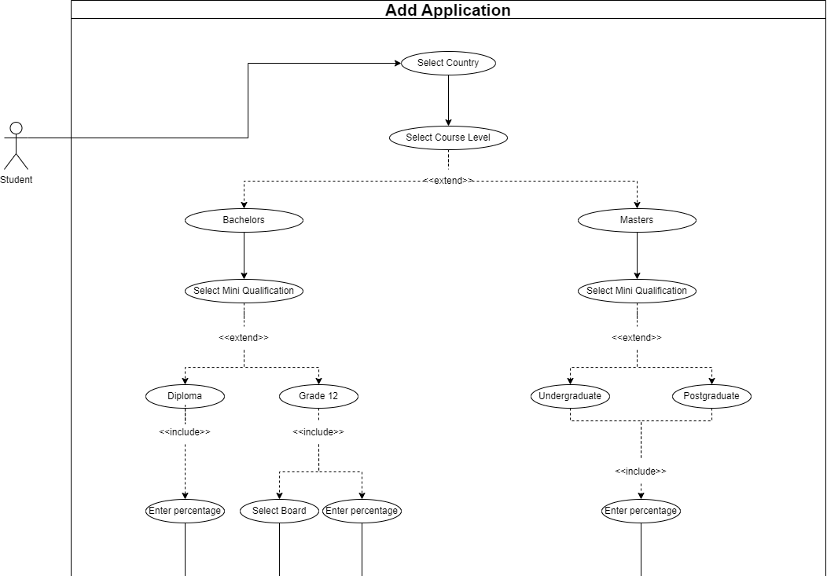

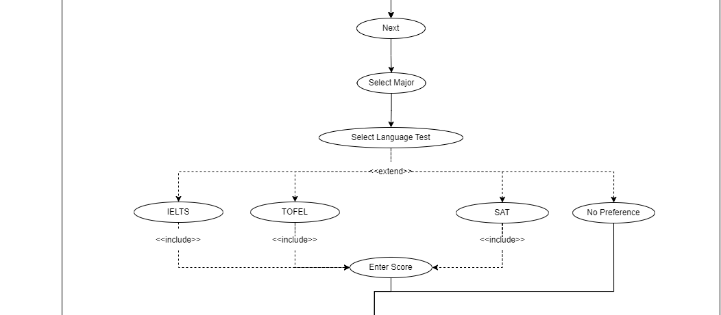

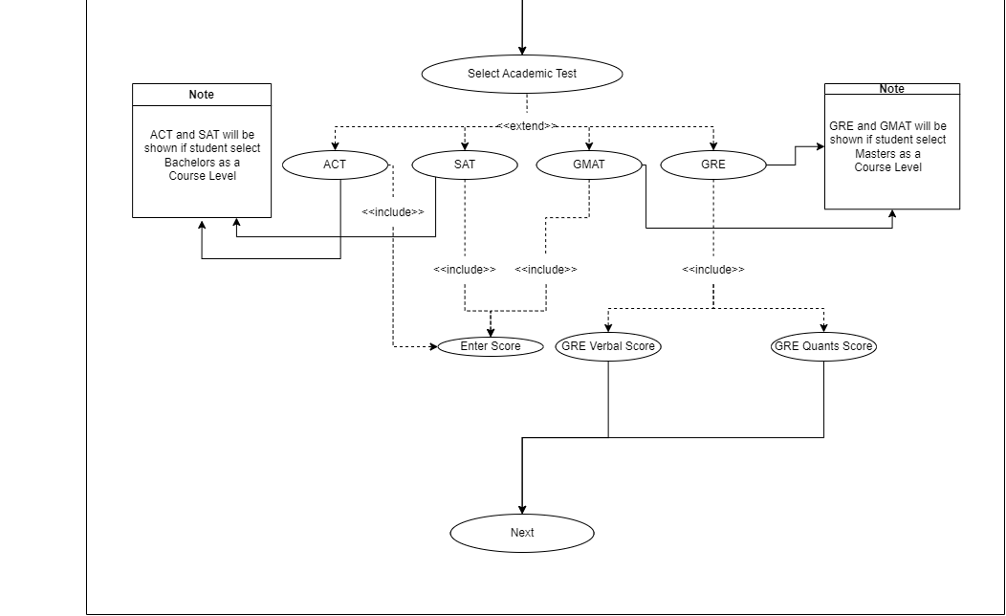

1. **COURSE FINDER**

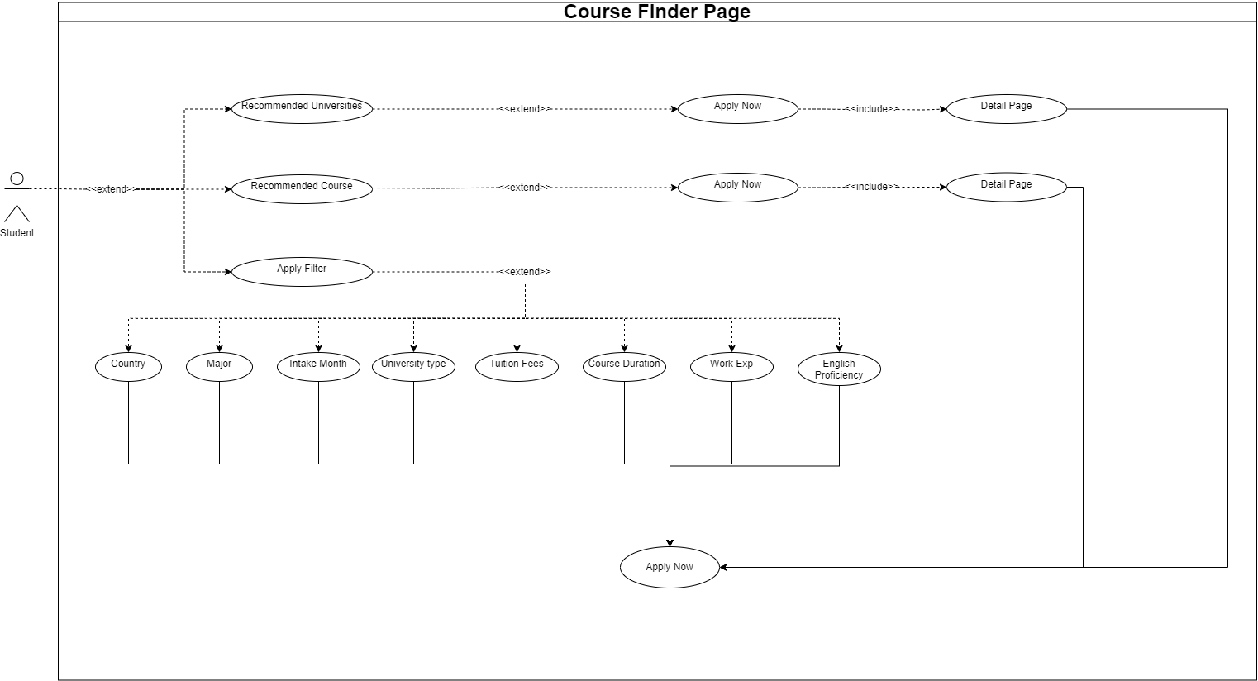

1. **DASHBOARD**

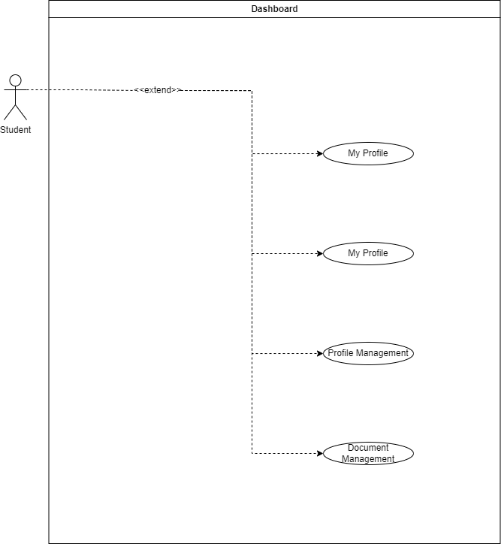

1. **PROFILE MANAGEMENT**

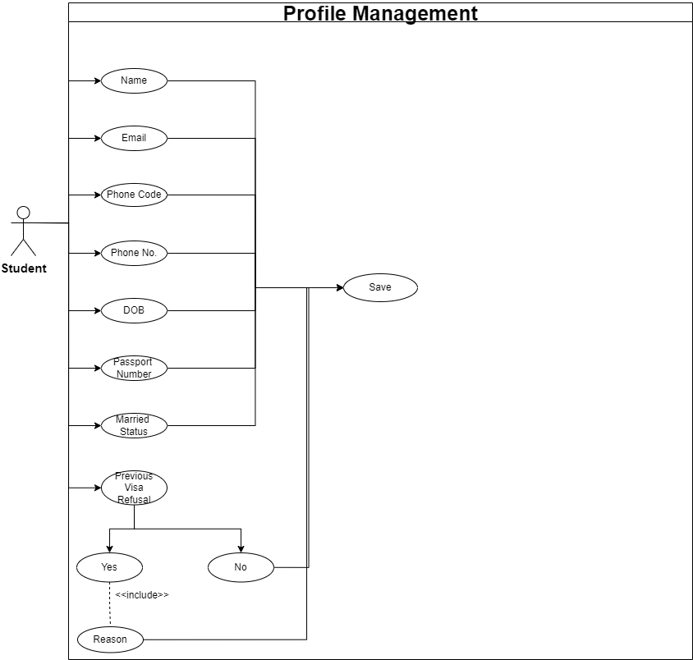

1. **DOCUMENT MANAGEMENT**

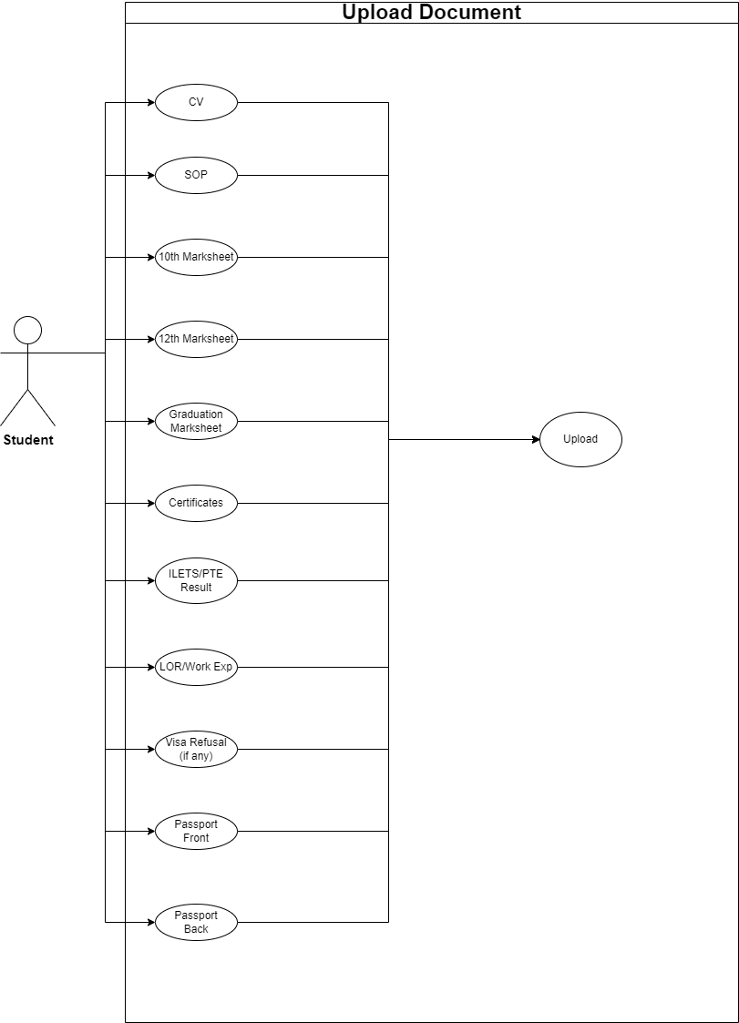

1. MY PROFILE

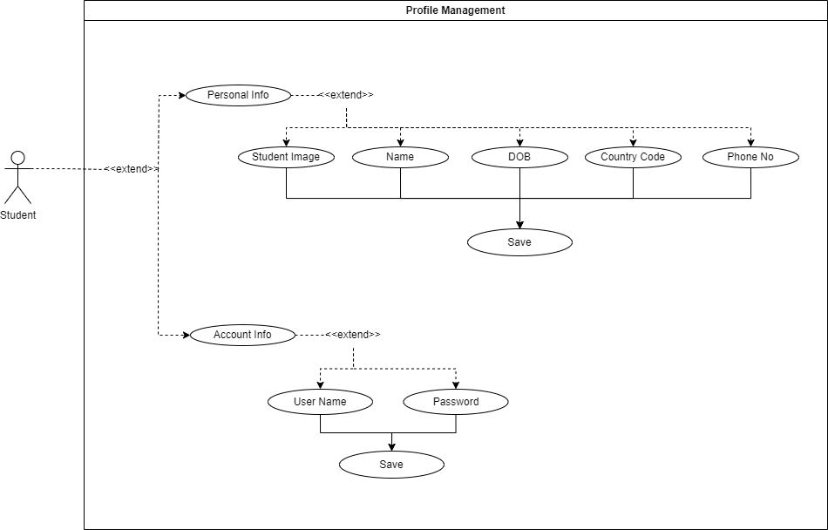

**3.3.1.B Agent Module**

Agent Module consists of -

1. Agent Dashboard
2. Agent Profile
3. Add new application
4. Add New Application
5. Add New Student
6. Upload Documents
7. Application History
8. Agent Dashboard

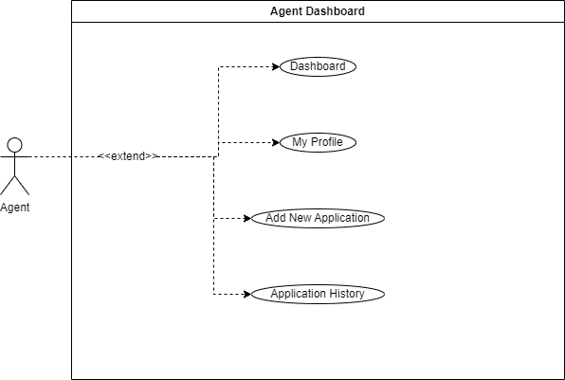

1. **Agent Profile**

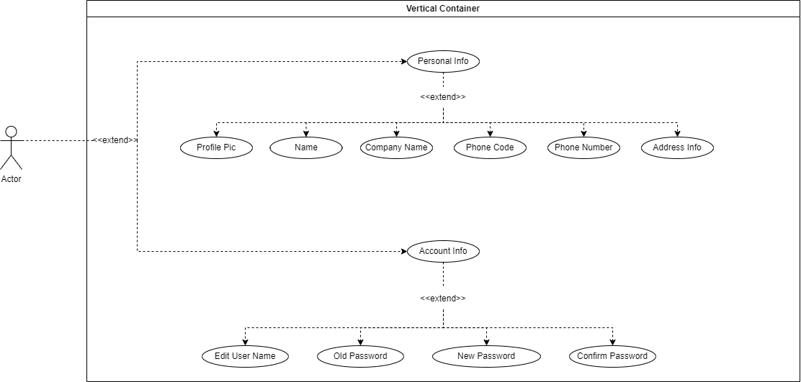

1. **Add New Application**
2. Add new Application

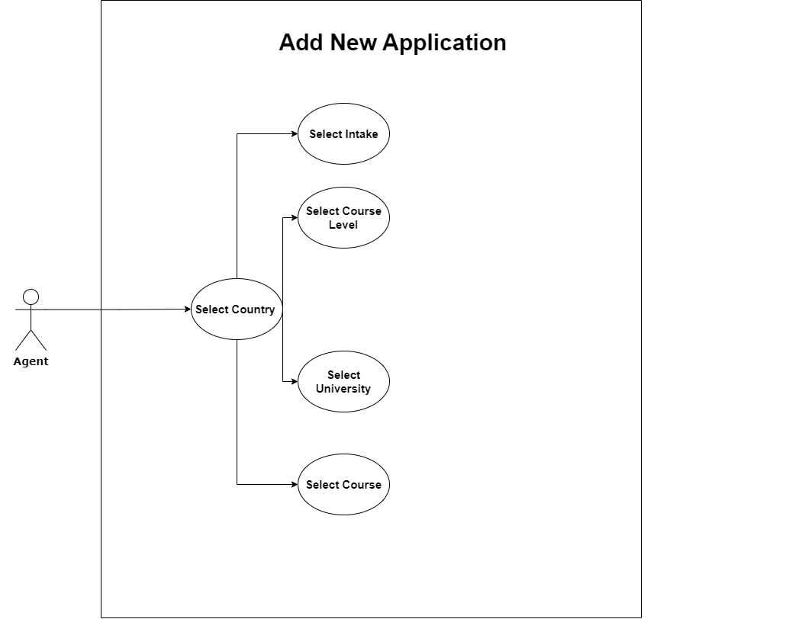

1. Add new student

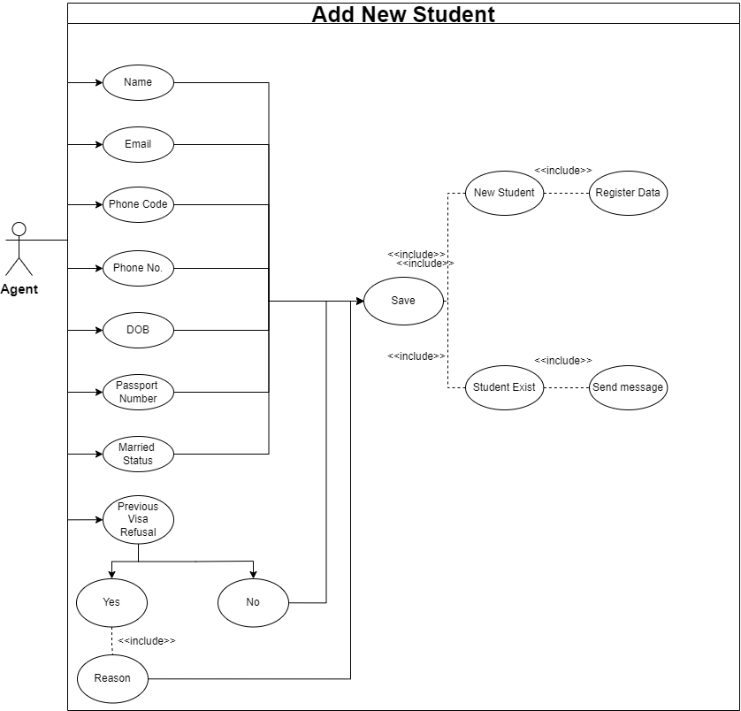

1. Upload Documents

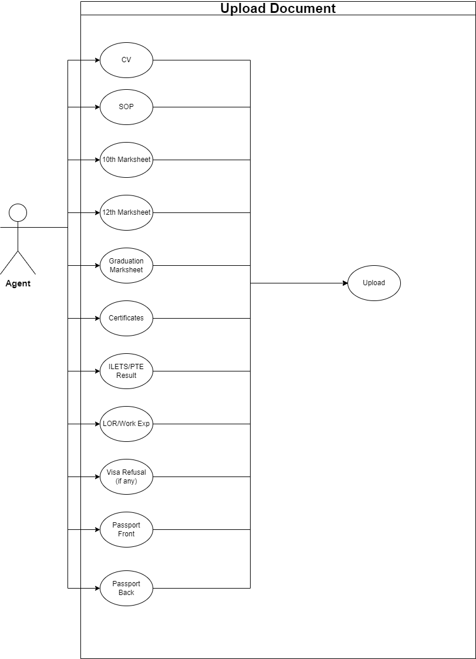

1. **Application History**

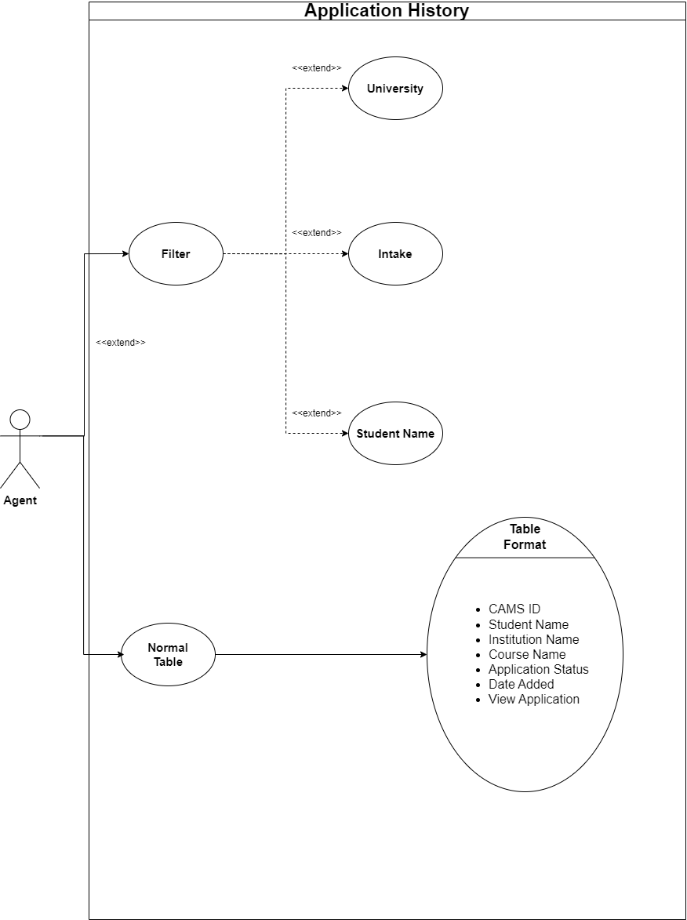

**3.3.1.C Admin Module**

Admin Module consists of –

1. Admin Dashboard
2. User Management
3. Agent Management
4. University Management
5. Course Management
6. Course Type Management
7. University & Course Management
8. Application History
9. **Admin Dashboard**

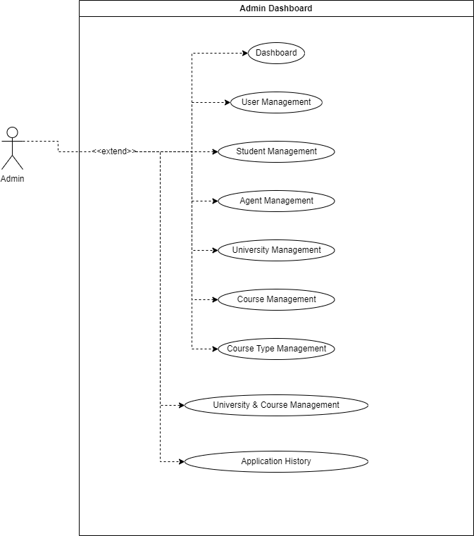

1. User Management

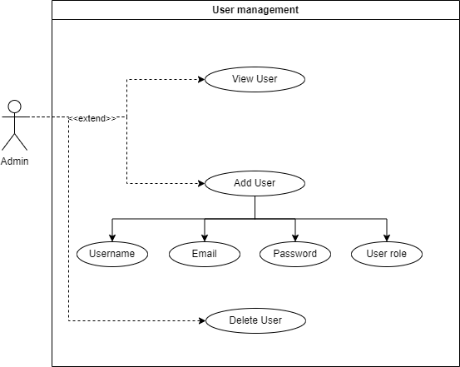

1. Agent Management

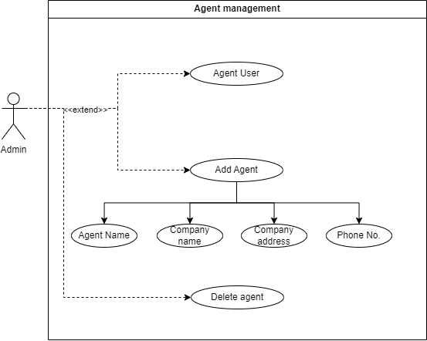

1. University Management

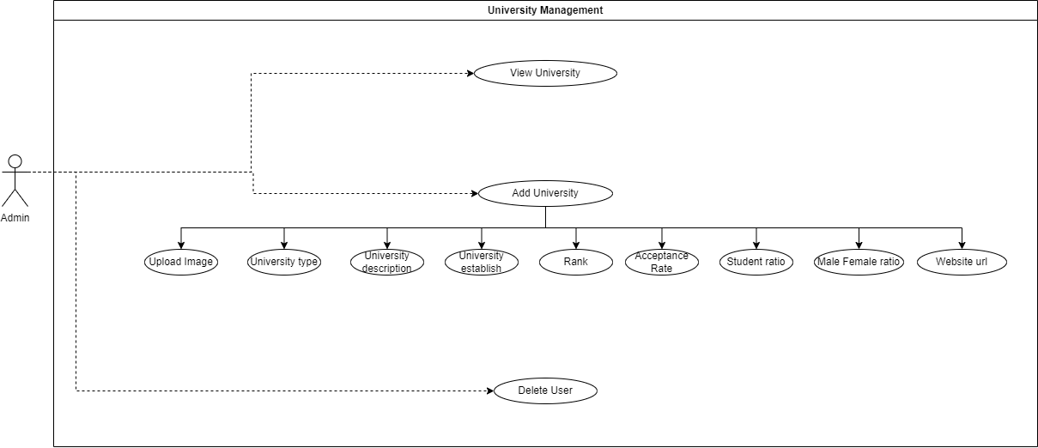

1. Course Management

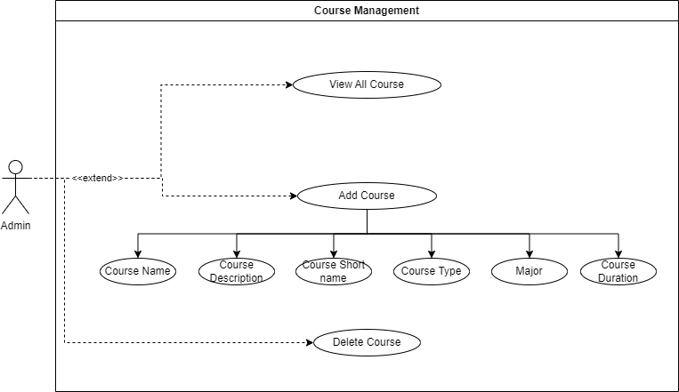

1. Course Type Management

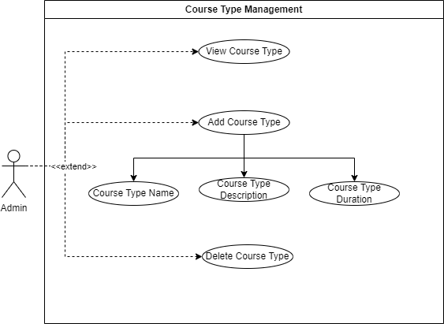

1. University and Course Management

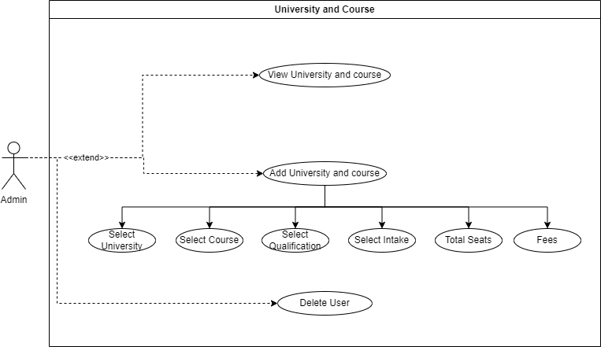

1. Application History



# 3.3.2 Activity Diagrams

An activity diagram is a powerful modelling tool that represents the dynamic behaviour of a system. It is a type of UML (Unified Modelling Language) diagram that depicts the flow of control between different activities in a system. The main purpose of an activity diagram is to show the sequence of activities, decisions, and conditions that occur in a process, from start to finish.

The diagram consists of various shapes and symbols, which represent different elements such as activities, transitions, and decision points. Activities represent the work that needs to be done in the system, while transitions depict the flow of control from one activity to another. Decision points are used to show branching paths in the process, depending on certain conditions.

One of the key benefits of using an activity diagram is that it allows you to visualize the entire process of a system, from start to finish, including all the decision points and possible outcomes. This helps to identify any potential problems or bottlenecks in the system and makes it easier to optimize the process for maximum efficiency.

Overall, activity diagrams are a powerful modelling tool that can help to improve the understanding, design, and documentation of complex systems. By using this diagram, you can effectively communicate the behaviour of a system to stakeholders and team members, ensuring that everyone is on the same page and working towards the same goals.

|  |  |  |
| --- | --- | --- |
| **NAME** | **SYMBOL** | **DESCRIPTION** |
| **INITIAL**  **STATE** | https://lh7-us.googleusercontent.com/5MlGE4_Ma7F8UMz6E_TJygCJe8wluRJNz-EDHI3rmR9Szi3EAHa-0EwezRETQ87pTPIIy3g7kr90JRi7heZ0LCuDAOO9lhwzMWByu6CYvTtjE_4_9V5w-CtFcZwLZKMqrycvCWBeP9dkM4IaXOqNLQ | **A black circle is standard notation for initial state before an activity takes place. It can either stand alone or can be further elucidated using a note.** |
| **ACTION**  **STATE** | https://lh7-us.googleusercontent.com/qz-0gvcLUbOXchwpSpzkVOfDabx03vIHml_7pCMzgemjh80uBa4SEH8kBh_YlqCKMDMXwPJB0oXorKn0hVZTJsYBodSeL9wX41eNF9A3LMvLeyAJoitV942dE821bAtEVZf8XhFtLpE1DEnWfwVFxw | **The activity symbols/ action states are the basic building blocks of an activity diagram and usually have a short description of the activity they represent.** |
| **CONTROL**  **FLOW** | https://lh7-us.googleusercontent.com/c8-TQrDq-HRHHIQ8nfC3hH0RLmczrw4Y-fXLVNpKGJJKjTGJNUpRd9MxBh_lwjBJhhIody9TRAb_tBUf50jQNRYlt8PpQrtkuIWNUe7aov7rXMz19cfdSSSisGaRps2NBtPwT1SXCL8fSJZkdvEuYQ | **Arrows represent the direction flow of the flow chart. The arrow points in the direction of progressing activities.** |
| **TRANSITION FORK** | https://lh7-us.googleusercontent.com/J3WWlMu0eWzI3wMnv92fYrrvoaRSioeynvclIm0JZ60-2wi84fhLqAB-b5x-5Y-hBrFiMWRr0Z7xp0TnUGUYB3PHkIcSsf5xkIwy9AzGUHg1P2qFS_l0zgXX7G2sSNMBkuMx0jVm9ZdsVnvmGu3ZpA  https://lh7-us.googleusercontent.com/gh8MrtGKxxj-wIiHAvngVrpM0qcSmC2-r-PjMLHjDkCIQ800LB9pJQZrWt5u4aznoCgkfz7KpxZFrbKqAuvkxjyn0FgkMsNAdeklapHERJ5PiLKx5_hgJklvh-_TnAHeIfuIqKbHKwSOHk4pVOnJTw | **A transition fork splits one activity flow into two concurrent activities or vice versa.** |
| **DECISION** | https://lh7-us.googleusercontent.com/a1pK05OXoWaL4RQZve-nkgQfvX2KFpI0ifIoLBwl-i8yfrYpfRnENDMTQDIyJdD6KORZvdAEZyULRYS7HVzPJjz9Y0IcVuD9skxqftmR0HQ8ckEhLRj9o0EuOas0KTCmwnVh7JShFFfuqUFj2jIl3Q | **A marker shaped like a diamond is the standard symbol for a decision. There are always at least two paths coming out of a decision and the condition text lets you know which options are mutually exclusive.** |
| **FINAL STATE** | https://lh7-us.googleusercontent.com/zE2qjZ4N-80EewTodDEPrRR5sx6suvnYfceSMFOWOKXBtkTPPV_gpcJvjbhgC3DKu_TU7JOdyUzSae2EHqUMofge9Feqd4eS4ax9dDIyE6tACJHlujE-JxZF5fPHwzggxYjOnR47a1kXGOCuTiR71g | **The black circle that looks like a selected radio button is the symbol for end state of an activity.** |
| **SWIM LANES** | https://lh7-us.googleusercontent.com/ufDD2Kr41ipKmM-OUsNNKz_vtNljsQLZ6AyuDvP6iMJHKe6hZwZy8Spd6xgYoNsmhyw7Ck4ZwMmu6GxuOiapx_UcSpfP6wYCe3IQ_8XU69ZvGVuxLeU0o5Q5e5BXAWLpWM_F3BVQWqTMqOfq8dj8zg | **The lanes are boundaries are drawn and the activities**  **Of a particular category are drawn in the same lane as that of the category.** |

3.3.2.A Student Module

1. AddNewApplication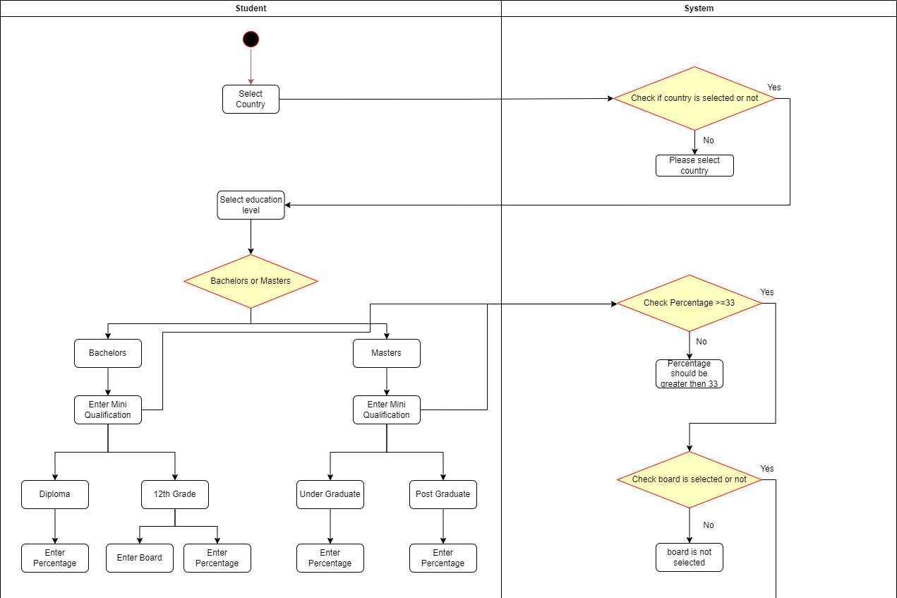

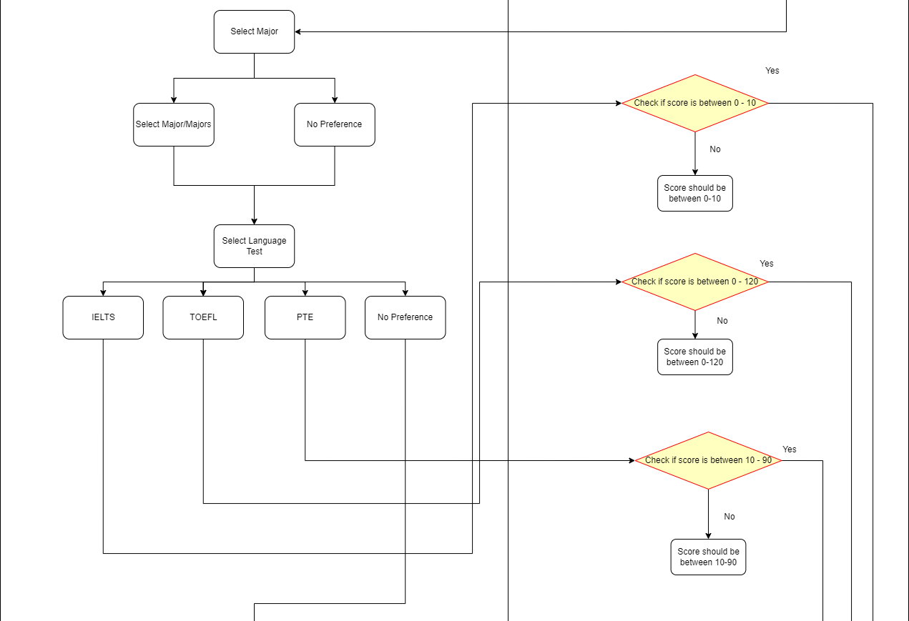

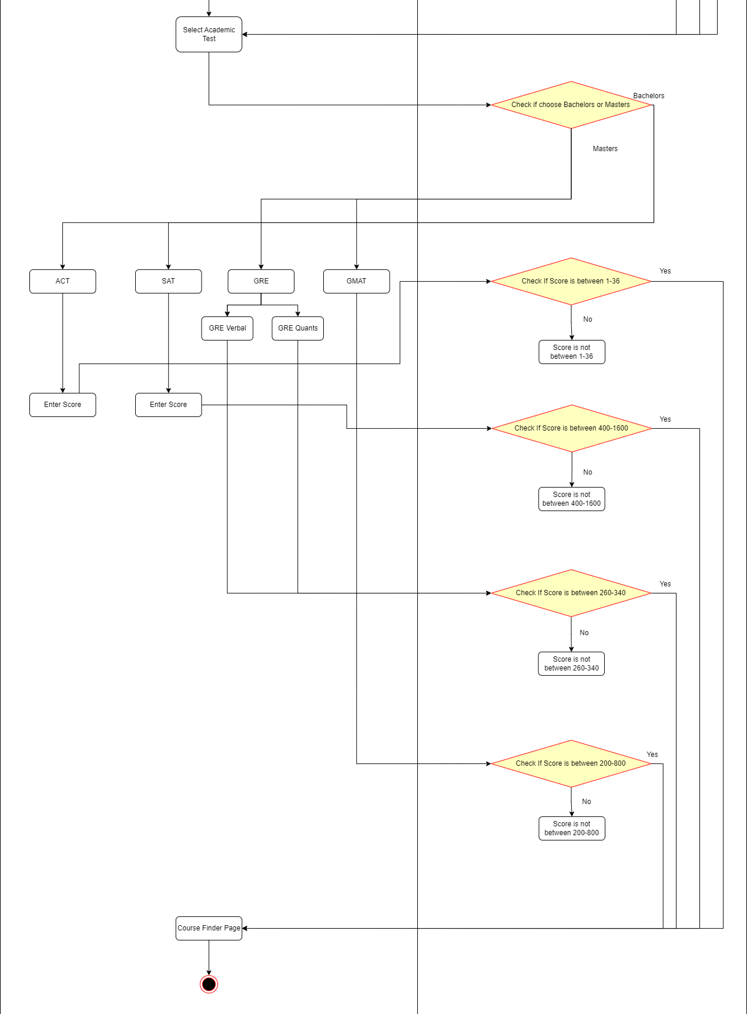

1. Course Finder

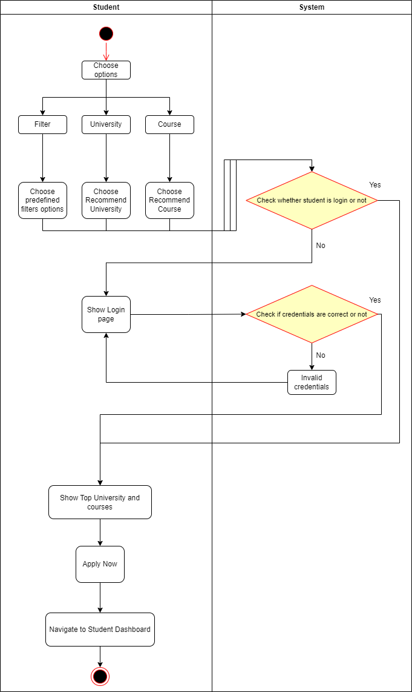

1. My Profile

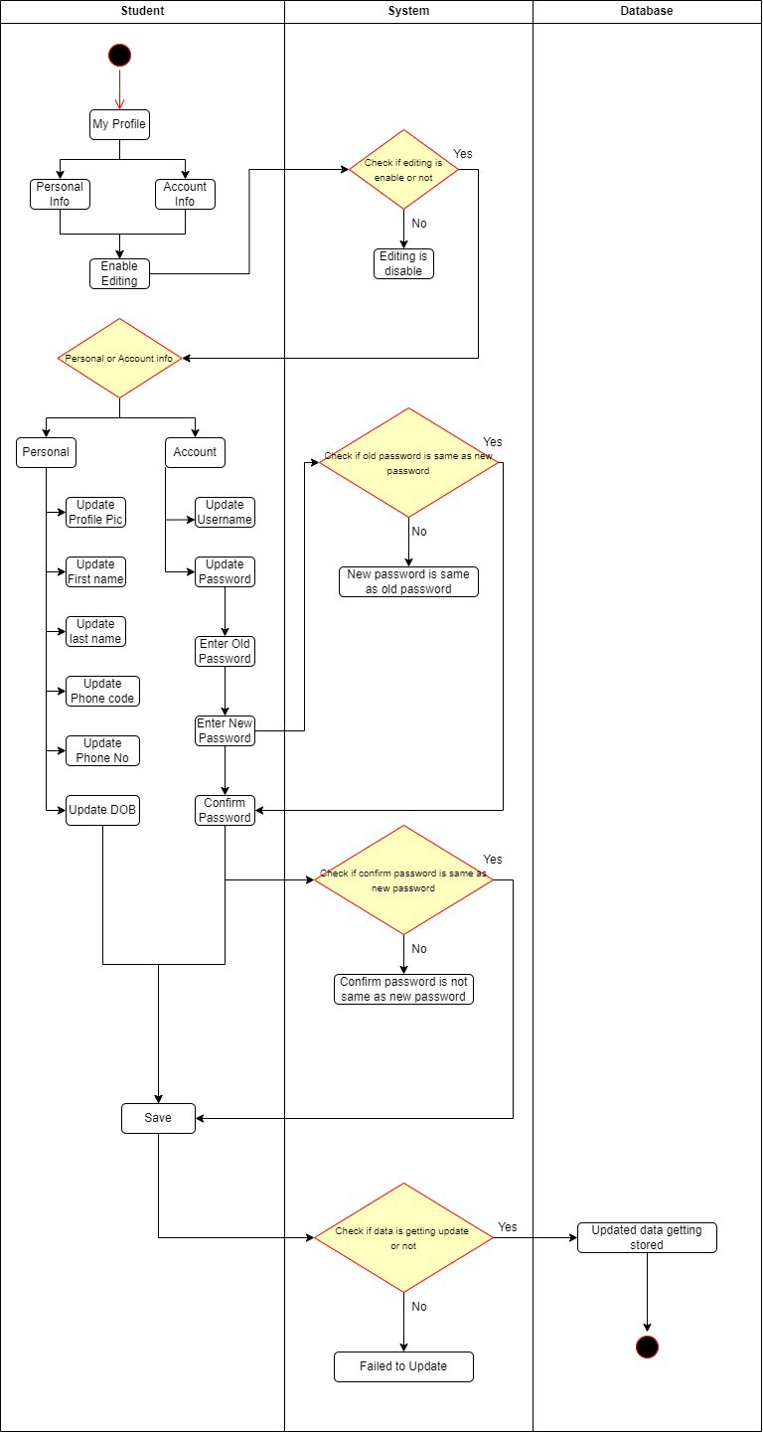

1. Upload Document

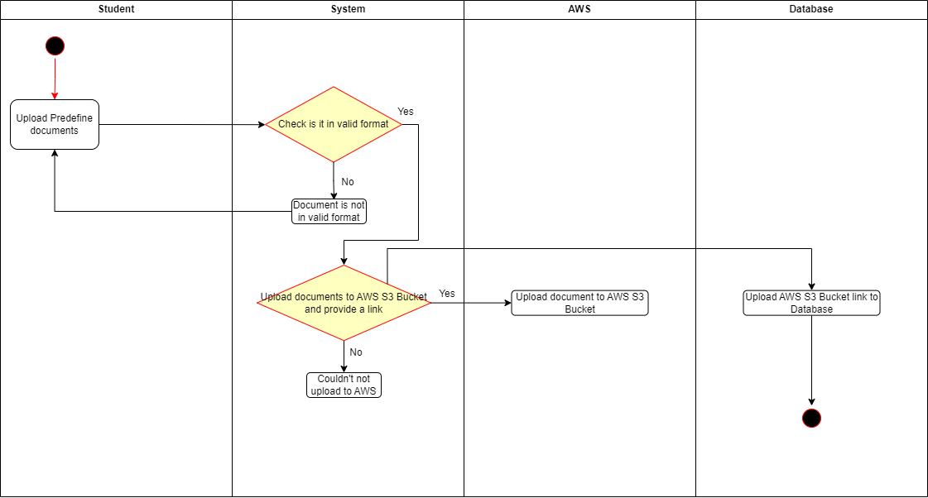

1. My Application Profile

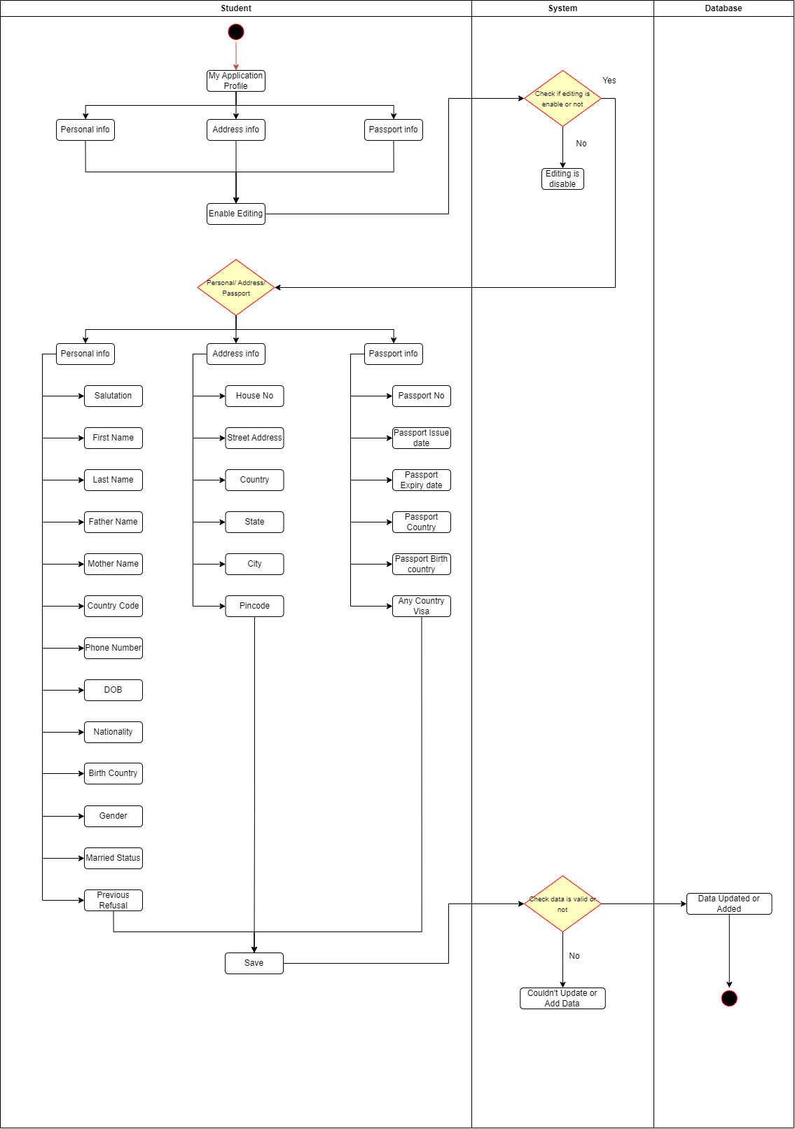

3.3.2.B Agent Module

a) Add New Application

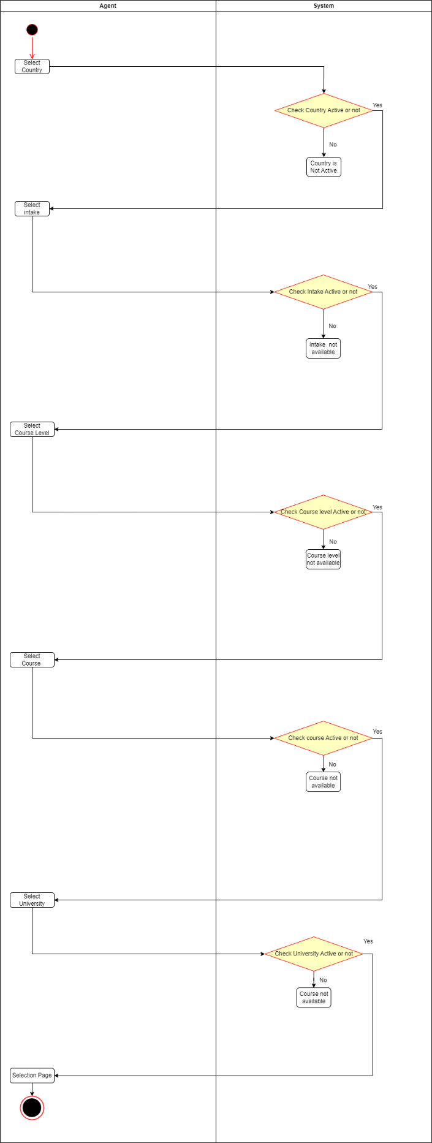

b) Add Student

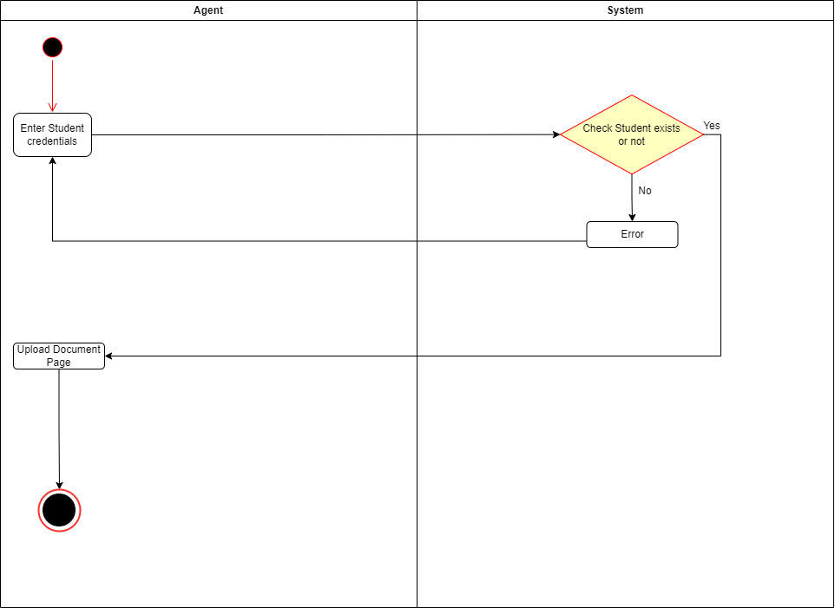

1. Upload Document

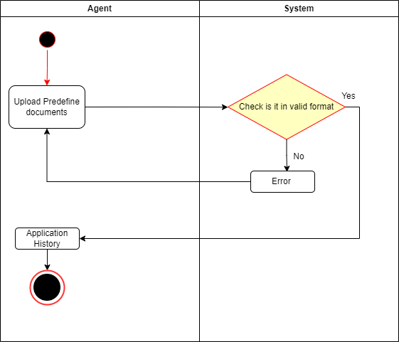

1. Application History

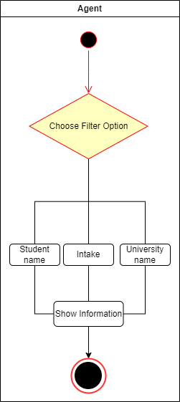

1. My Profile

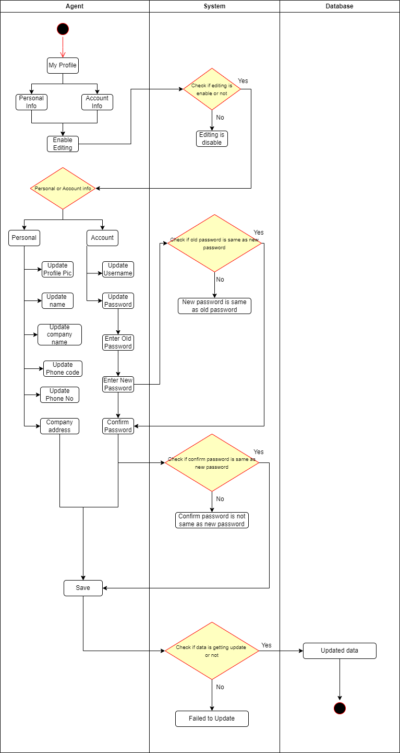

# 3.3.3 Sequence Diagram

A sequence diagram is a powerful tool for visualizing the interactions between objects in a system. Objects are represented as lifelines, which run down the page, and interactions between them are shown as messages drawn as arrows from the source lifeline to the target lifeline. Sequence diagrams are particularly effective for depicting object communication patterns and the messages that trigger those communications.

By using a sequence diagram, you can quickly understand the flow of messages and the interactions between objects, which can be critical for debugging and system analysis. Sequence diagrams are especially useful for illustrating complex object interactions and message sequences, which can be difficult to convey through other means.

|  |  |  |
| --- | --- | --- |
| **NAME** | **SYMBOL** | **DESCRIPTION** |
| **TIMELINES** | https://lh7-us.googleusercontent.com/0mM8u5mDKFVAtU-1Rlc_5Ex7hHbNFaisvkz9jF4BbhpipAe625WFMYyTAb04ns3R0qlBHmxaf8oxxXf5sCHhq38OI1vibkHQAuIuay1mqyRGkfh-Lmz6Sme6WZ1x2iYvxZxK_DrHeRJlhG9DsLCAZQ | **A Timeline represents an individual participant in a sequence diagram. A lifeline will usually have a rectangle containing its object name. If its name is "self", that indicates that the lifeline represents the classifier which owns the sequence**  **diagram.** |
| **MESSAGES** | https://lh7-us.googleusercontent.com/IU-zDtHh1AQGquE-R-qWeCFNzDjPHXzvmv4gISaQ2UD530njFeJCQZuBd7j97fVbNxp5ThaX0ljTXcFJvYo6EhD7pvHY59JtdSsGhmg9xfPdePFuru1XzLQTjCR4sc09u145RUoGGm8X0CmIyn2zZQ | **A message represents an interaction between objects, or between an object and the environment. A message can be an event, a triggered operation, or a primitive operation. In the metamodel, a message defines a specific type of communication.** |
| **OBJECT** | https://lh7-us.googleusercontent.com/igFYqy4uJIUcWOPuQ8H2G6QO840AZnGNvwrlcFaHPIp3KJFtjYiytHC1eeKczAtlE_u3B4ybFchXdUcLGcat02p7lLq3MFx6zF97OZbeL9f1allOBW_gb_jTdaTGPZB8Vpz1sUsB-M1JDI1Oa4Y3QA | **The sequence diagram consists of a group of objects that are represented by lifelines and the messages that they exchange over time during the interaction** |
| **FOCUS OF CONTROL** | https://lh7-us.googleusercontent.com/JcT7qL4aFpdcx37kUJ_ooYRBpmKeBxEyXtQCE7pf6oXWbc2q6kV3SeJjfFIk48FzZfN45yUGxasMEaDponzuCN7yYuV6-2Ee99UrMsHCmZIQu5iNyBgQ08cqwnmAK6l1znlvd3oa9wlERRP0PqUNJQ | **Focus of control (FOC) is used in sequence**  **diagrams to show the period of time during which an object performs an action. FOC is rendered as a thin, rectangular object that sits on top of object lifelines** |

**3.3.A Student Module**

a) Course Finder Flow

- Select Country and Education

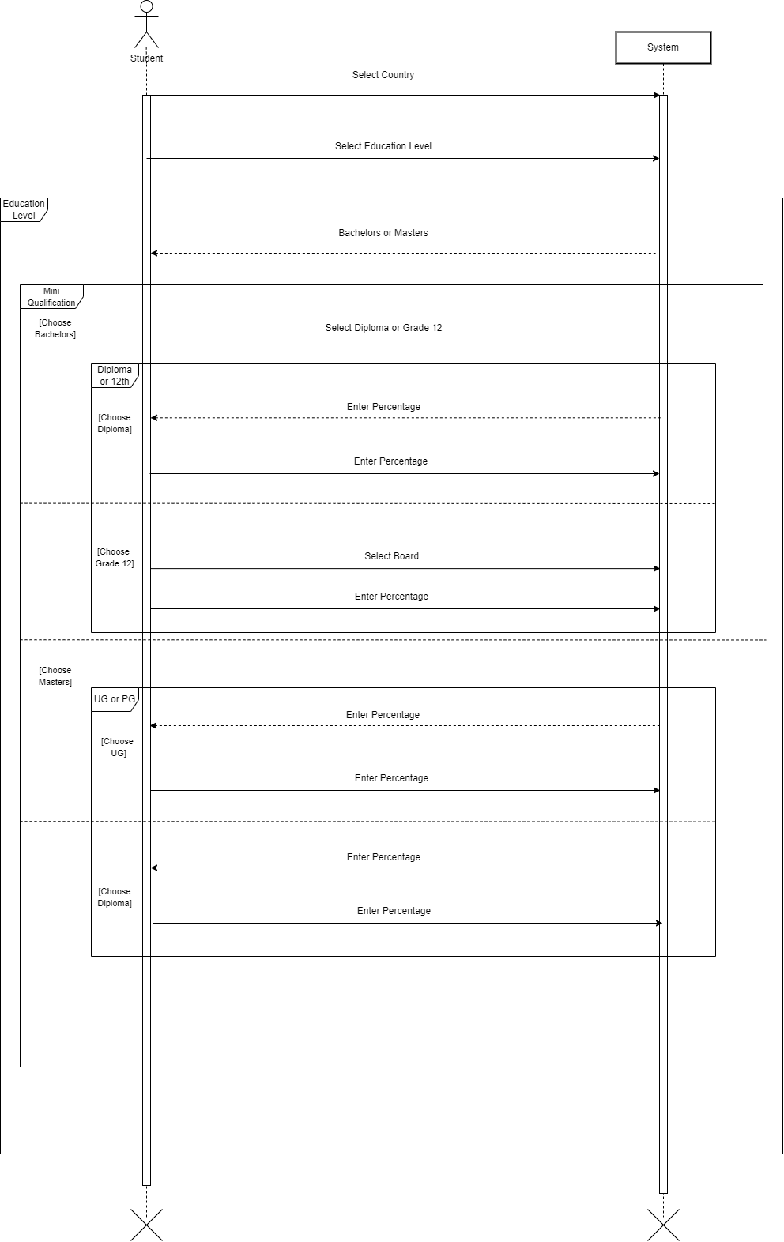

- Select Major and Language Test

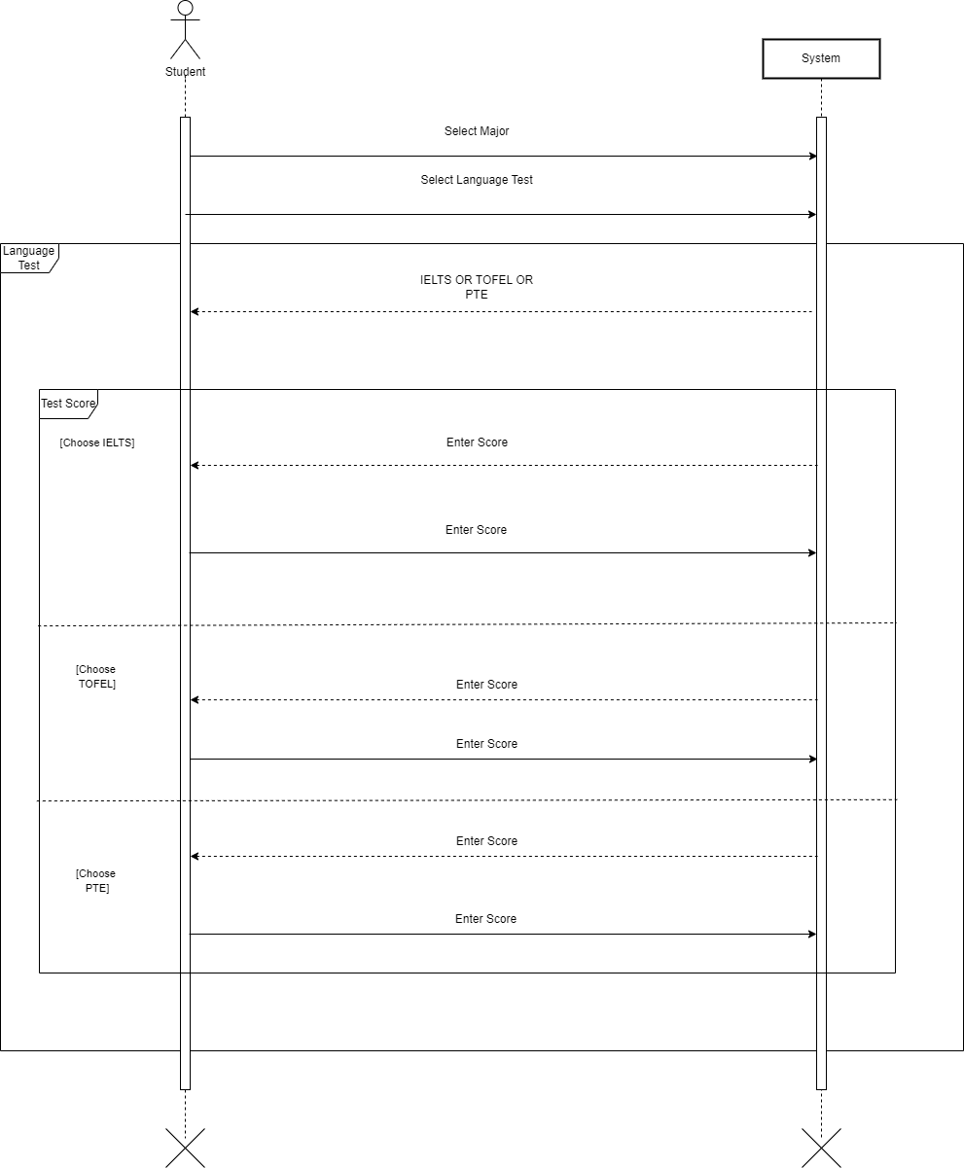

* Select Academic Test

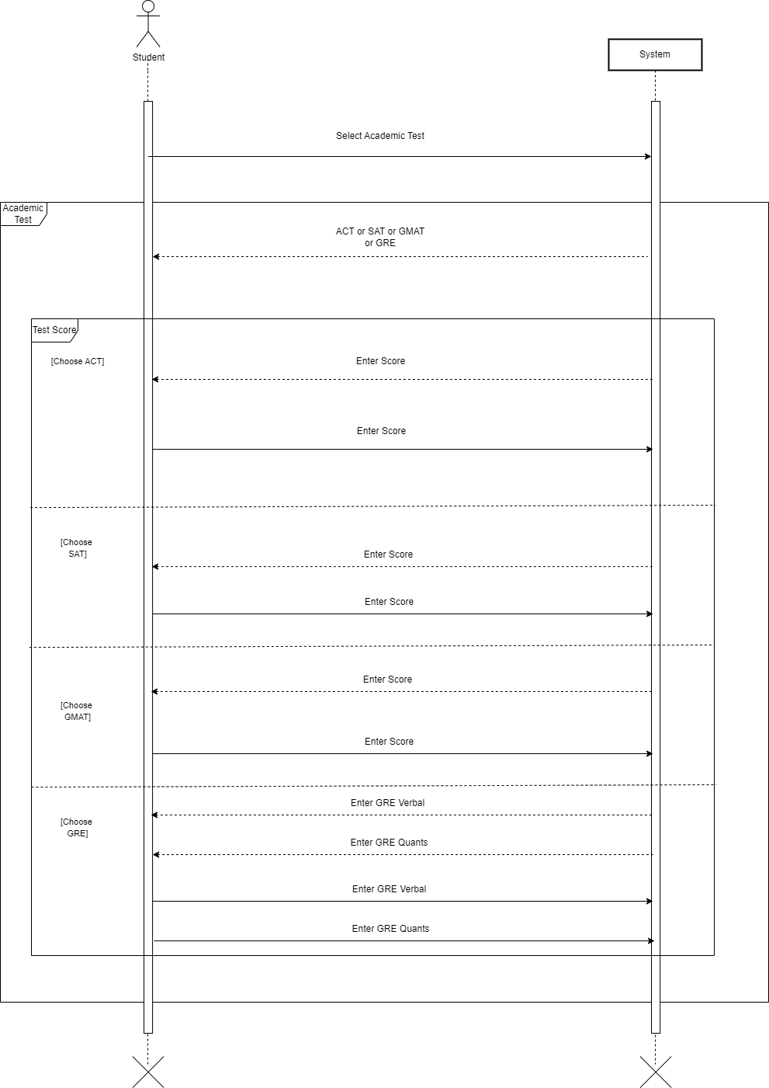

# Chapter 4:- Database Schema Design

4.1 Data Dictionary

*Collection Name:- User*

| **Field Name** | **Datatype** | **Constrain** | **Description** |
| --- | --- | --- | --- |
| _id | ObjectID | Auto generated | An ID to identify each instance uniquely |
| student | ObjectId, ref: 'StudentModel' | - | Reference to the student model |
| agent | ObjectId, ref: 'agentModel' | - | Reference to the agent model |
| username | String | Optional | Username of the user |
| firstname | String | Optional | First name of the user |
| lastname | String | Optional | Last name of the user |
| email | String | Required | Email address of the user |
| mobile | String | Optional | Mobile number of the user |
| password | String | Optional | Password of the user |
| otp | String | Optional | One-time password (OTP) of the user |
| isprimary | Boolean | Optional | Indicates if the user is primary |
| agencyid | ObjectId, ref: 'AgencyModel' | - | Reference to the agency model |
| profile_pic | String | Optional | URL of the user's profile picture |
| roletype | String | - | Type of role the user has |
| role | Number | Required | Role of the user |
| access_token | String | - | Access token for user authentication |
| status | String | - | Status of the user (e.g., active, inactive) |
| created_at | Date | - | Creation time of the user record |
| updated_at | Date | - | Last update time of the user record |

**Collection Name:- Student**

| **Field Name** | **Datatype** | **Constrain** | **Description** |
| --- | --- | --- | --- |
| _id | ObjectID | Auto generated | An ID to identify each instance uniquely |
| agent | ObjectId, ref: 'UserModel' | Optional | Reference to the agent user model |
| salutation | String | Optional | Salutation for the student (e.g., Mr., Mrs.) |
| fullname | String | Optional | Full name of the student |
| firstname | String | Optional | First name of the student |
| lastname | String | Optional | Last name of the student |
| fathername | String | Optional | Father's name of the student |
| mothername | String | Optional | Mother's name of the student |
| email | String | Optional | Email address of the student |
| phonenumber | String | Optional | Phone number of the student |
| phonecode | String | Optional | Country code for the phone number |
| middlename | String | Optional | Middle name of the student |
| previousname | String | Optional | Previous name of the student |
| gender | String | Optional | Gender of the student |
| dob | String | Optional | Date of birth of the student |
| countryofbirth | String | Optional | Country of birth of the student |
| nationality | String | Optional | Nationality of the student |
| isdualcitizen | Boolean | Optional | Indicates if the student has dual citizenship |
| marriegestatus | String | Optional | Marital status of the student |
| isdifferentlyabled | Boolean | Optional | Indicates if the student is differently abled |

**Collection Name:- Agent**

| **Field Name** | **Datatype** | **Constrain** | **Description** |
| --- | --- | --- | --- |
| _id | ObjectID | Auto generated | An ID to identify each instance uniquely |
| name | String | Required | Name of the agent |
| address | String | Optional | Address of the agent |
| company_name | String | Optional | Name of the company associated with the agent |
| phone | String | Optional | Phone number of the agent |
| phone_code | String | Optional | Country code for the agent's phone number |
| country | ObjectId, ref: 'CountryModel' | Optional | Reference to the country where the agent is located |
| state | ObjectId, ref: 'StateModel' | Optional | Reference to the state where the agent is located |
| city | ObjectId, ref: 'CityModel' | Optional | Reference to the city where the agent is located |
| created_at | Date | - | Creation time of the agent's record |
| updated_at | Date | - | Last update time of the agent's record |

**Collection Name:- University**

| **Field Name** | **Datatype** | **Constrain** | **Description** |
| --- | --- | --- | --- |
| _id | ObjectID | Auto generated | An ID to identify each instance uniquely |
| university_name | String | Required | Name of the university |
| image | String | Optional | URL of the university's image |
| description | String | Optional | Description of the university |
| rank | String | Optional | Ranking of the university |
| acceptancerate | String | Optional | Acceptance rate of the university |
| studentratio | String | Optional | Student to faculty ratio of the university |
| intakes | String | Optional | Intake periods of the university |
| malefemaleratio | String | Optional | Male to female student ratio of the university |
| websiteurl | String | Optional | URL of the university's website |
| address | String | Optional | Address of the university |
| linkedinurl | String | Optional | URL of the university's LinkedIn page |
| youtubeurl | String | Optional | URL of the university's YouTube channel |
| instagramurl | String | Optional | URL of the university's Instagram page |
| twitterurl | String | Optional | URL of the university's Twitter page |
| university_type | String | Optional | Type of the university (e.g., public, private) |
| university_establish | String | Optional | Year of establishment of the university |
| country | ObjectId, ref: 'CountryModel' | Optional | Reference to the country where the university is located |
| state | ObjectId, ref: 'StateModel' | Optional | Reference to the state where the university is located |
| city | ObjectId, ref: 'CityModel' | Optional | Reference to the city where the university is located |
| status | Boolean, Default: true | - | Current activity status of the university |
| created_at | Date | - | Creation time of the university record |
| updated_at | Date | - | Last update time of the university record |

**Collection Name:- Major**

| **Field Name** | **Datatype** | **Constrain** | **Description** |
| --- | --- | --- | --- |
| _id | ObjectID | Auto generated | An ID to identify each instance uniquely |
| name | String | Required | Name of the major |
| icon | String | Optional | Icon associated with the major |
| status | Boolean | Default: true | Current activity status of the major |
| created_at | Date | - | Creation time of the major's record |
| updated_at | Date | - | Last update time of the major's record |

**Collection Name:- CourseType**

| **Field Name** | **Datatype** | **Constrain** | **Description** |
| --- | --- | --- | --- |
| _id | ObjectID | Auto generated | An ID to identify each instance uniquely |
| title | String | Required | Title of the Course Type |
| before | String | Optional | Indicates any prerequisite for this Course Type |
| description | String | Optional | Description of the Course Type |
| months | String | Required | Duration of the Course Type in months |
| status | Boolean | Default: true | Current activity status of the Course Type |
| created_at | Date | - | Creation time of the Course Type’s record |
| updated_at | Date | - | Last update time of the Course Type’s record |

**Collection Name:- Course**

| **Field Name** | **Datatype** | **Constrain** | **Description** |
| --- | --- | --- | --- |
| _id | ObjectID | Auto generated | An ID to identify each instance uniquely |
| course_name | String | Required | Name of the course |
| course_short_name | String | Optional | Short name or abbreviation of the course |
| course_description | String | Optional | Description of the course |
| course_duration | String | Optional | Duration of the course |
| major | ObjectId, ref: 'MajorModel' | - | Reference to the major associated with the course |
| course_type_id | ObjectId, ref: 'CourseTypeModel' | - | Reference to the type of course |
| status | Boolean, Default: true | - | Current activity status of the course |
| created_at | Date | - | Creation time of the course's record |
| updated_at | Date | - | Last update time of the course's record |

**Collection Name:- Intake**

| **Field Name** | **Datatype** | **Constrain** | **Description** |
| --- | --- | --- | --- |
| Index | Integer | Required | Index of the intake period in the array |
| group | Integer | optional | Group identifier for the intake period |
| parent | Boolean | optional | Indicates if the intake period is a parent |
| title | String | optional | Title of the intake period (e.g., "Dec 2023 - Mar 2024") |
| title2 | String | optional | Alternative title of the intake period (e.g., "Dec/Jan/Feb/Mar 2024") |

**Collection Name:- Application**

| **Field Name** | **Datatype** | **Constrain** | **Description** |
| --- | --- | --- | --- |
| _id | ObjectID | Auto generated | An ID to identify each instance uniquely |
| status | Boolean | - | Status of the application |
| university_course | Array of Objects | - | Array containing university and course references |
|  | university_id: ObjectId, ref: 'UniversityModel' | Optional | Reference to the university associated with the application |
|  | course_id: ObjectId, ref: 'CourseModel' | Optional | Reference to the course associated with the application |
| intake | String | - | Intake information for the application |
| coursetype_id | ObjectId, ref: 'CourseTypeModel' | Optional | Reference to the course type associated with the application |
| student_id | ObjectId, ref: 'StudentModel' | Optional | Reference to the student associated with the application |
| created_at | Date | - | Creation time of the application's record |
| updated_at | Date | - | Last update time of the application's record |

**Collection Name:- Application**

| **Field Name** | **Datatype** | **Constrain** | **Description** |
| --- | --- | --- | --- |
| _id | ObjectID | Auto generated | An ID to identify each instance uniquely |
| CV | String | Optional | Path or URL to the student's CV |
| SOP | String | Optional | Path or URL to the student's Statement of Purpose |
| Marksheet10 | String | Optional | Path or URL to the student's 10th grade marksheet |
| Marksheet12 | String | Optional | Path or URL to the student's 12th grade marksheet |
| GraduationMarksheet | String | Optional | Path or URL to the student's graduation marksheet |
| CertAndOriginalDegree | String | Optional | Path or URL to the student's certificates and original degree |
| IELTS_PTE | String | Optional | Path or URL to the student's IELTS/ PTE scores |
| LORSWorkExpLetter | String | Optional | Path or URL to the student's Letters of Recommendation and Work Experience Letters |
| Visa_Refusal | String | Optional | Path or URL to the student's Visa Refusal document |
| passport | Object | - | Object containing paths or URLs to the student's passport images (front and back) |
| front | String | Optional | Path or URL to the front image of the student's passport |
| back | String | Optional | Path or URL to the back image of the student's passport |
| student_id | ObjectId, ref: 'StudentModel' | Required | Reference to the student associated with the documents |
| status | Boolean, Default: true | - | Status of the document |
| created_at | Date | - | Creation time of the document's record |
| updated_at | Date | - | Last update time of the document's record |

**Collection Name:- University and Course**

| **Field Name** | **Datatype** | **Constrain** | **Description** |
| --- | --- | --- | --- |
| _id | ObjectID | Auto generated | An ID to identify each instance uniquely |
| university_id | ObjectId, ref: 'UniversityModel' | - | Reference to the university offering the course |
| course_id | ObjectId, ref: 'CourseModel' | - | Reference to the specific course |
| qualification | ObjectId, ref: 'CourseTypeModel' | - | Reference to the qualification or course type |
| intake_month | String | Required | Month of intake for the course |
| total_seats | Number | Required | Total number of seats available for the course |
| currency | String | Required | Currency used for the course fees |
| entry_criteria | Object | - | Entry criteria for the course |
| - name | String | - | Name of the entry criteria (e.g., GPA, GRE score) |
| - score | Object | - | Score required for the entry criteria |
| english_proficiency_test | Object | - | English proficiency test requirements for the course |
| - name | String | - | Name of the English proficiency test (e.g., IELTS) |
| - score | String | - | Minimum score required for the English proficiency test |
| fee | Number | Required | Fee for the course |
| status | Boolean | Default: true | Status of the course (active/inactive) |
| created_at | Date | - | Creation time of the course's record |
| updated_at | Date | - | Last update time of the course's record |

# Chapter 5:- Screen Shots of UI

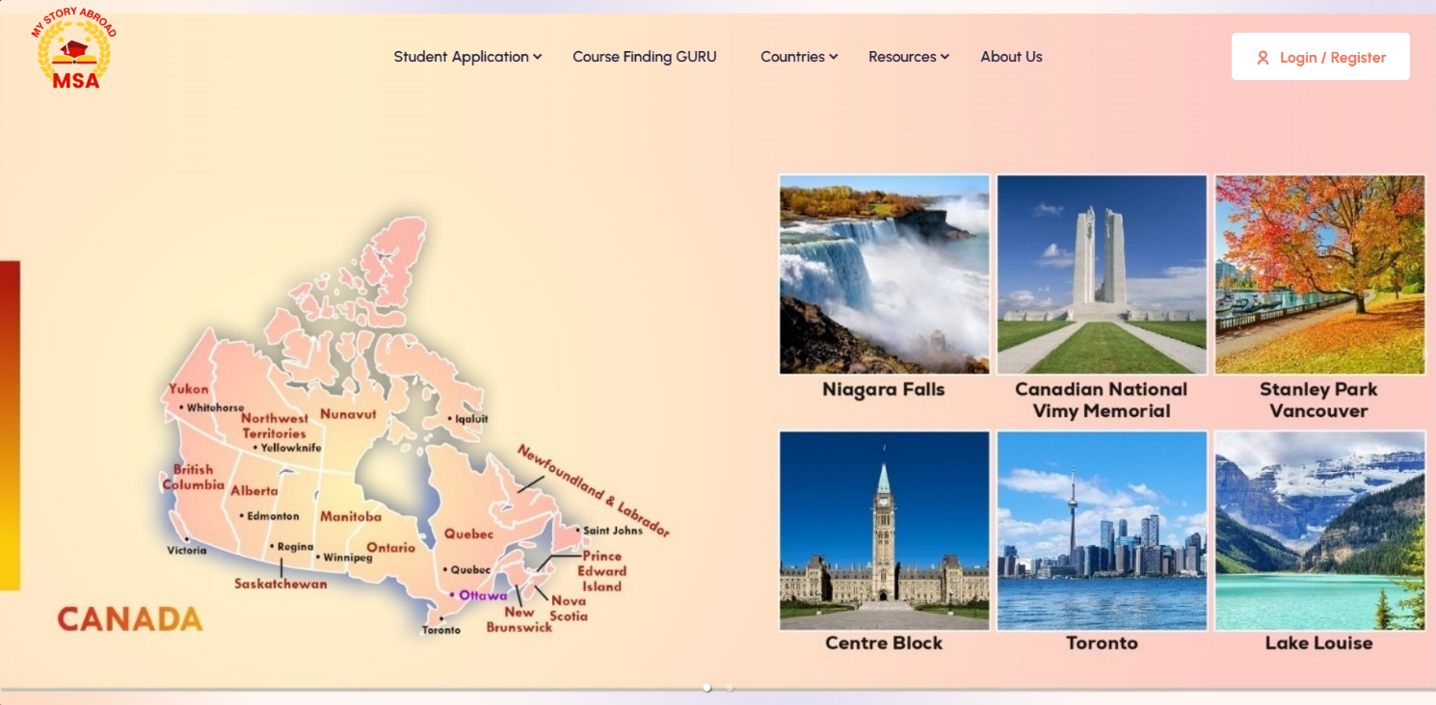

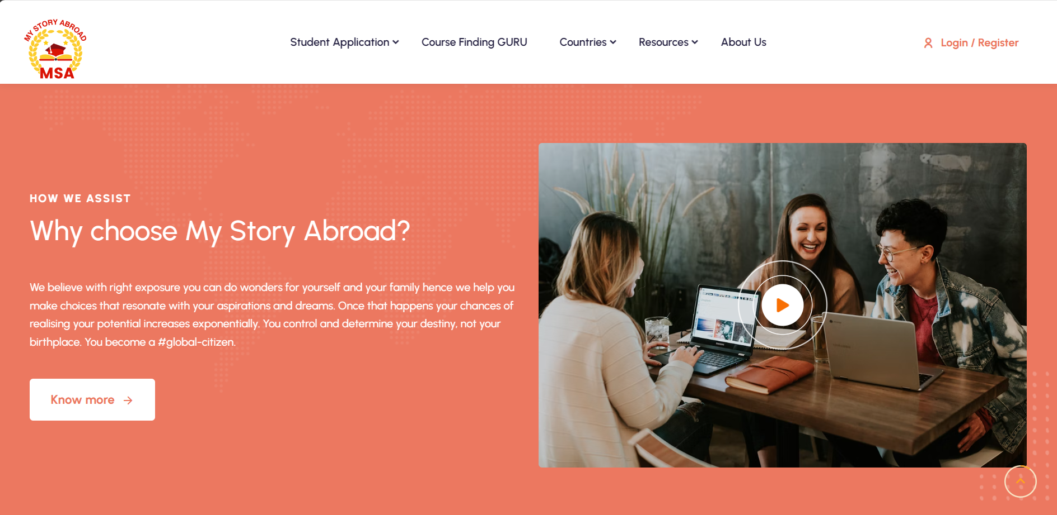

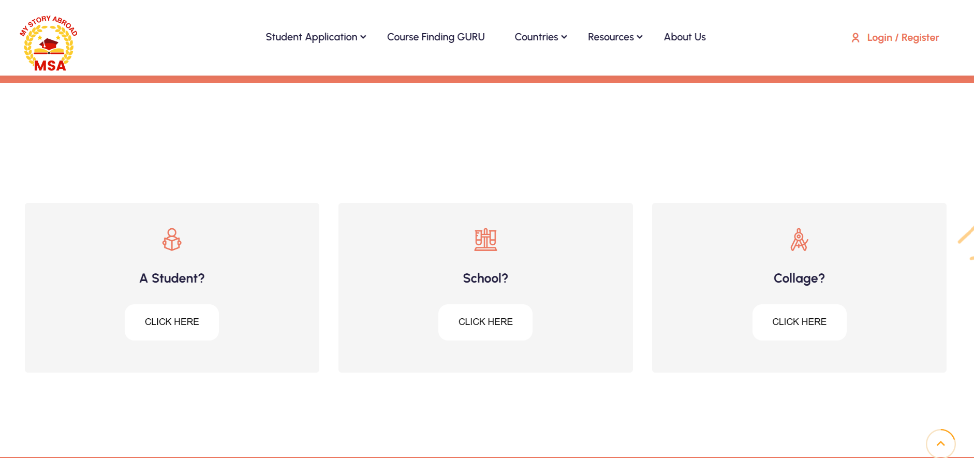

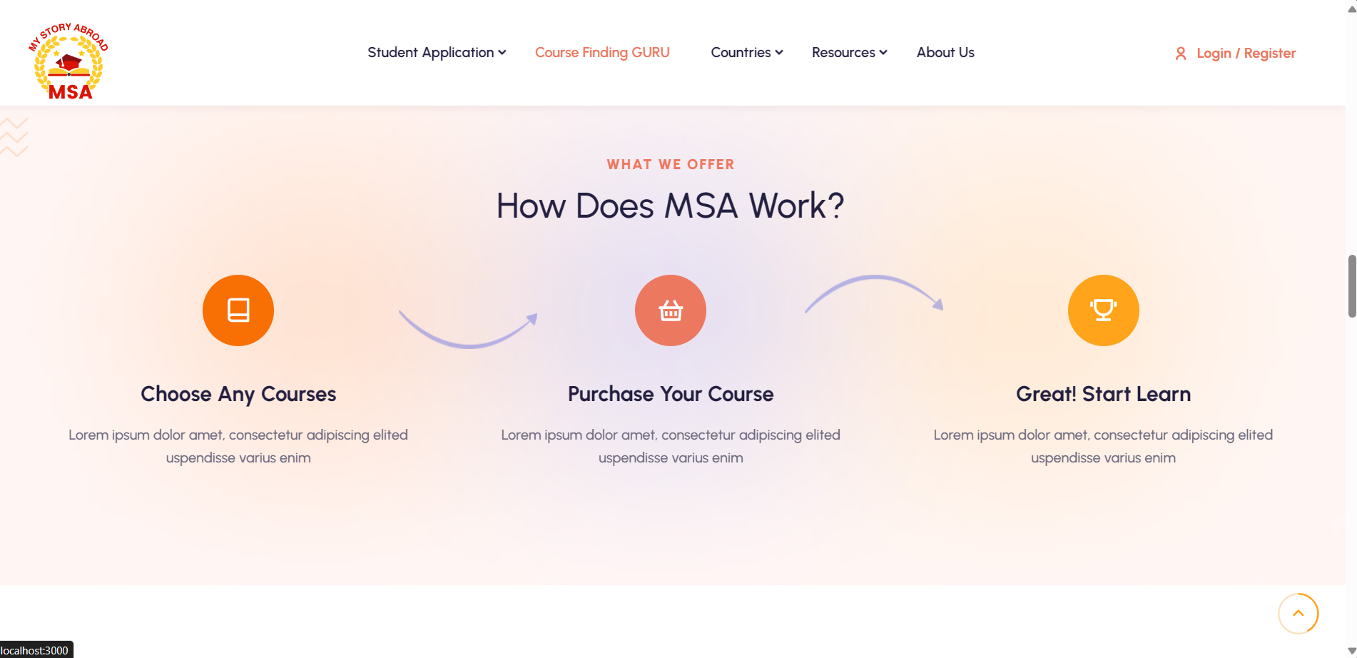

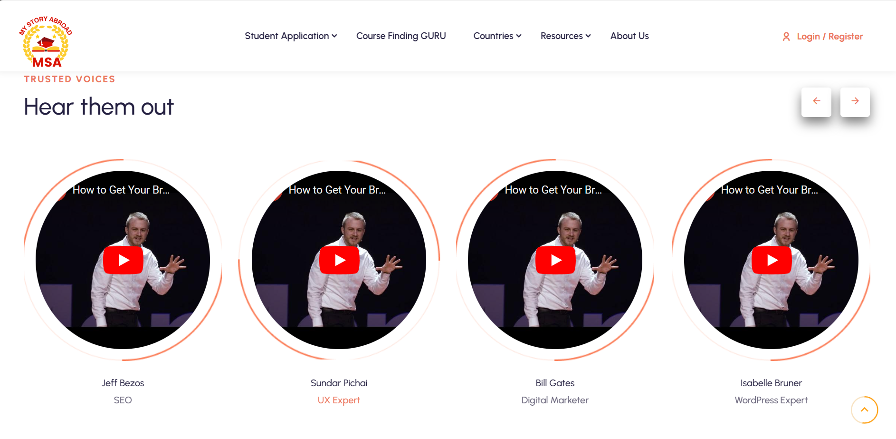

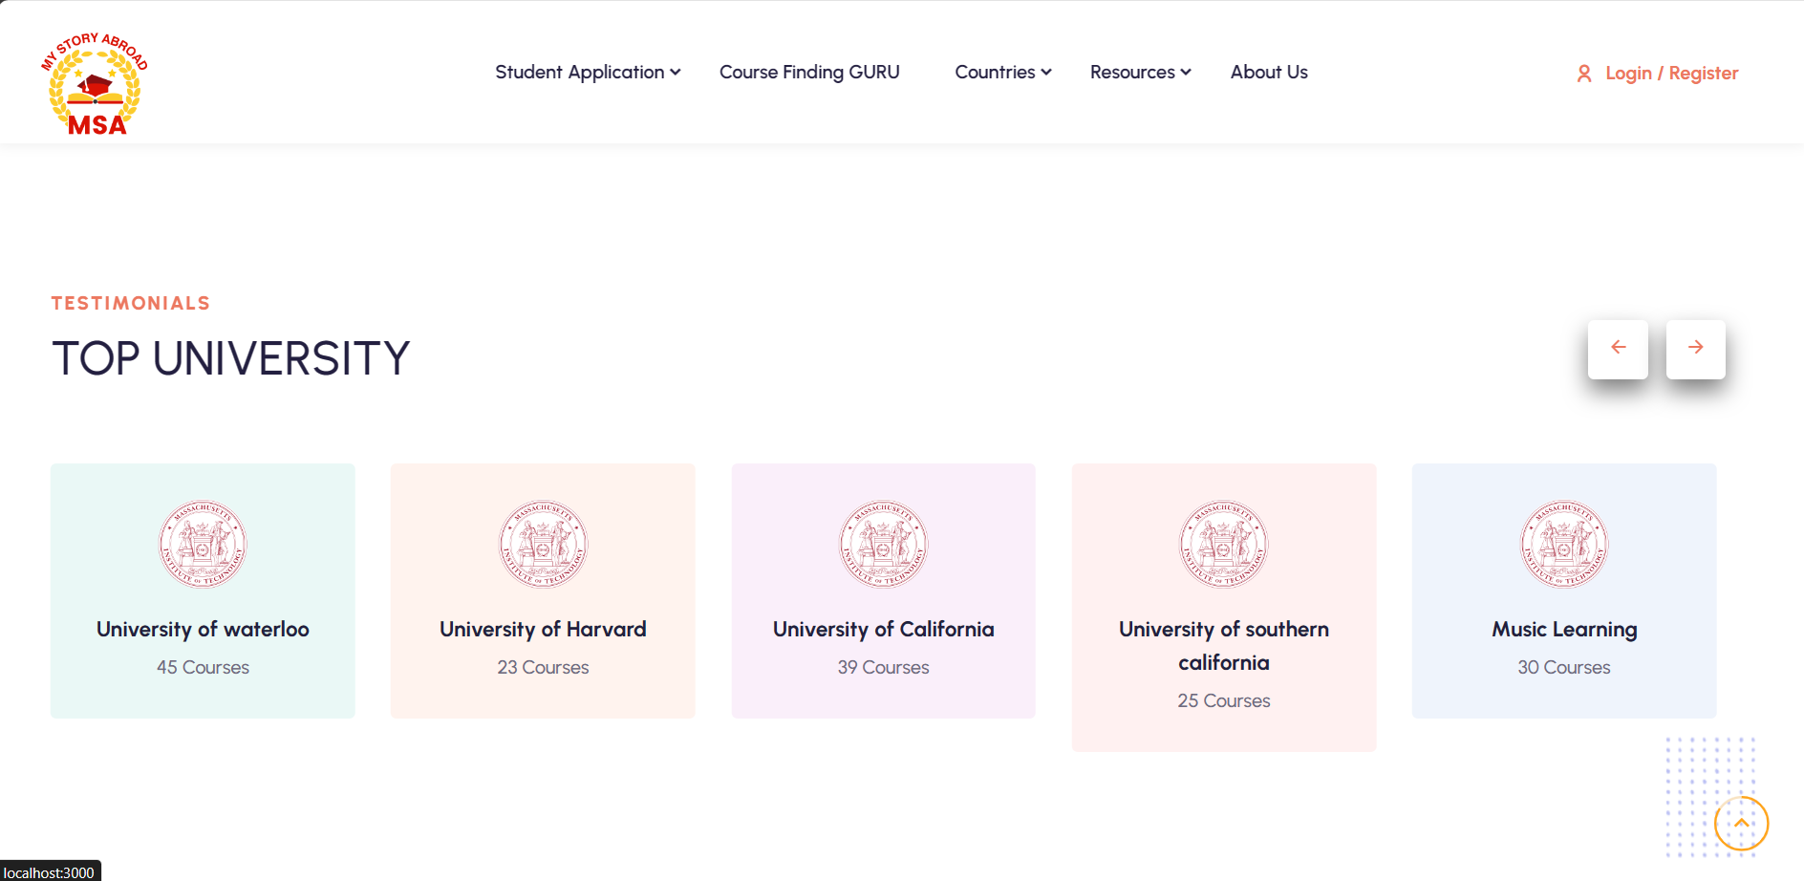

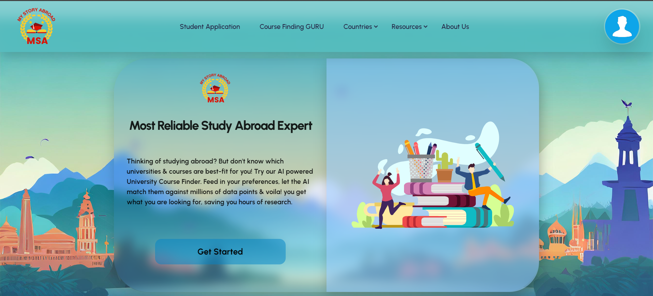

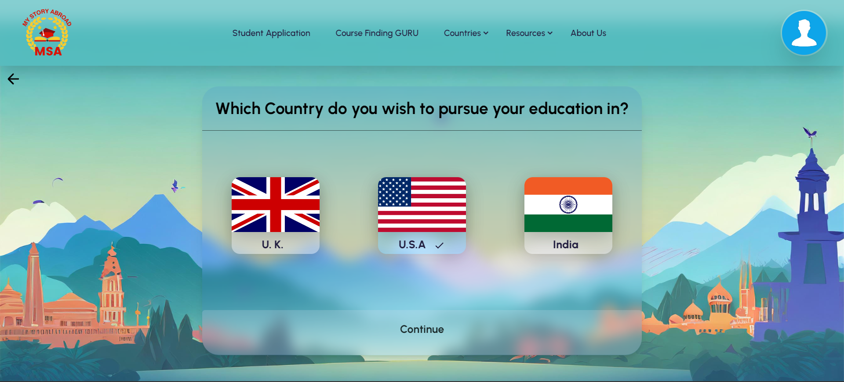

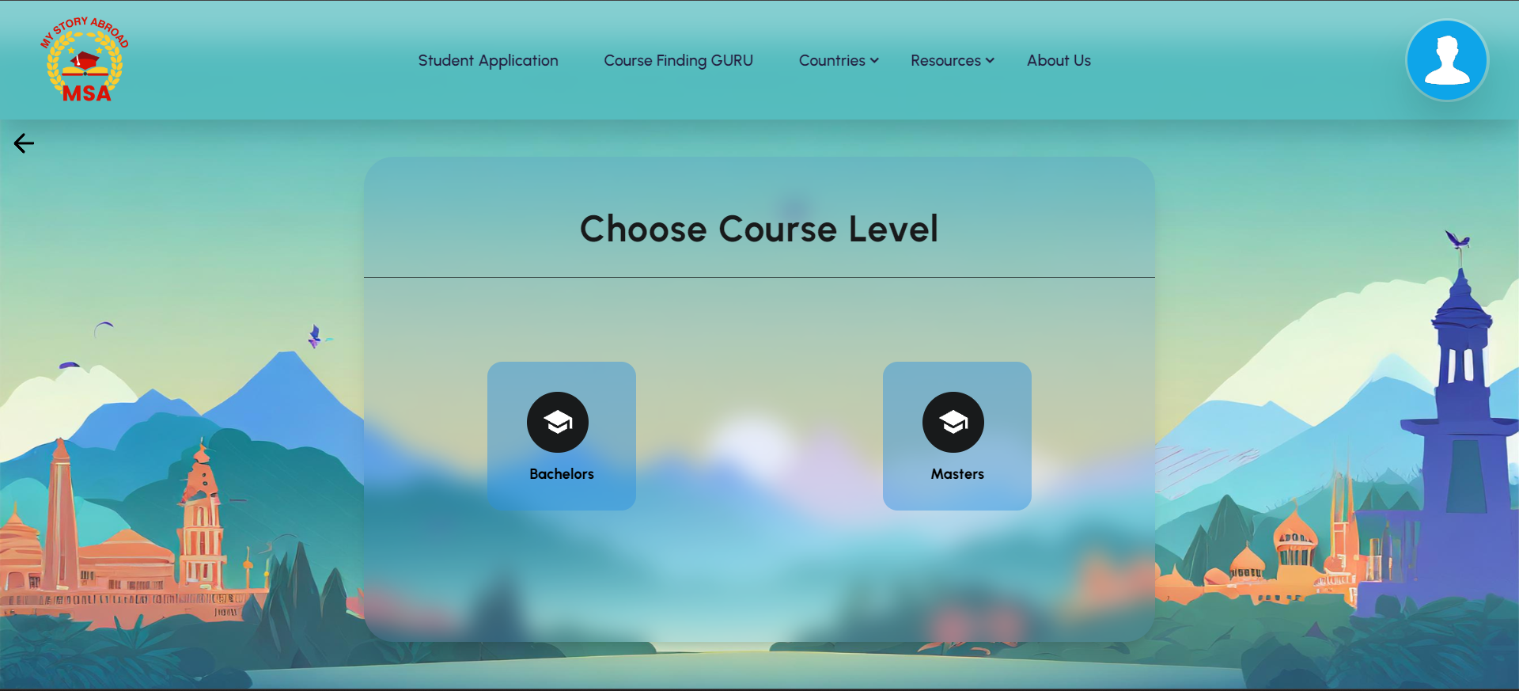

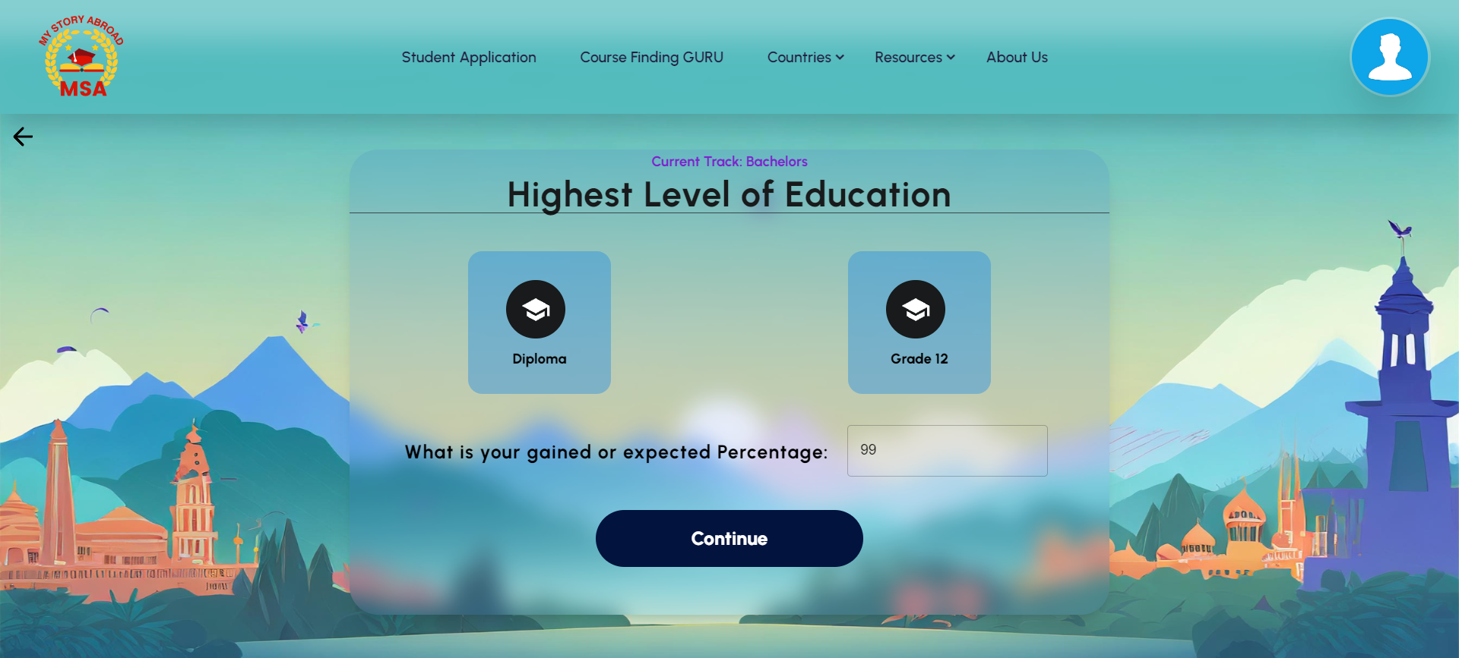

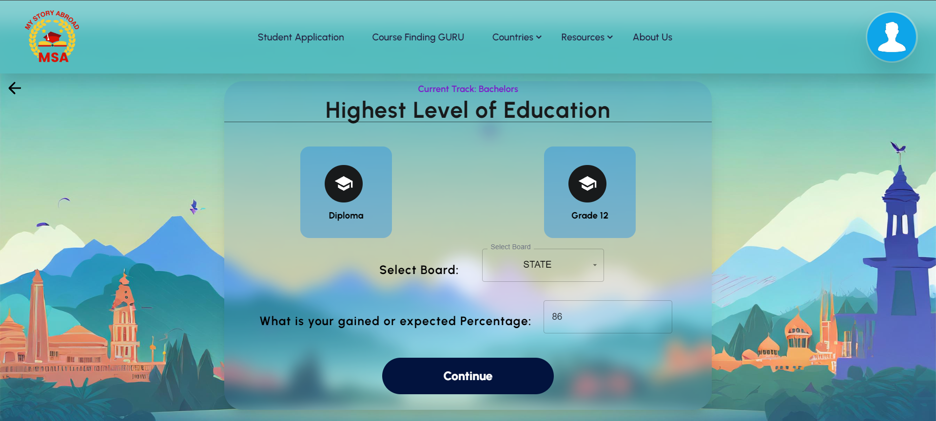

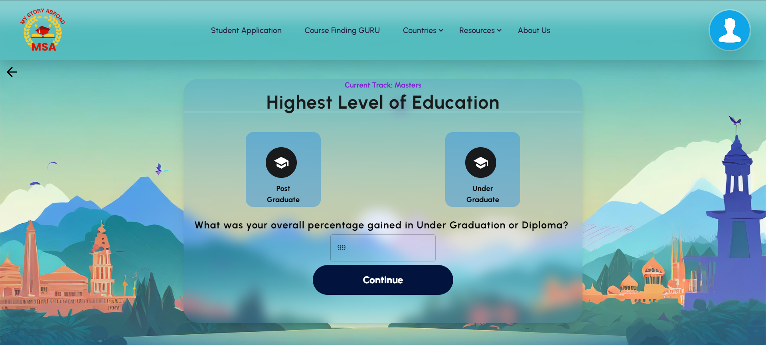

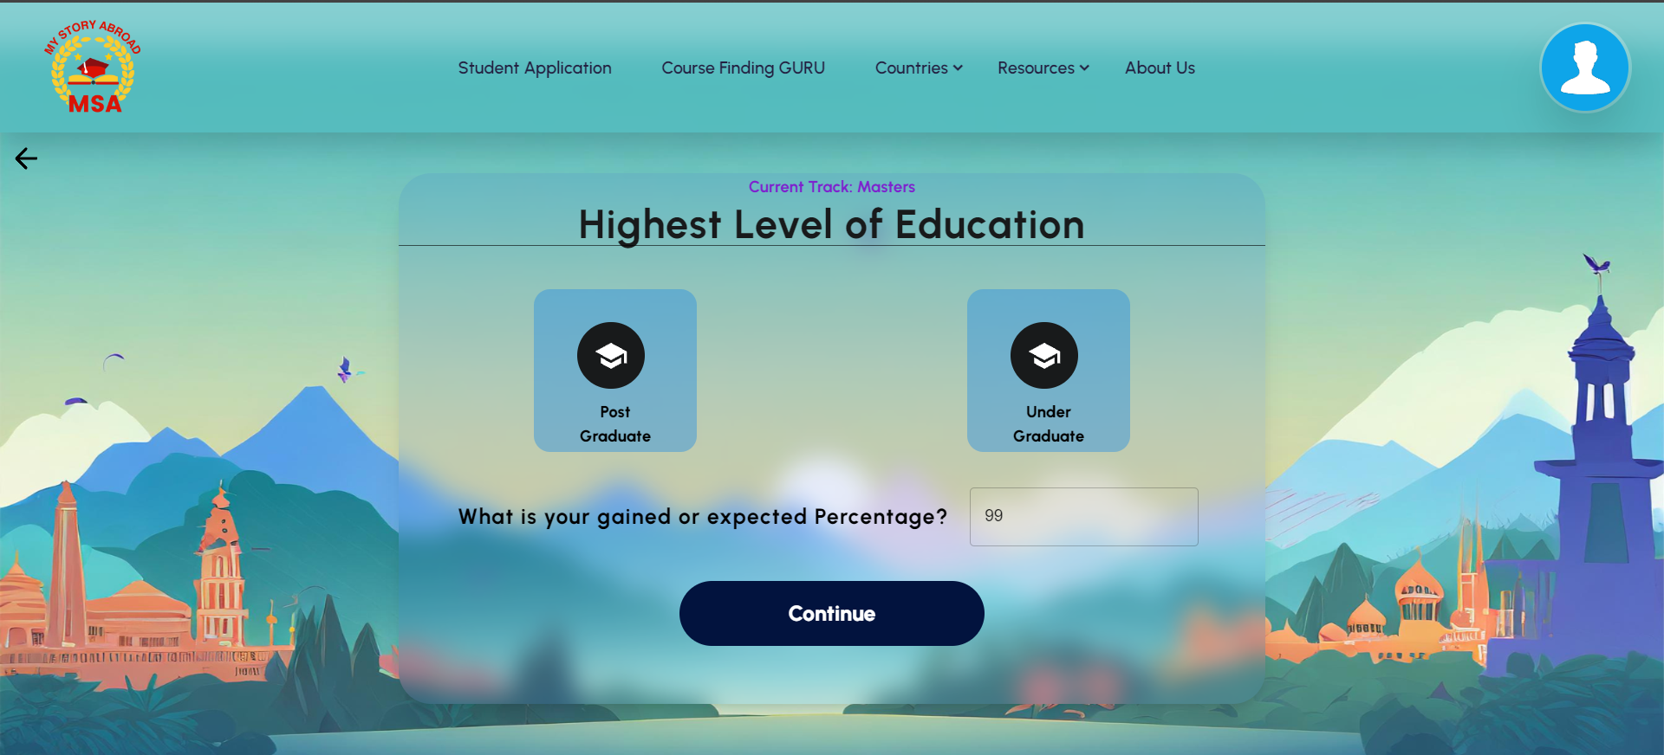

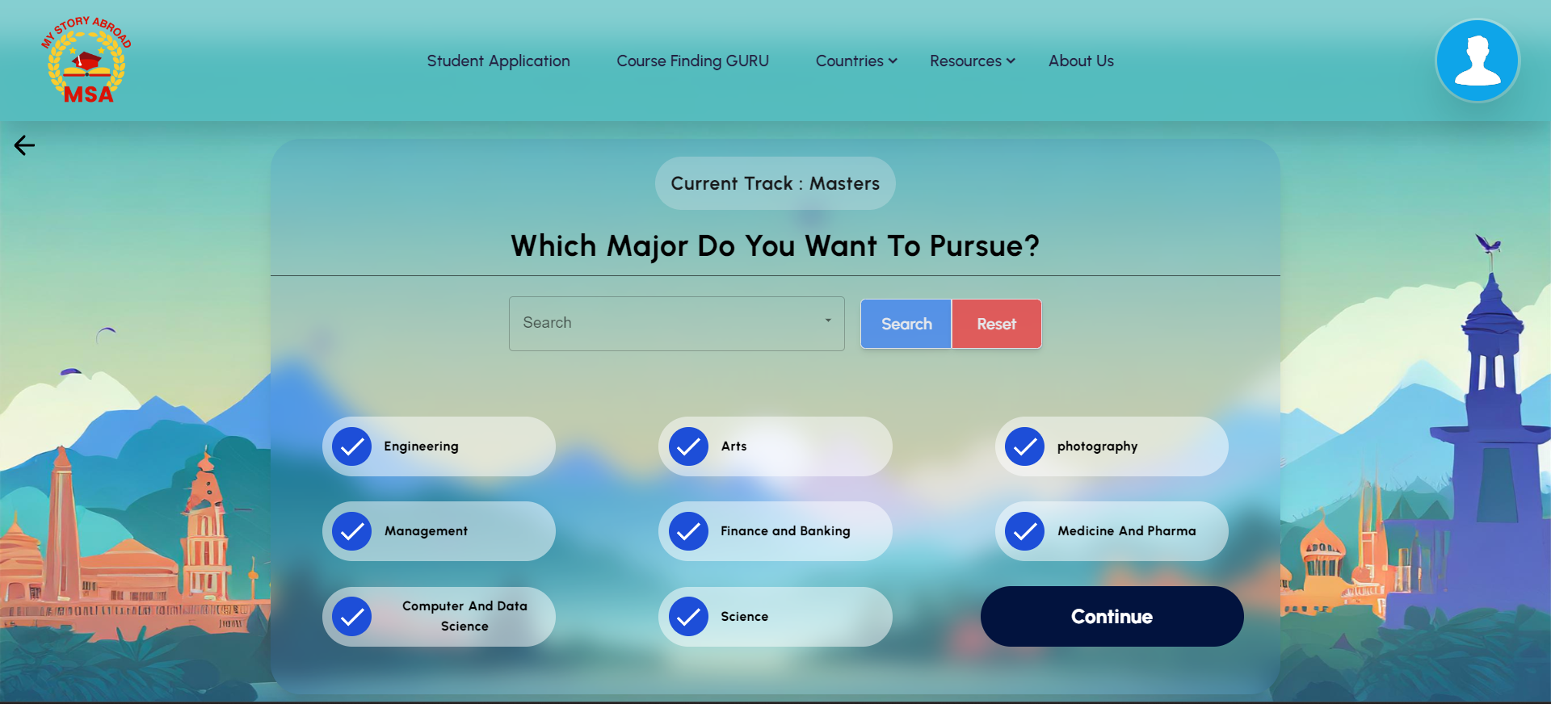

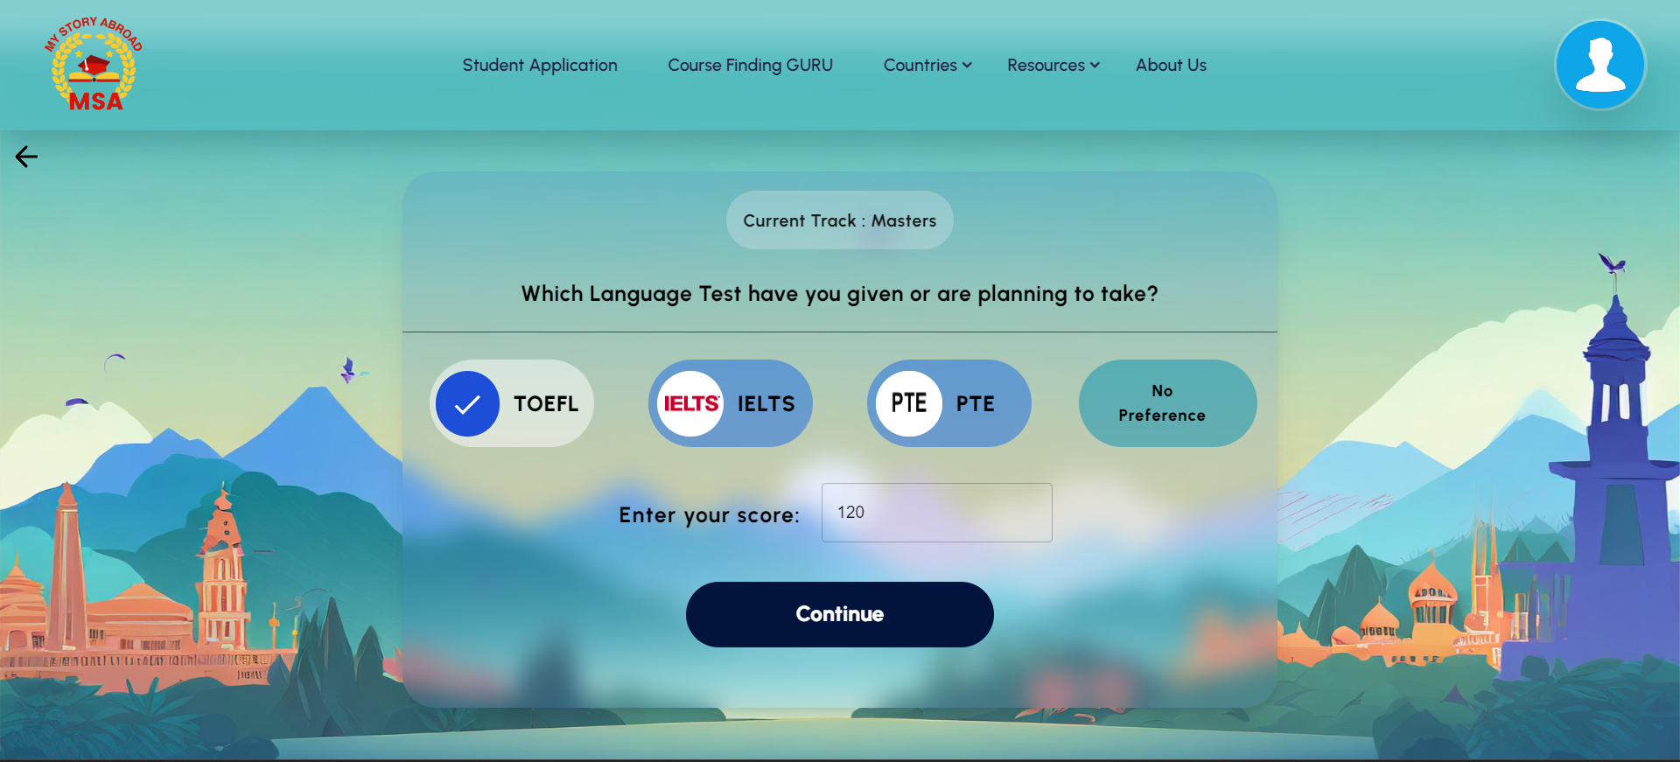

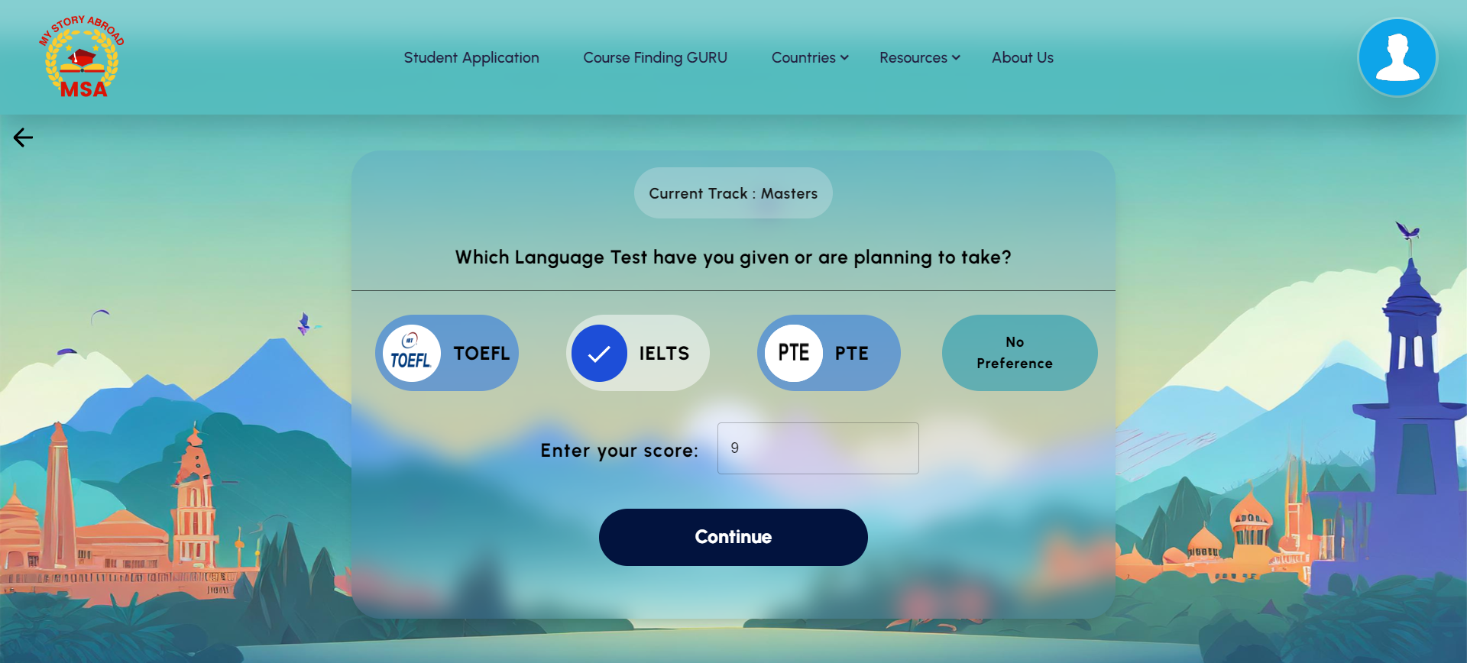

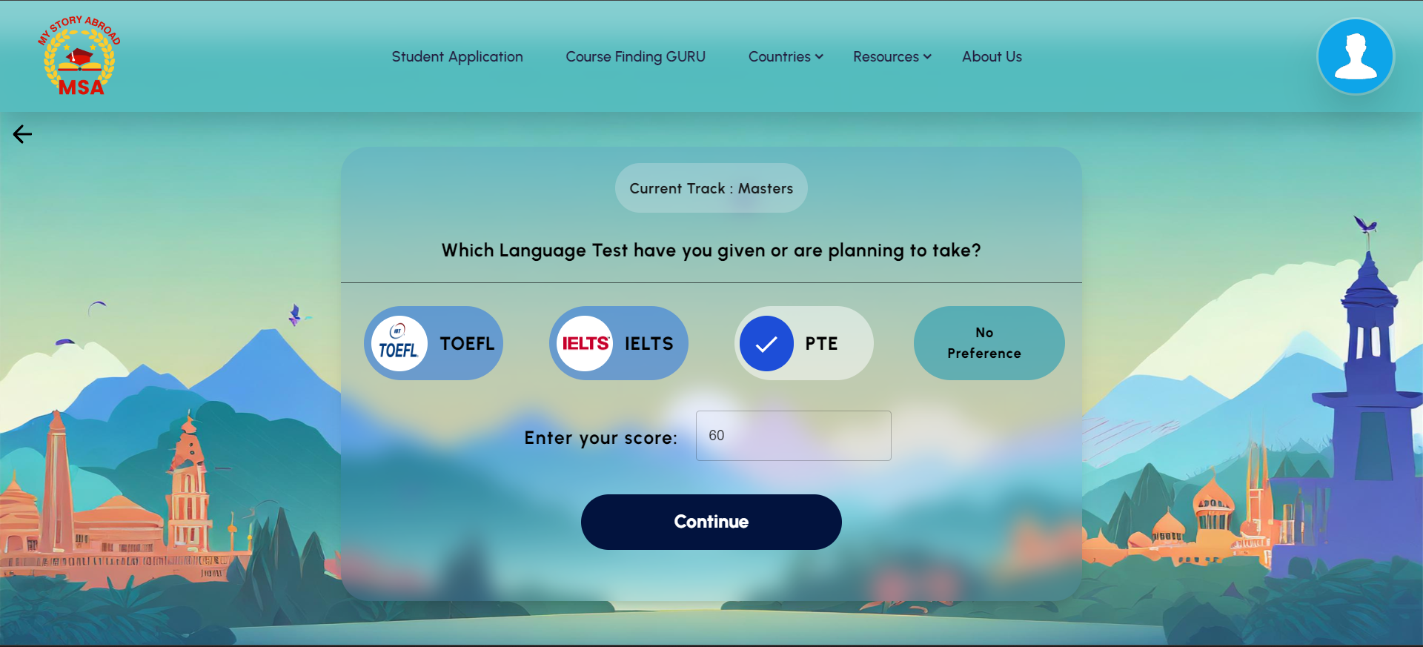

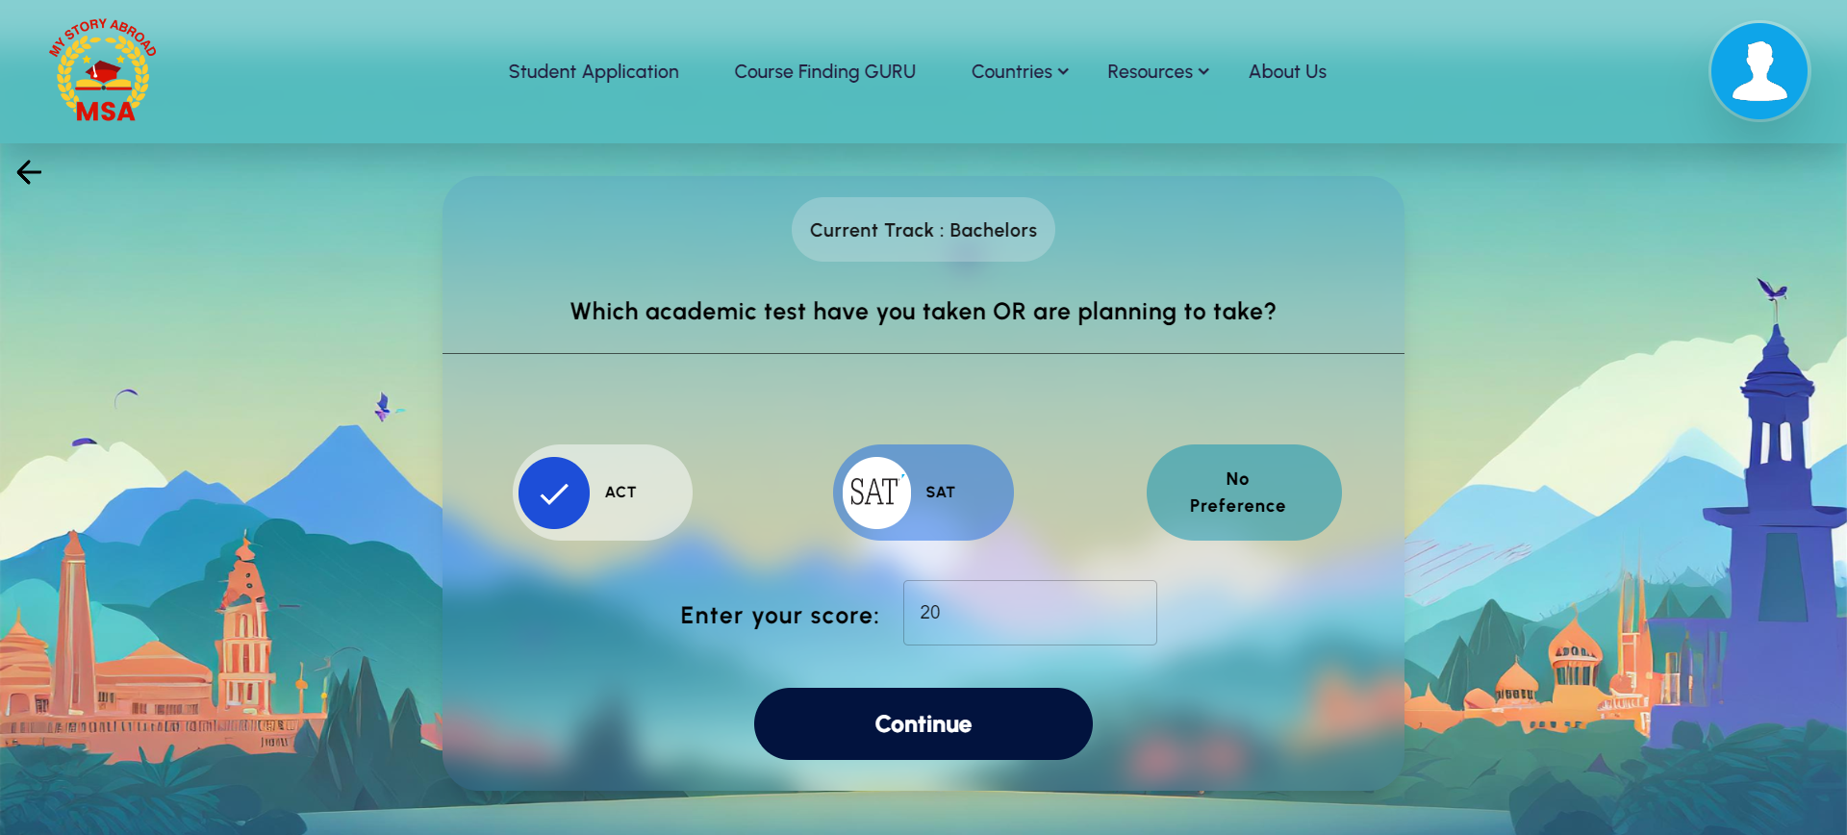

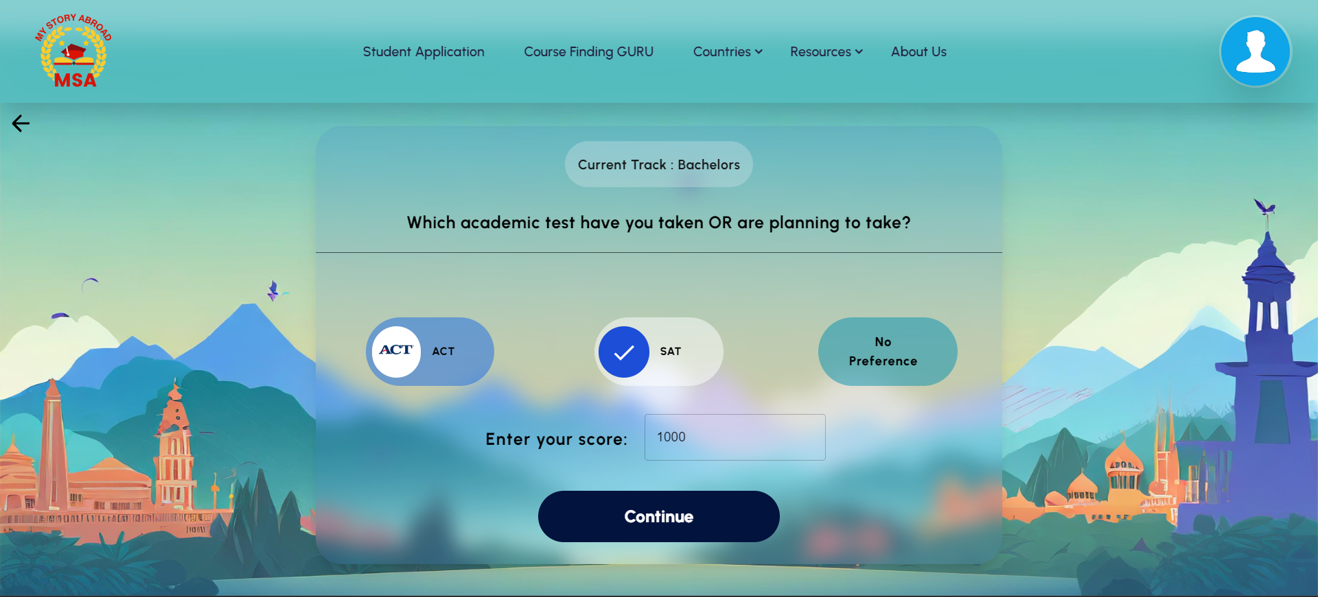

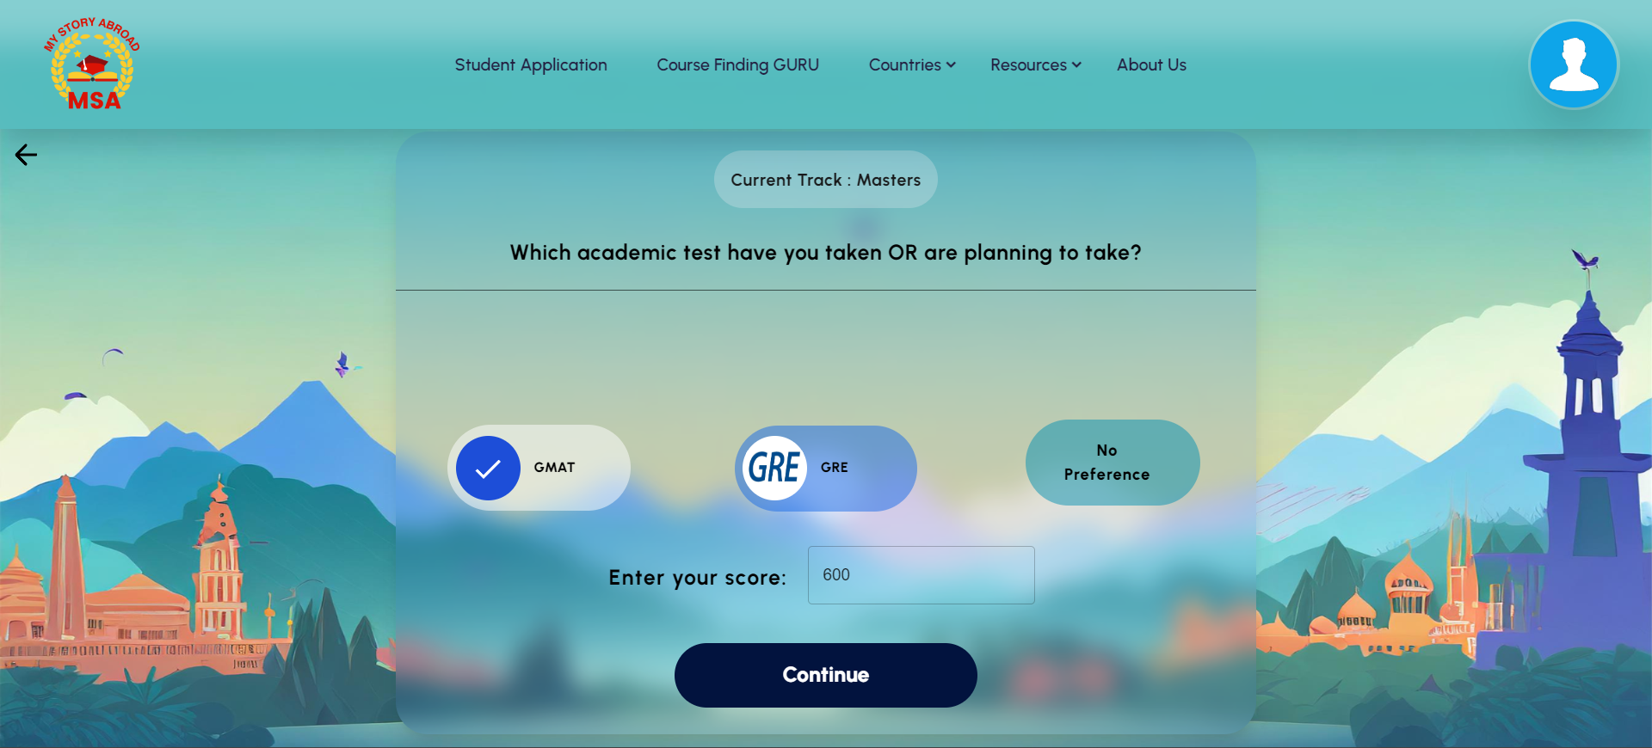

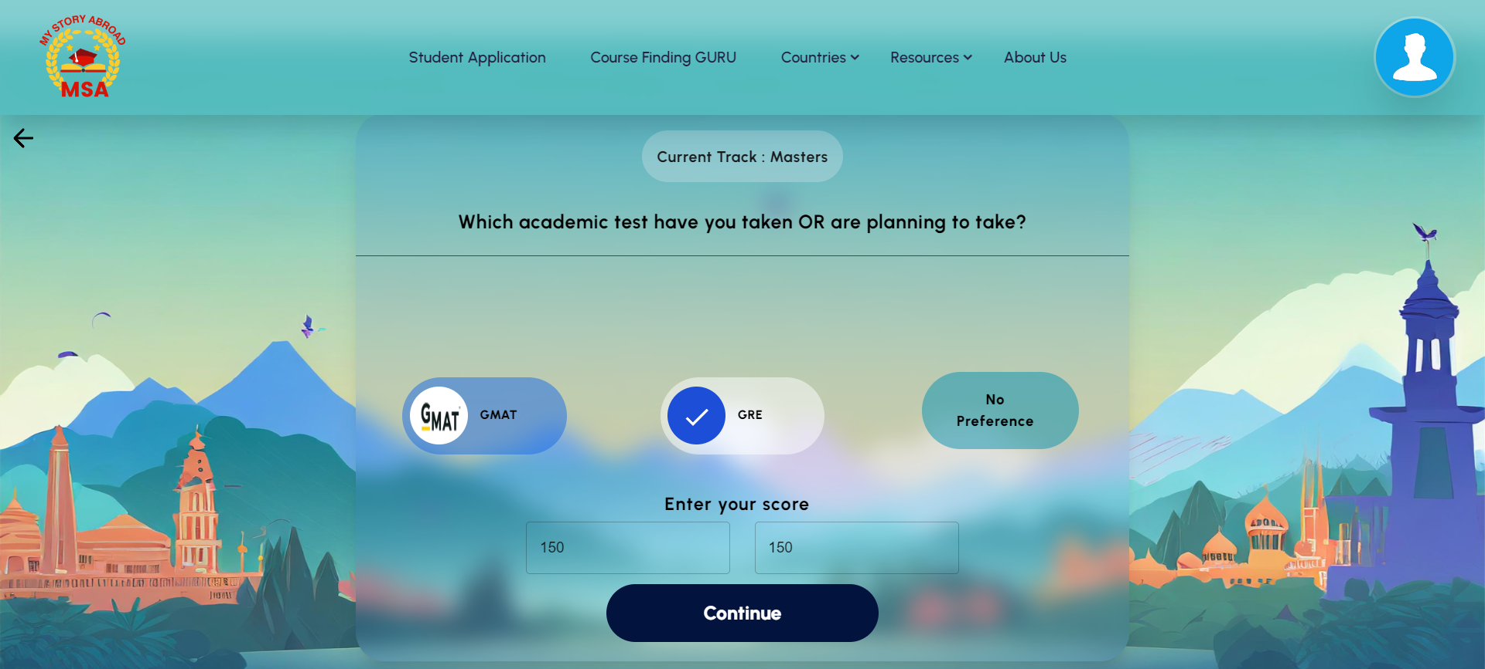

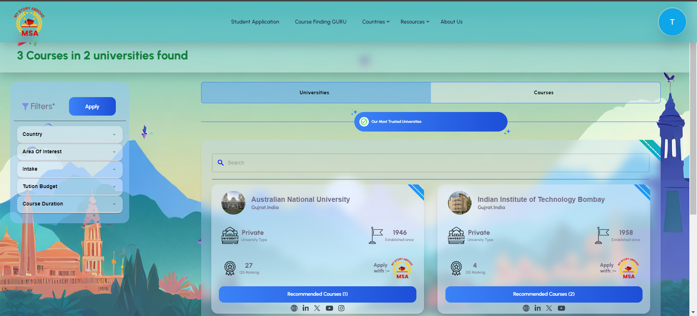

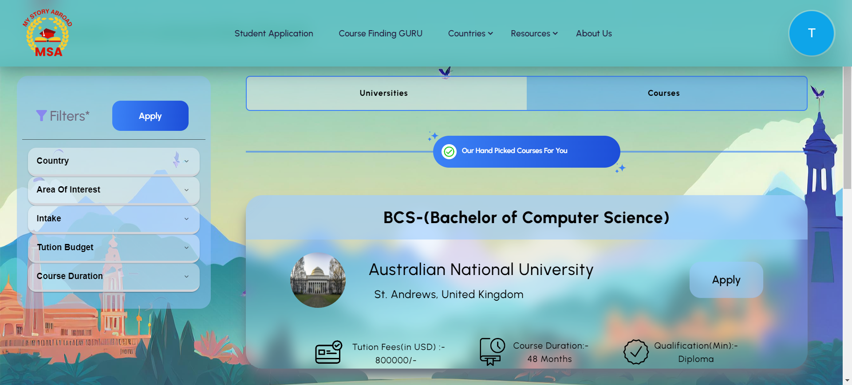

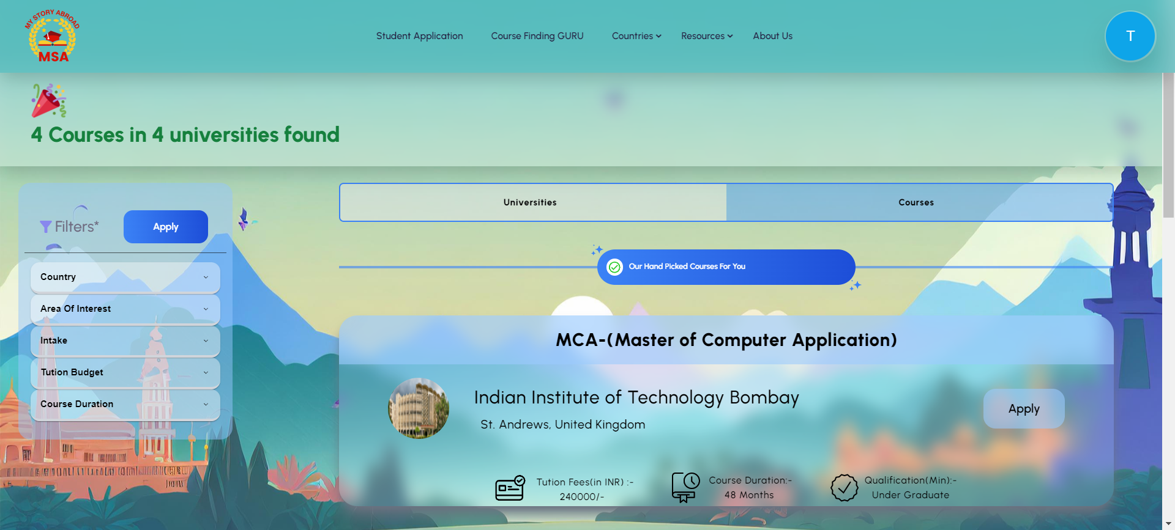

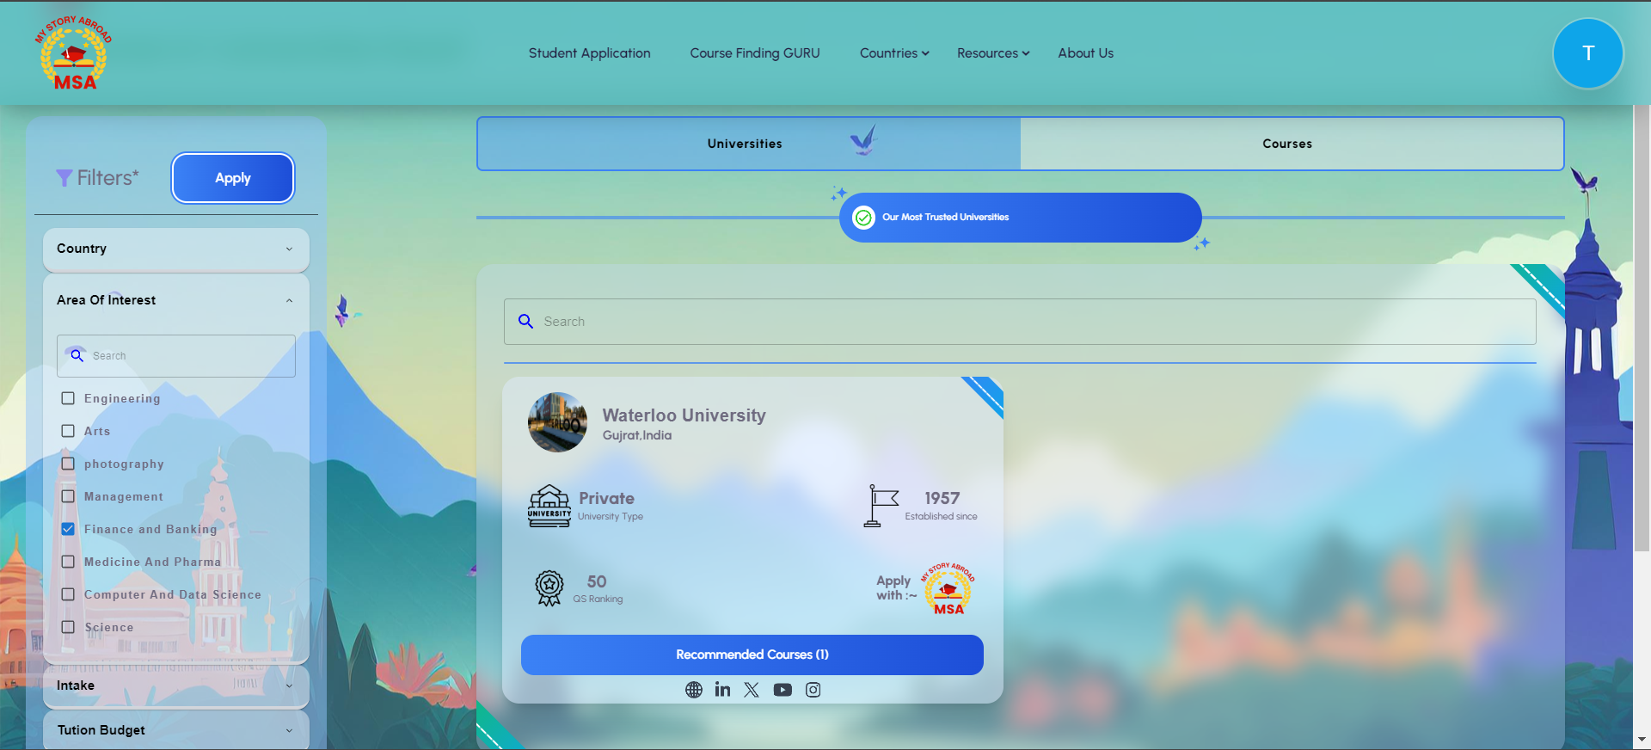

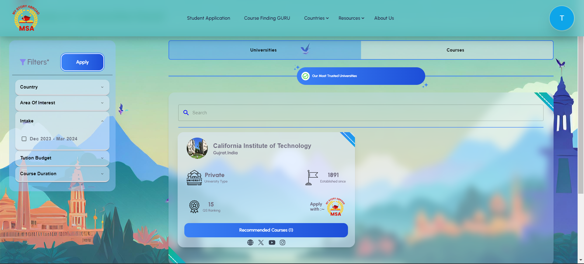

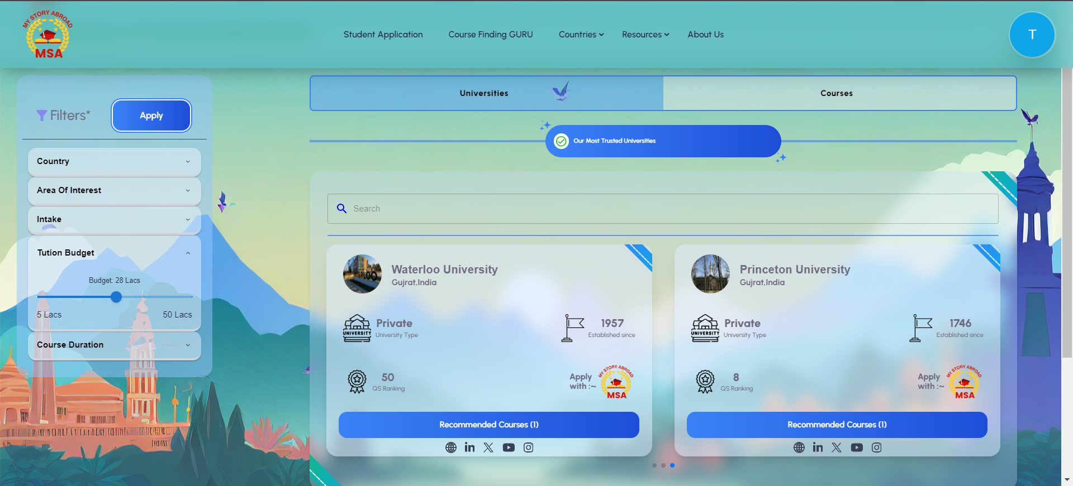

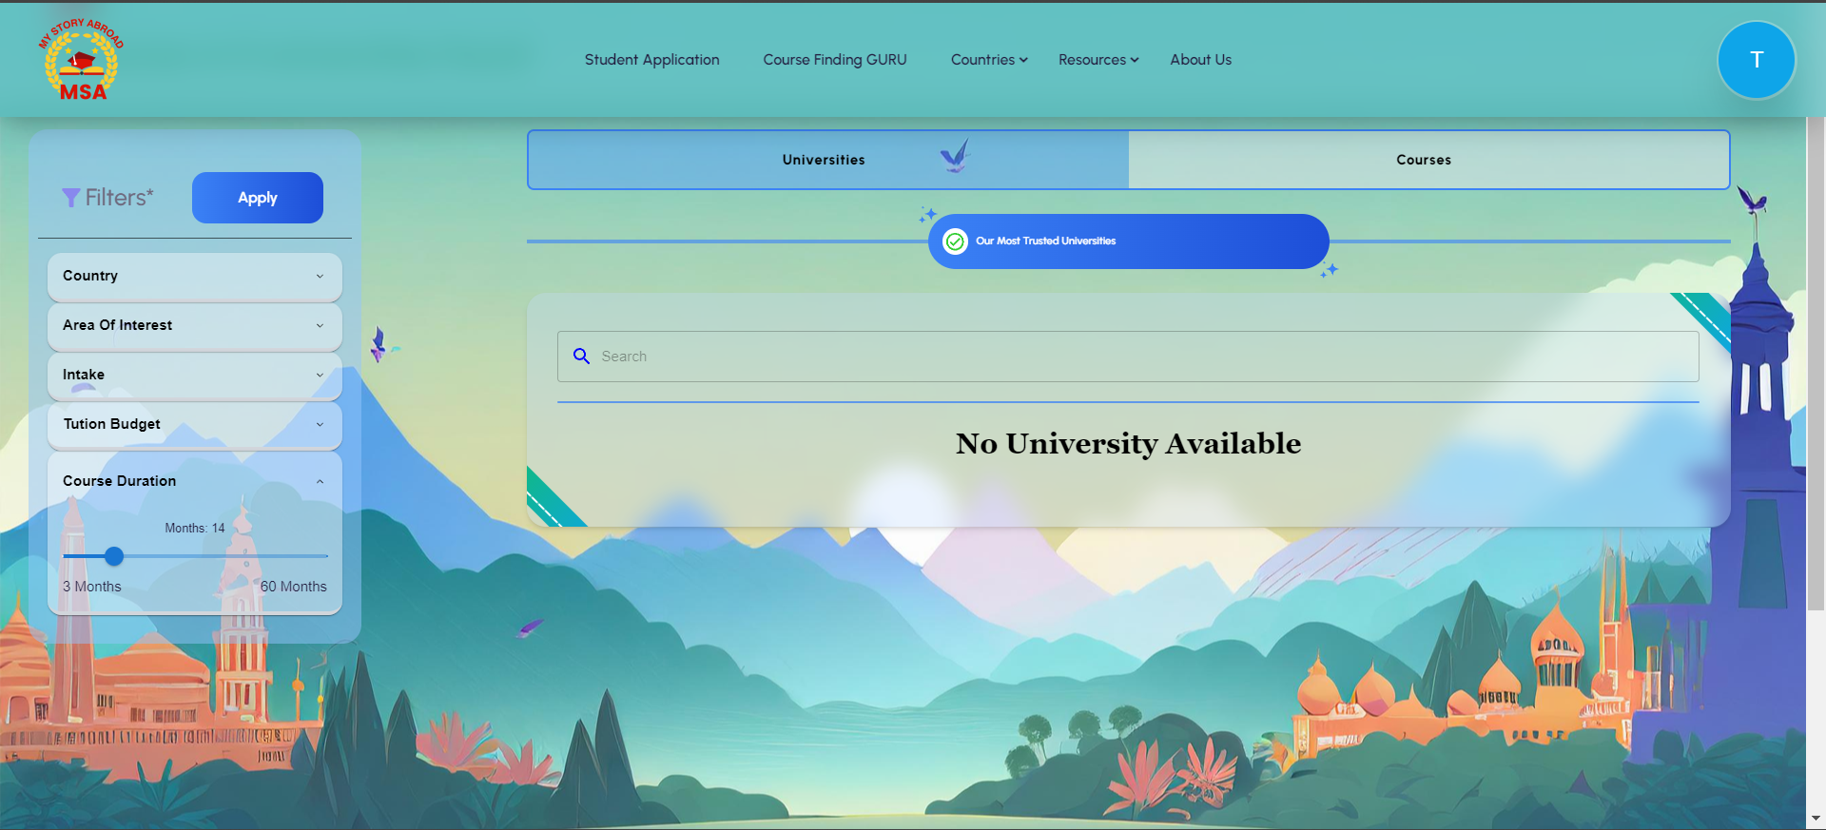

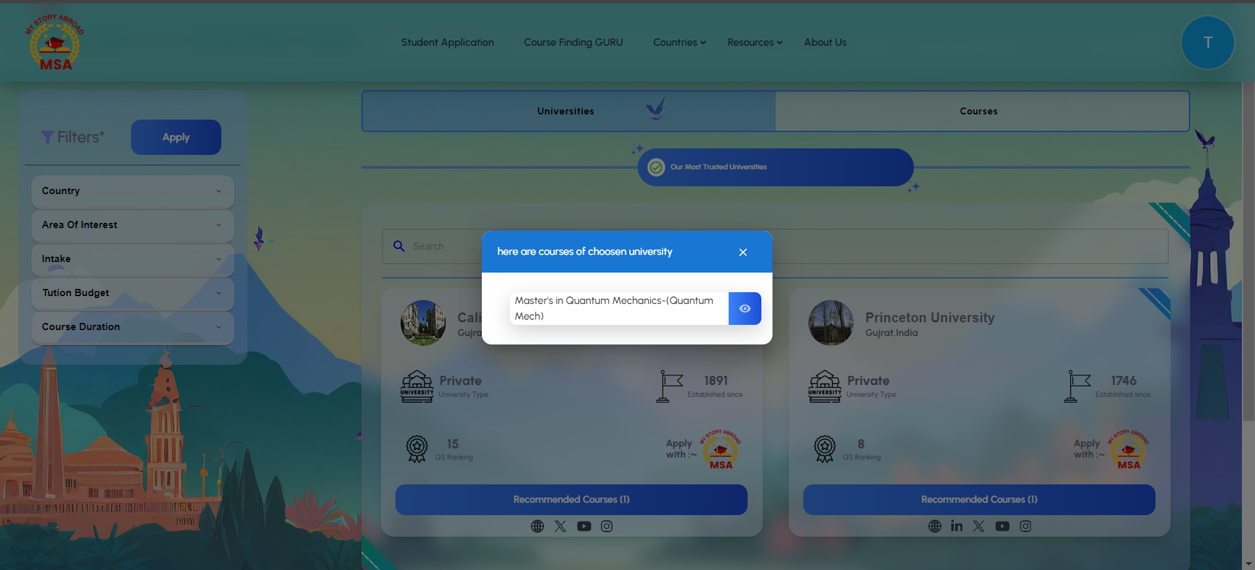

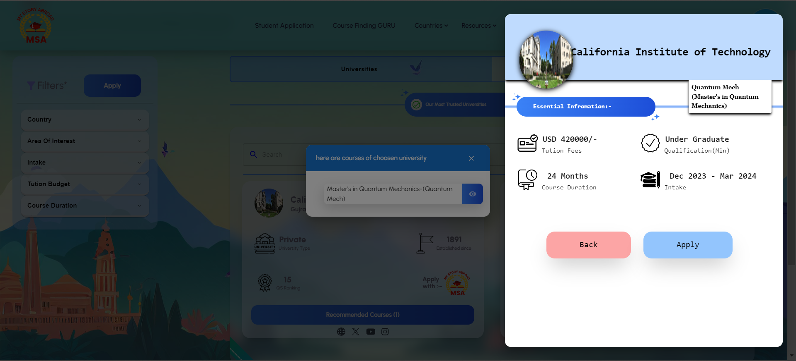

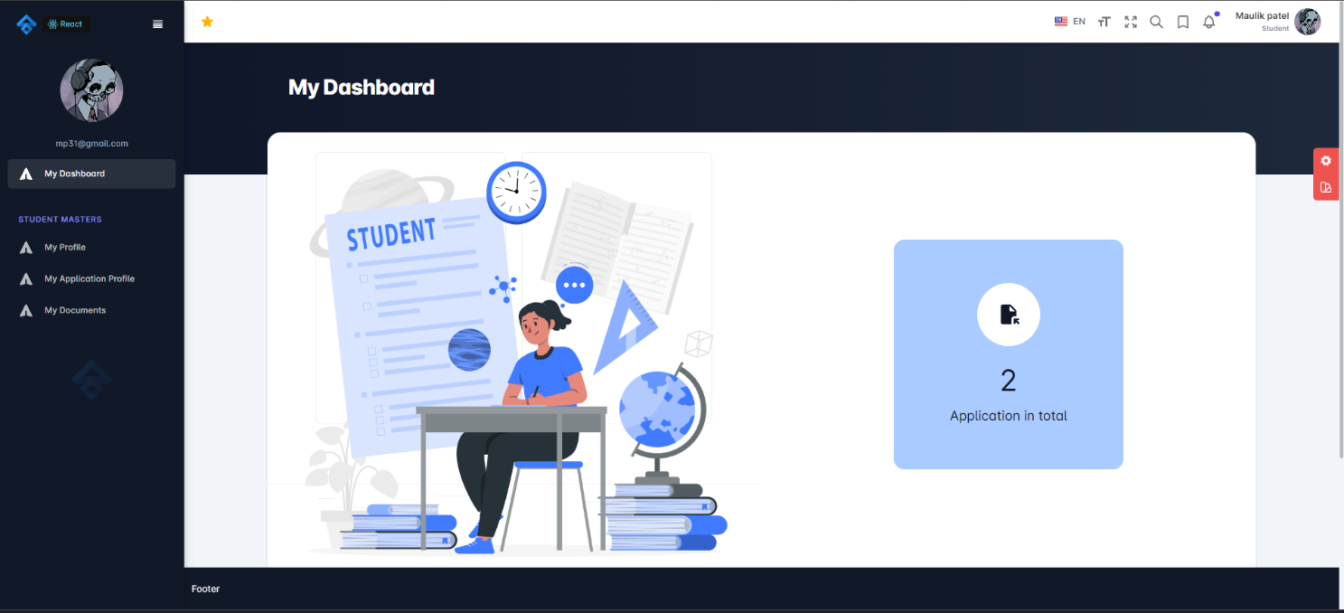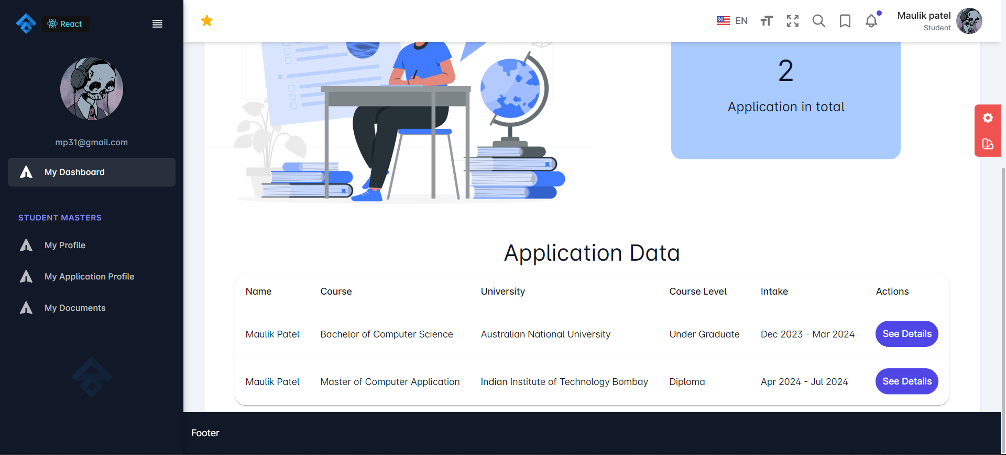

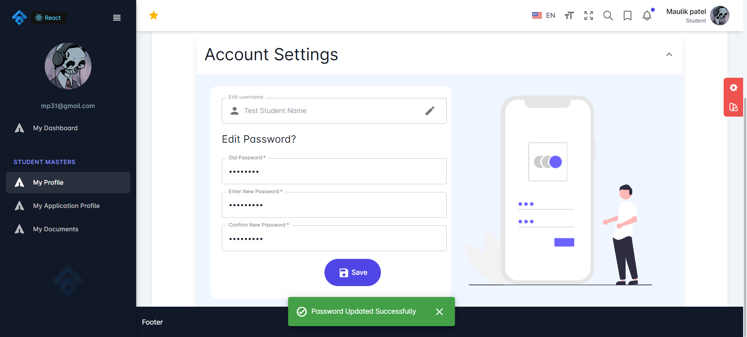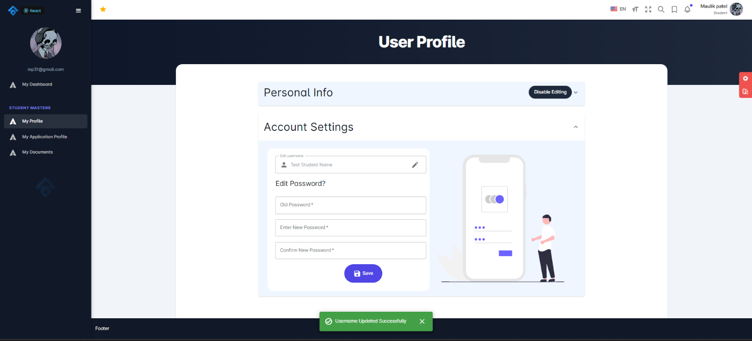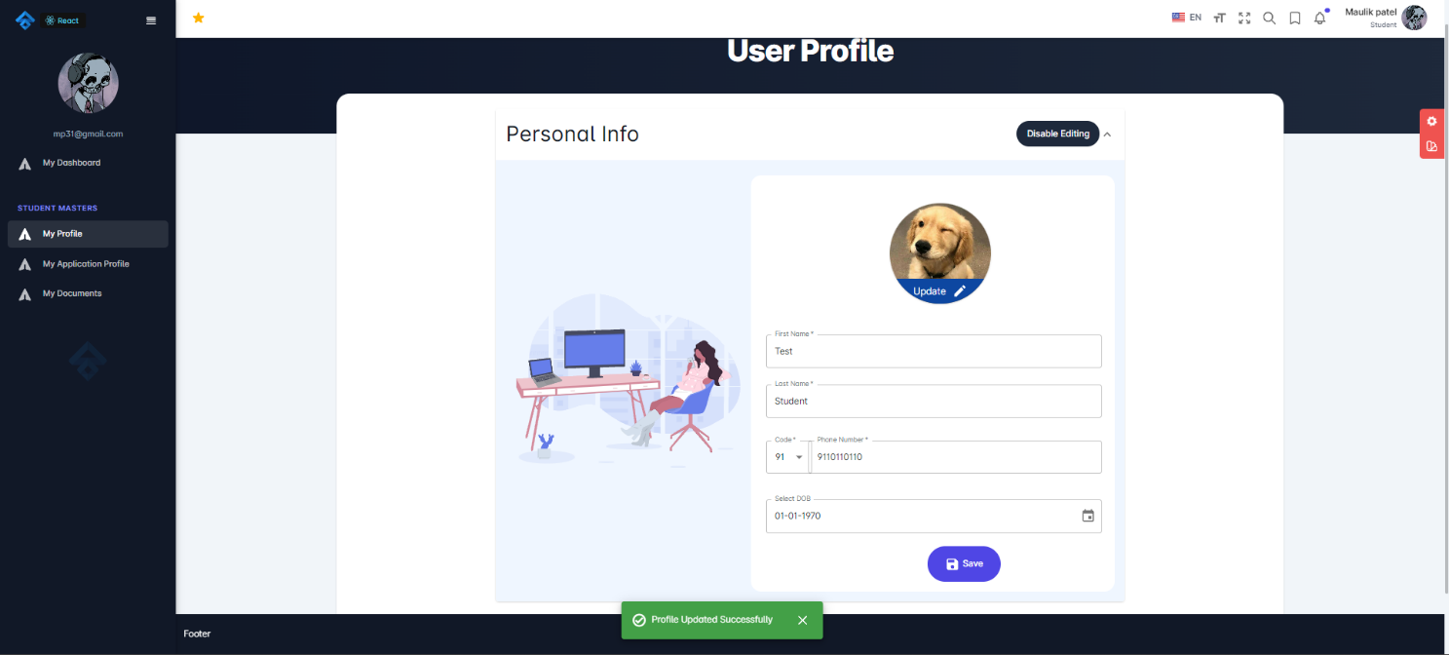

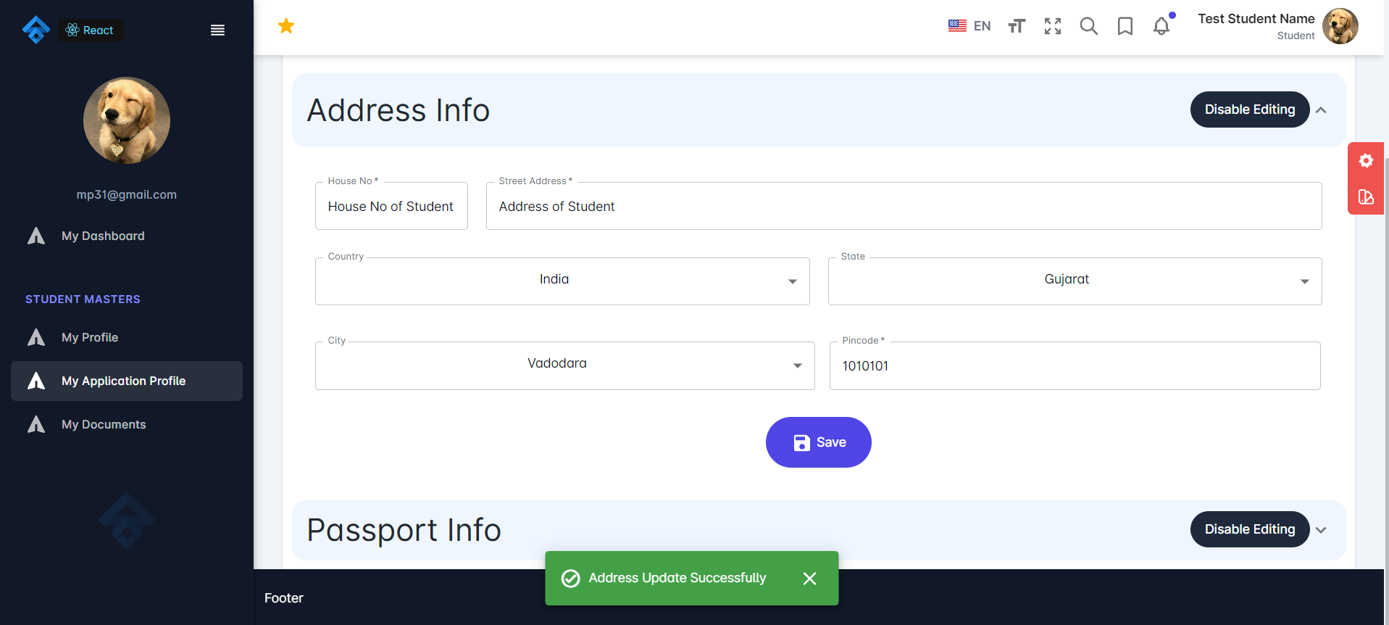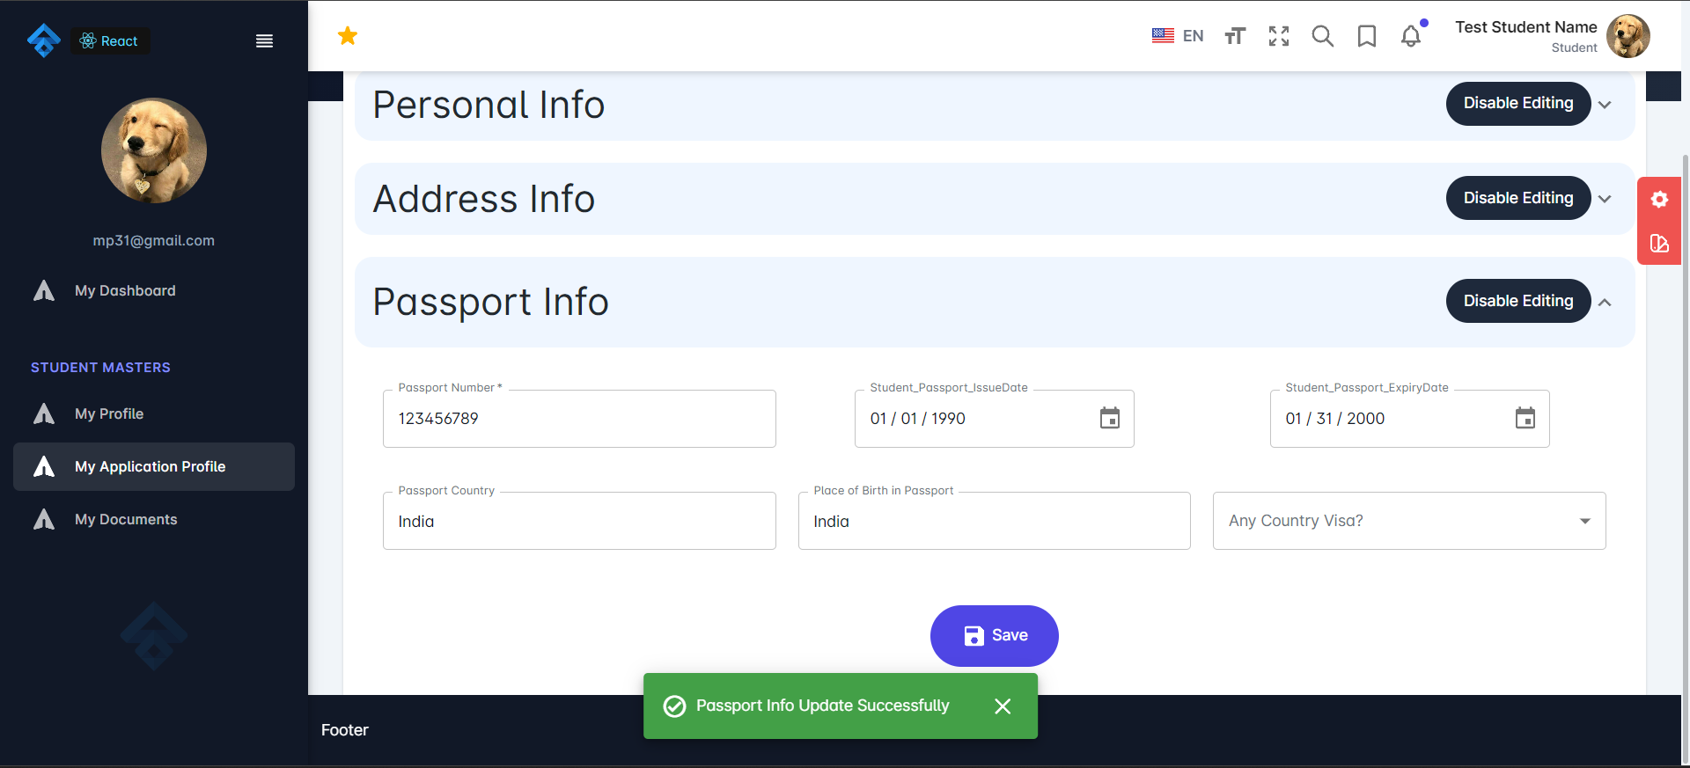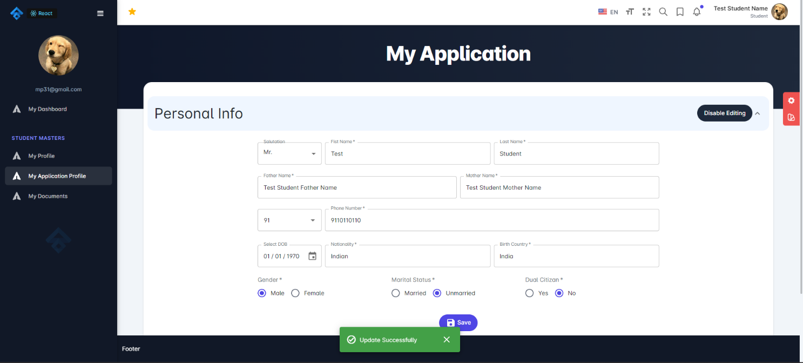

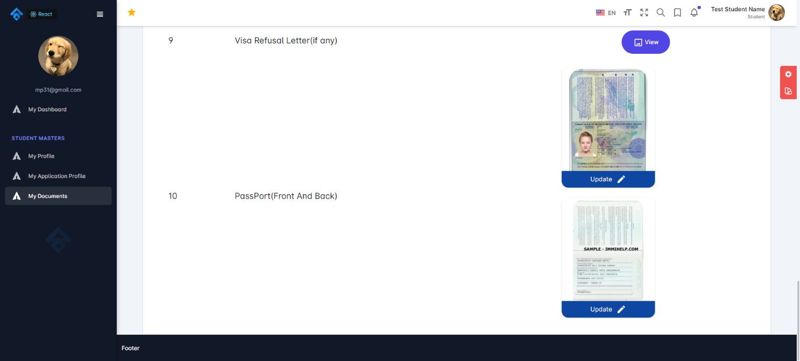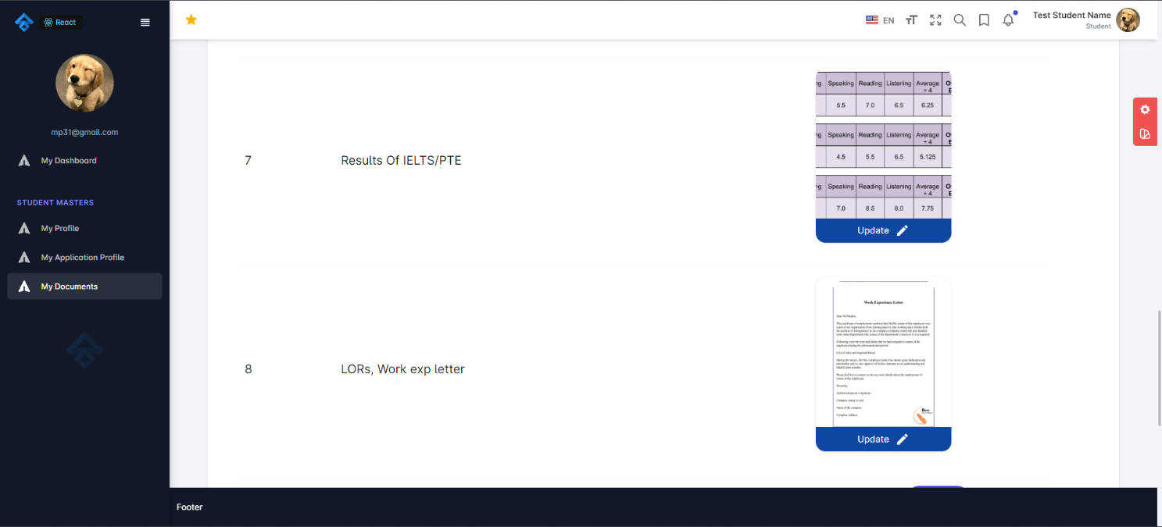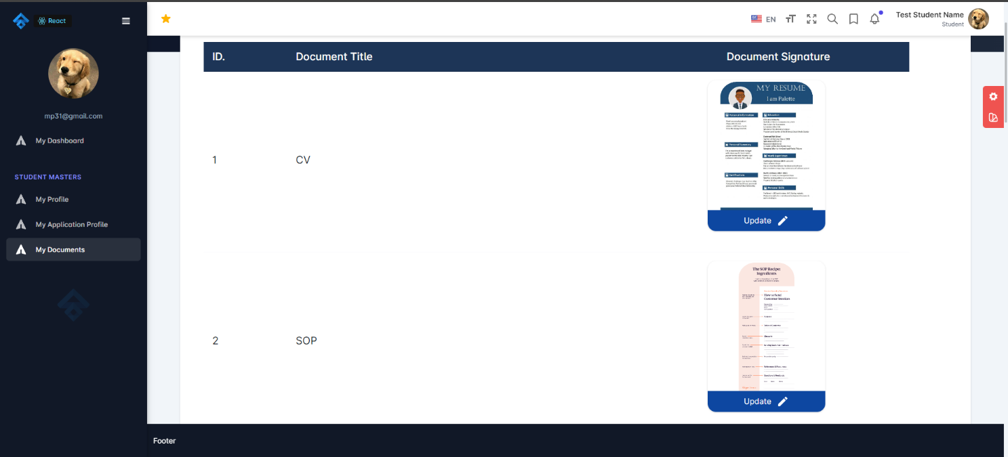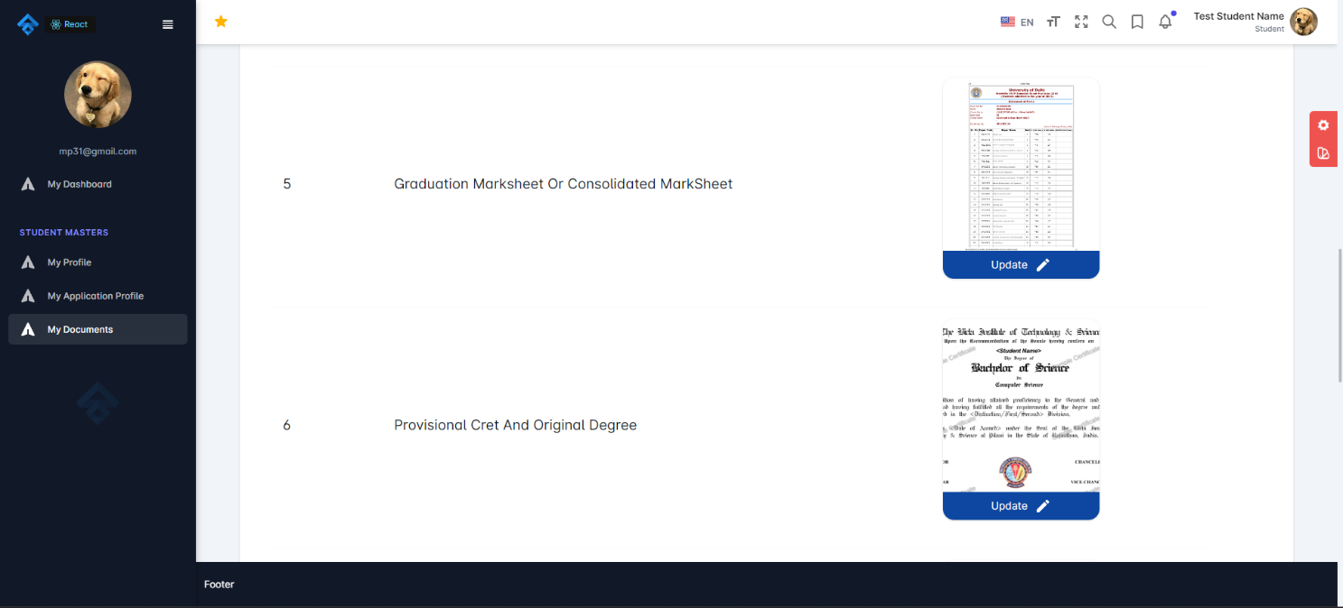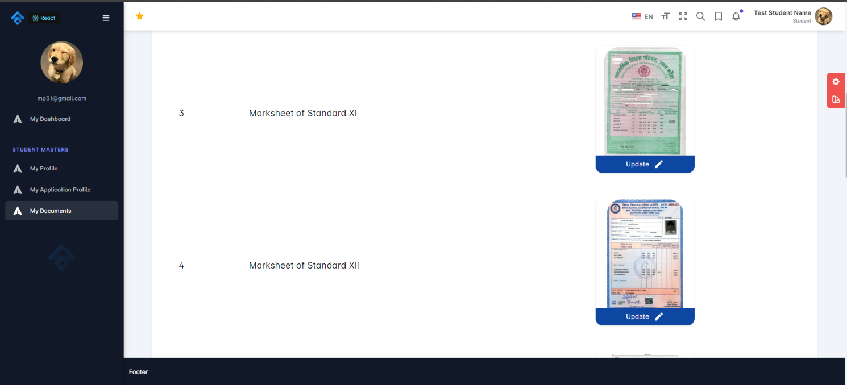

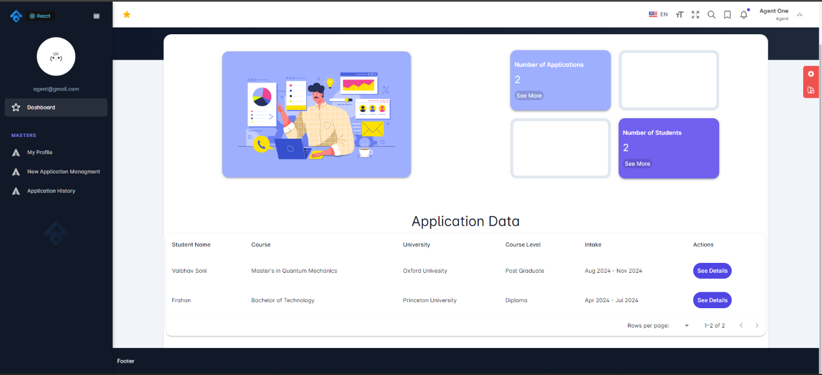

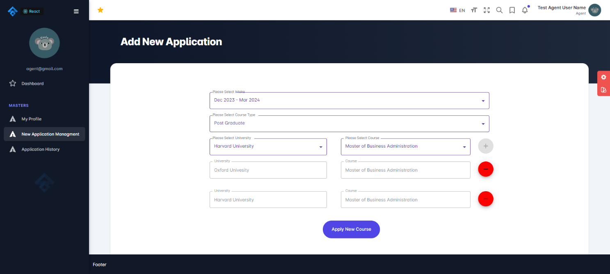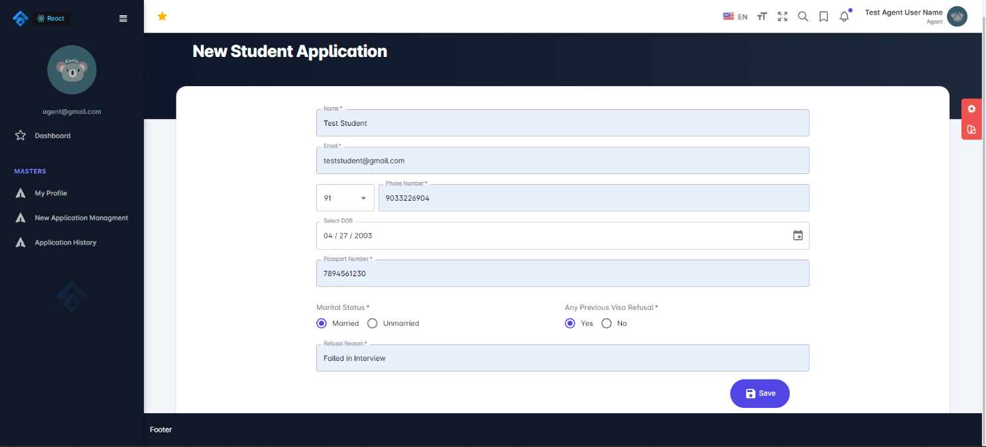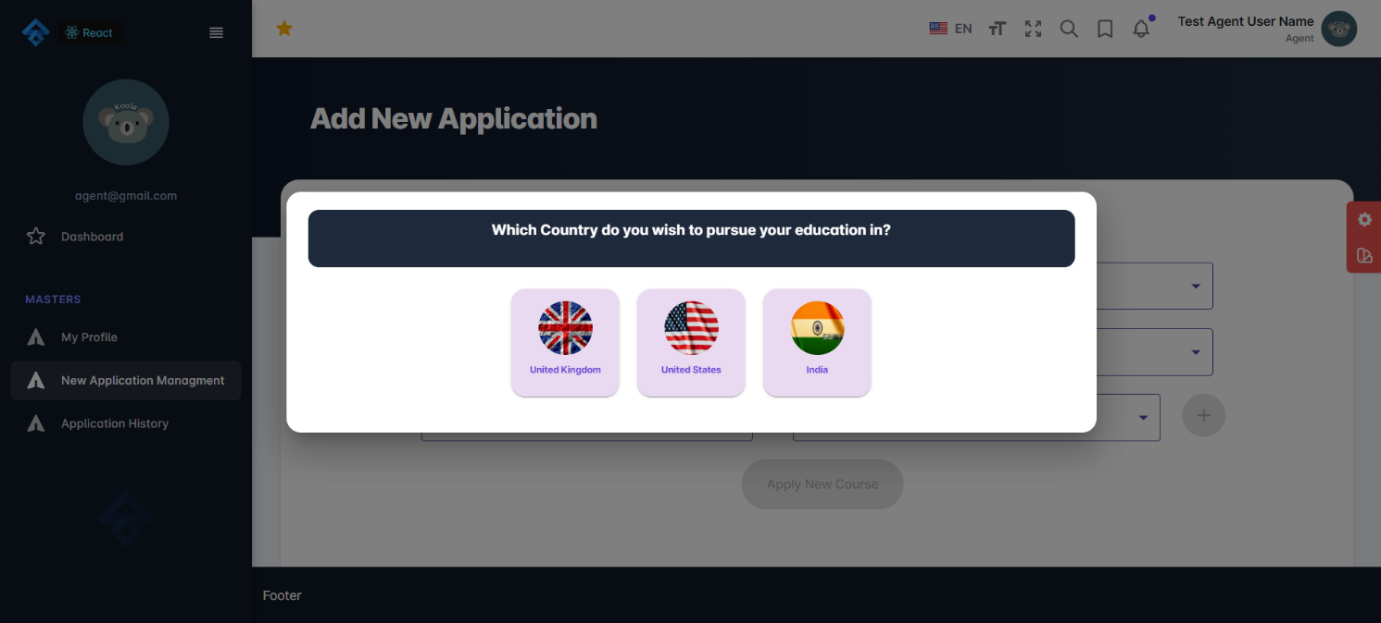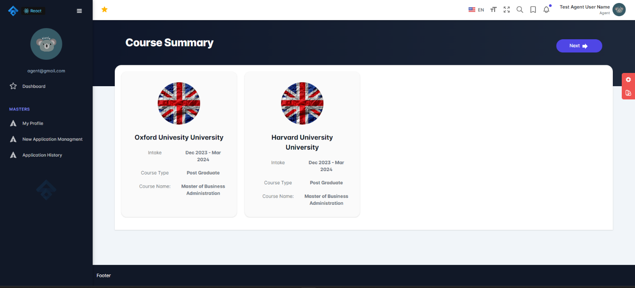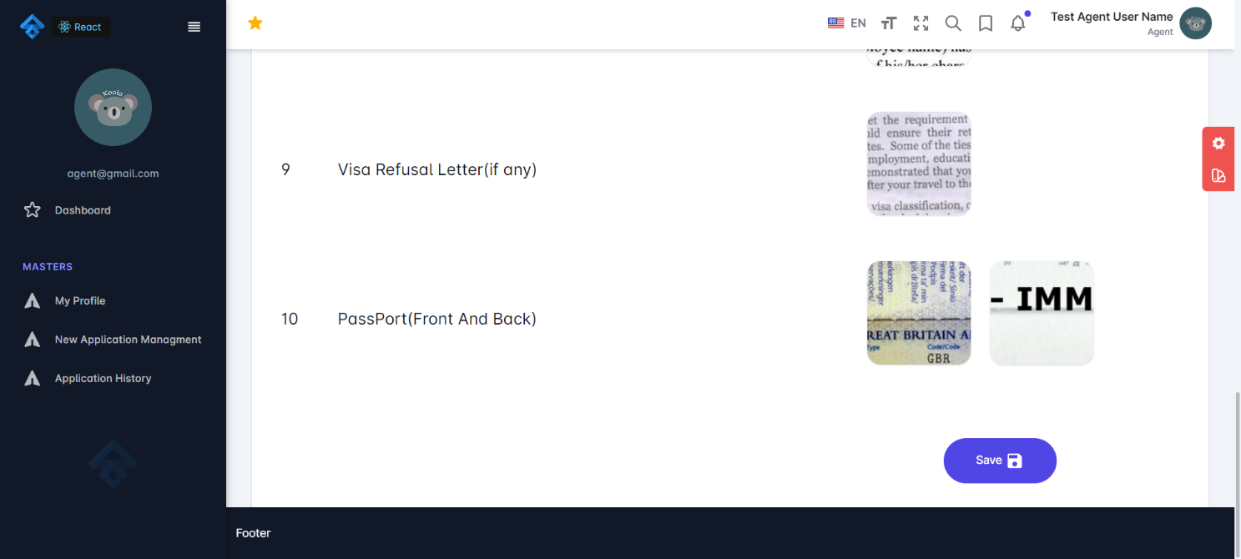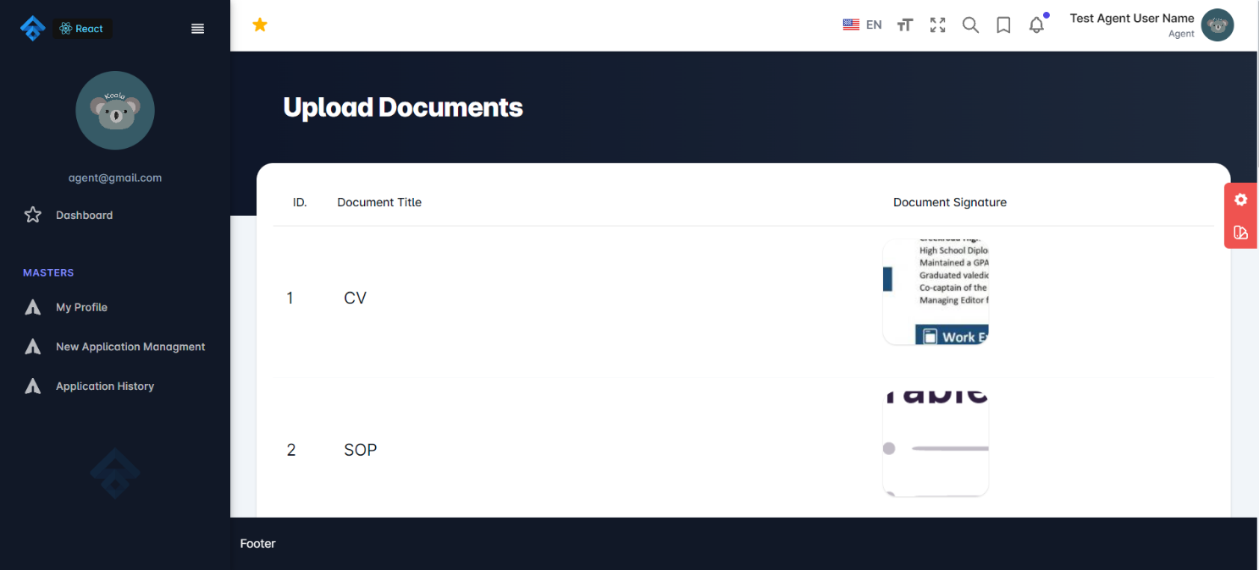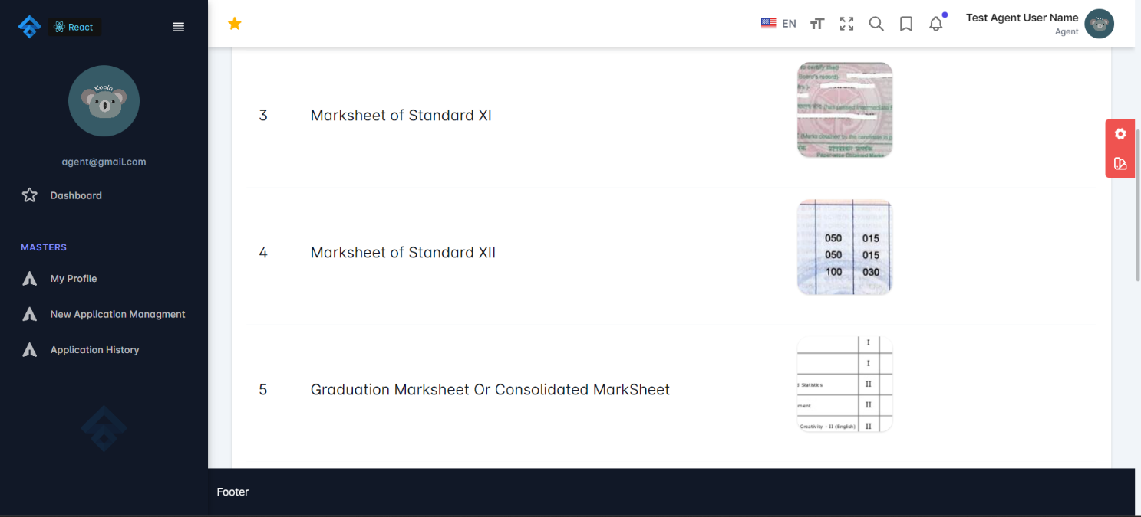

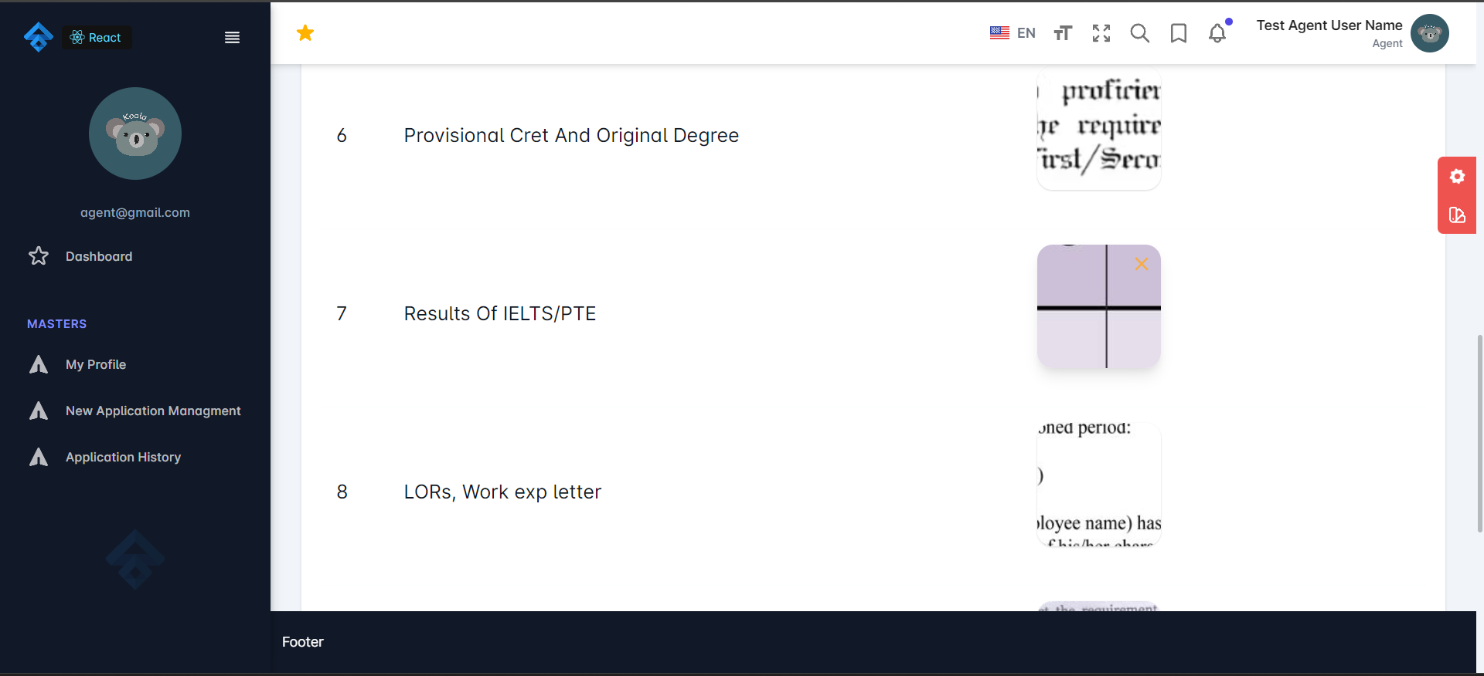



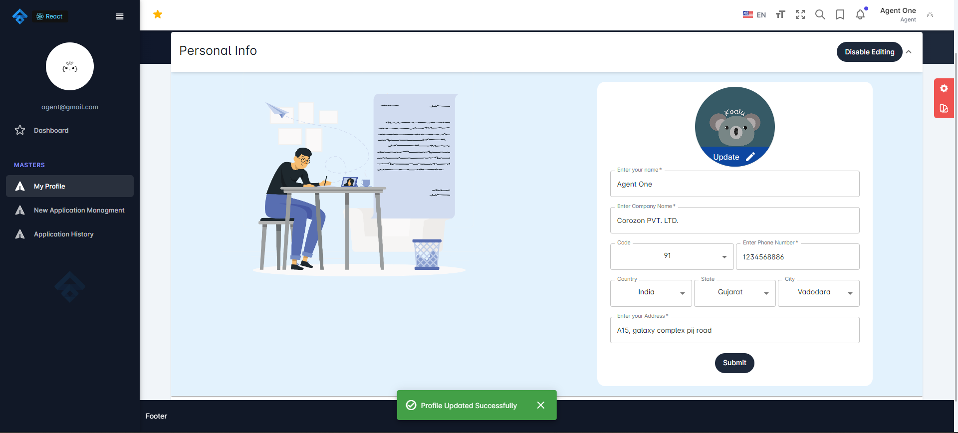

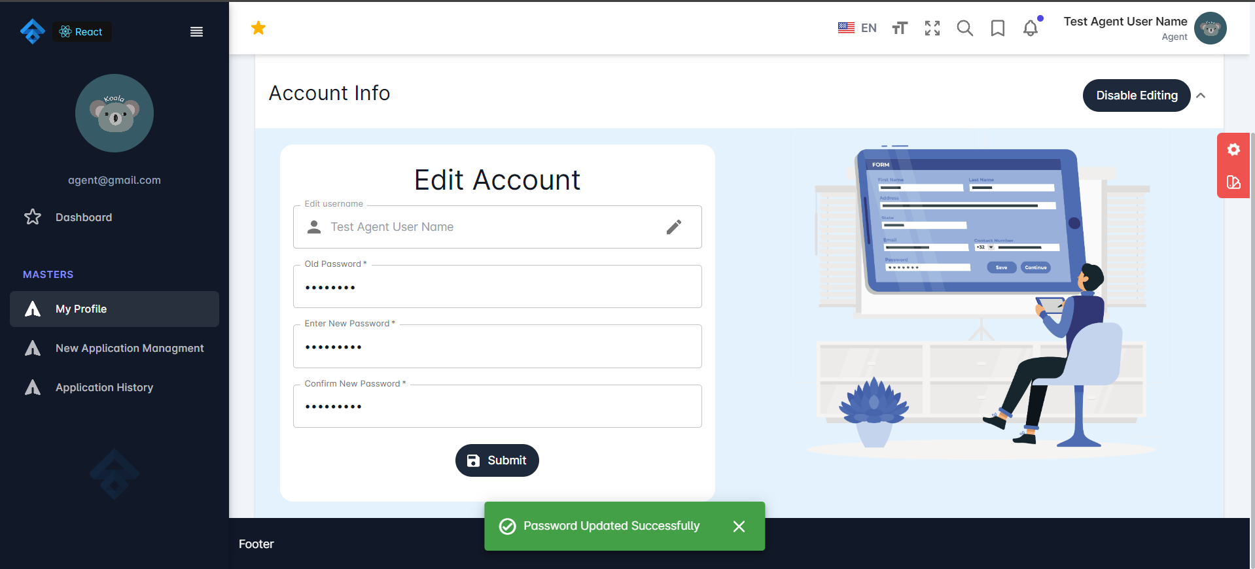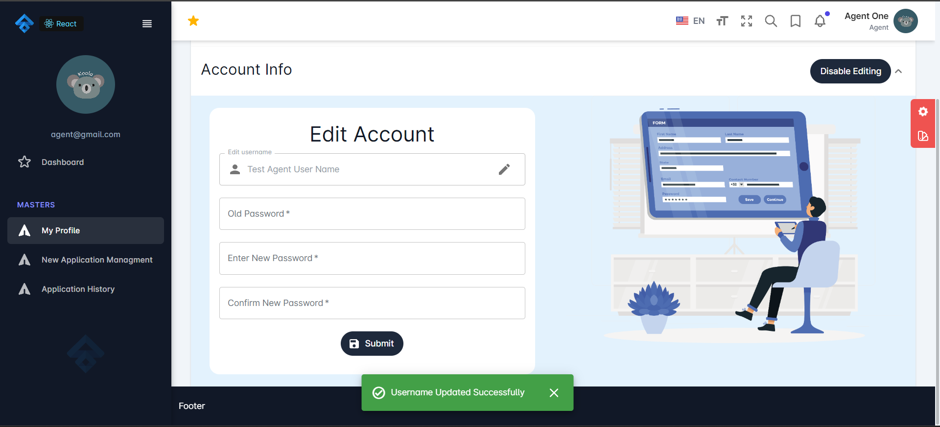

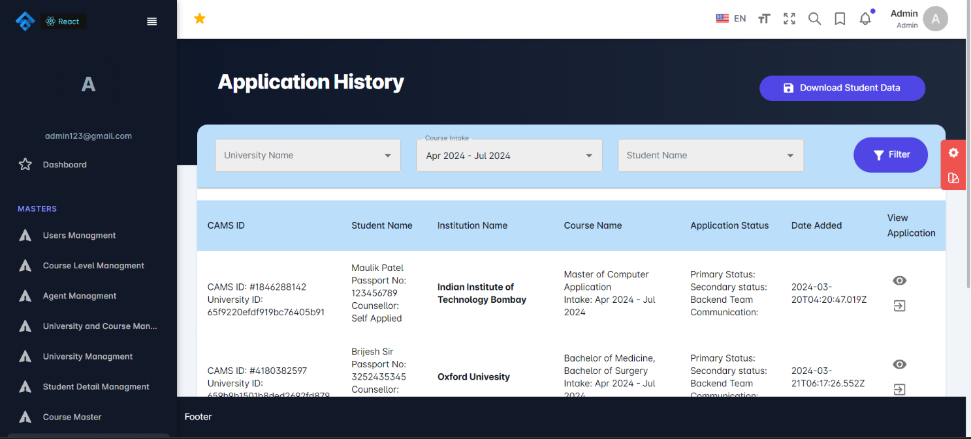

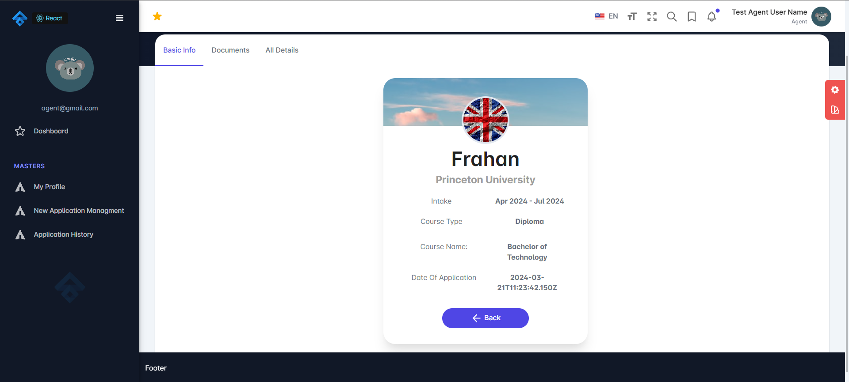

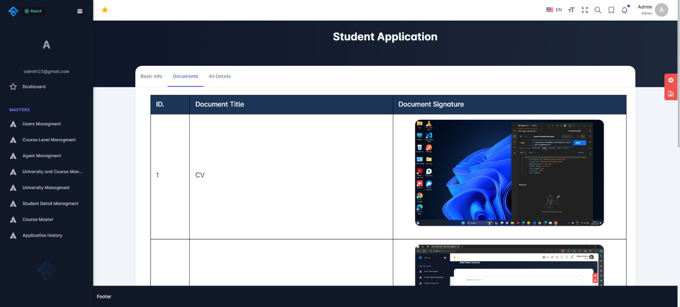

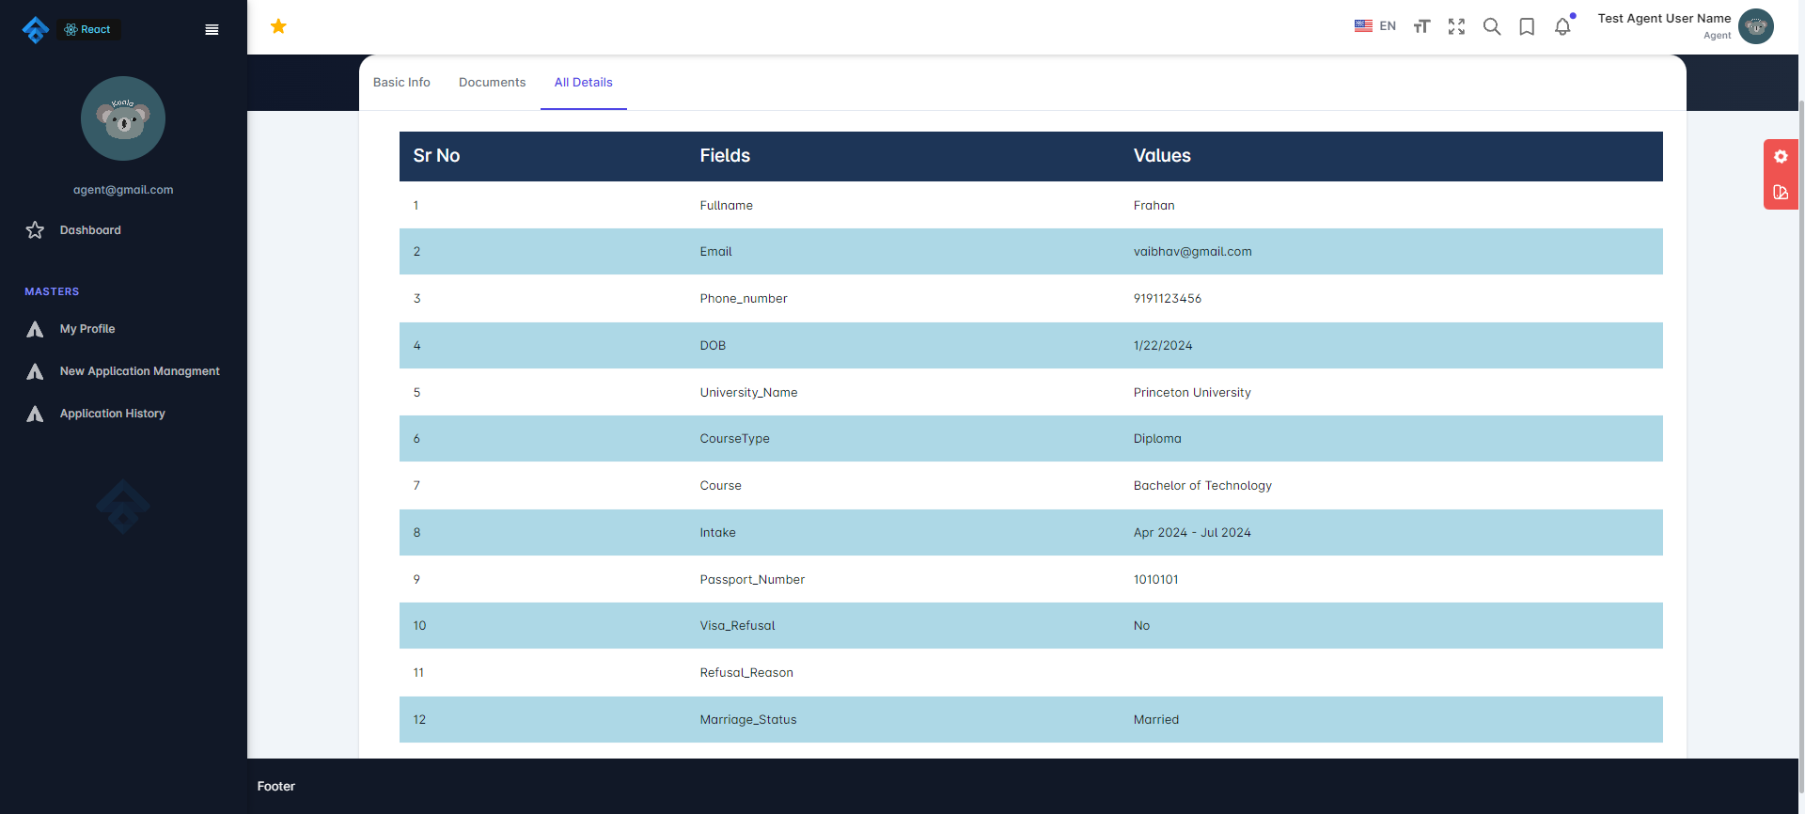

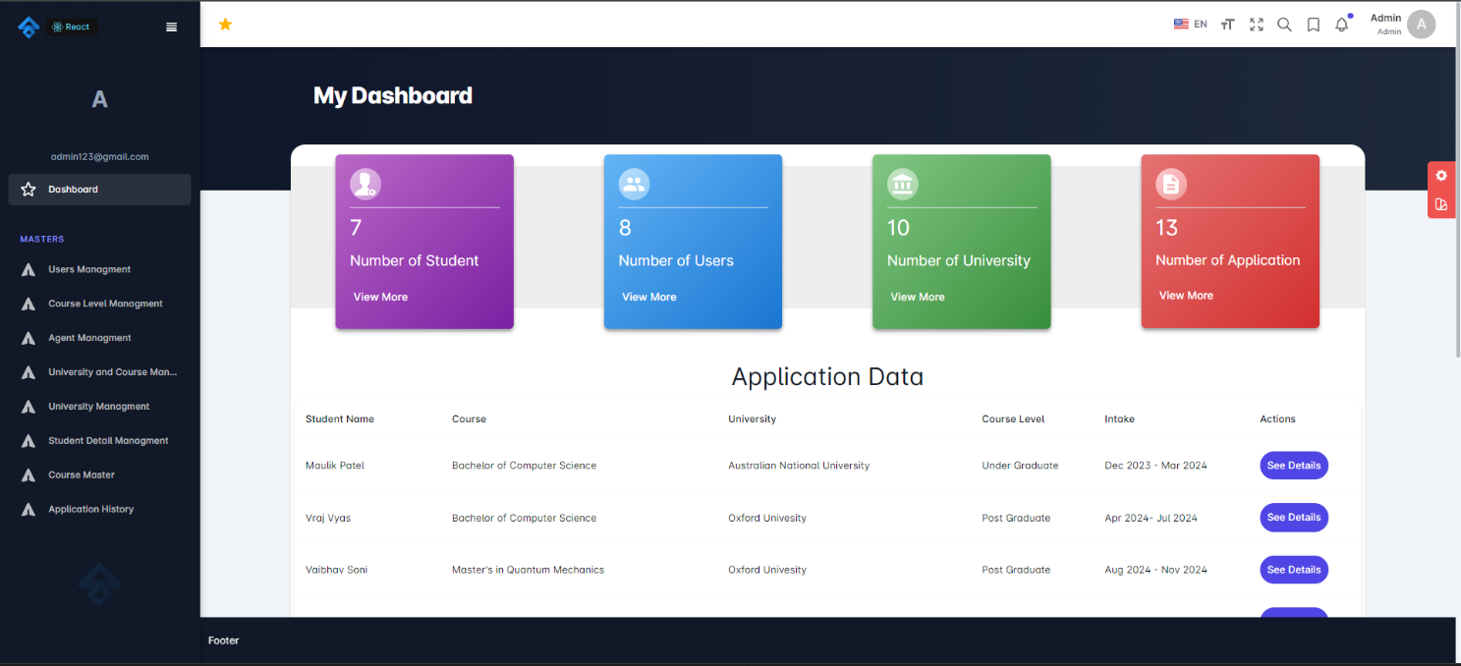

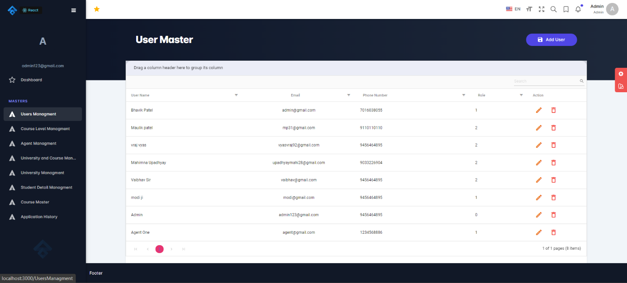

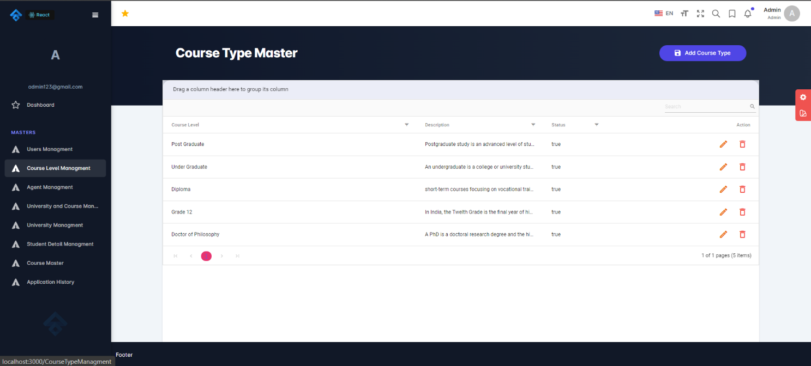

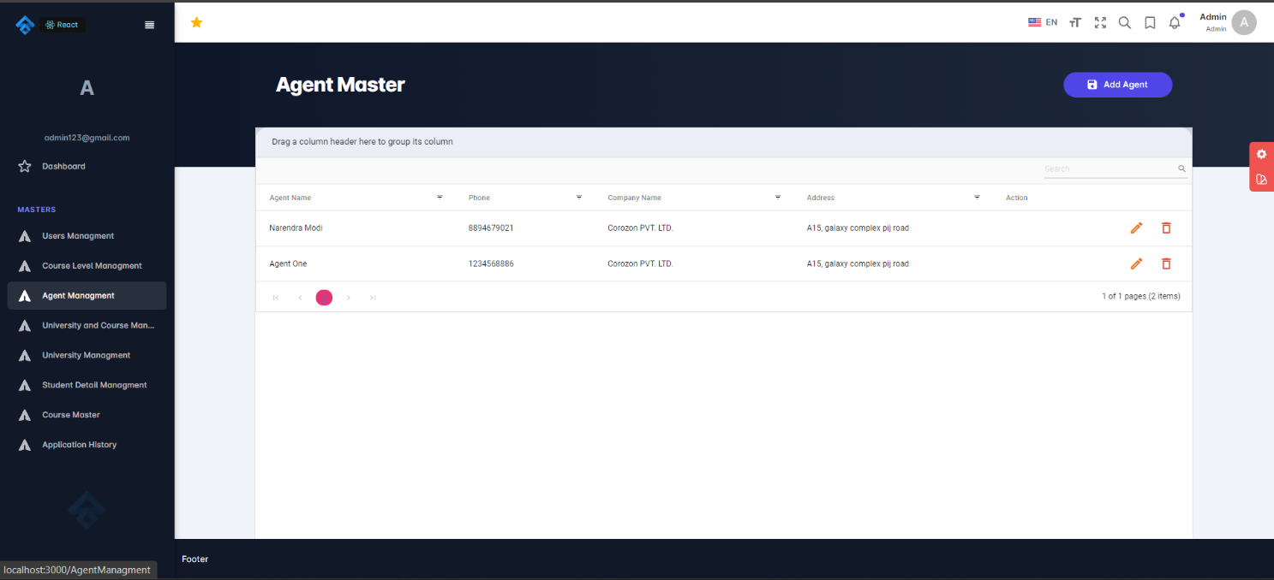

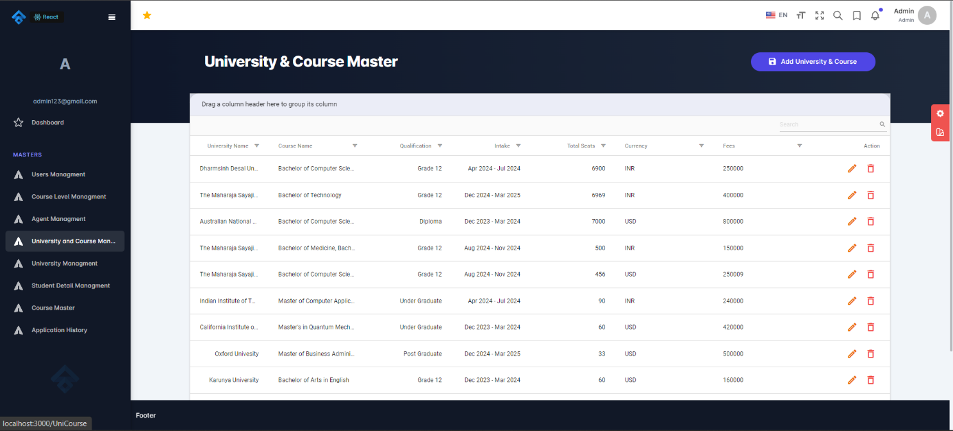

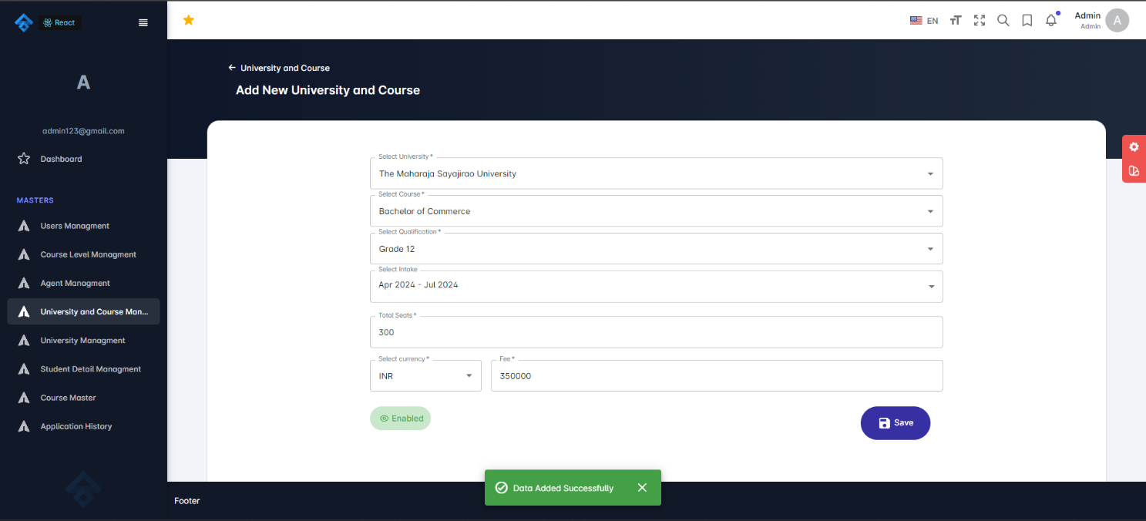

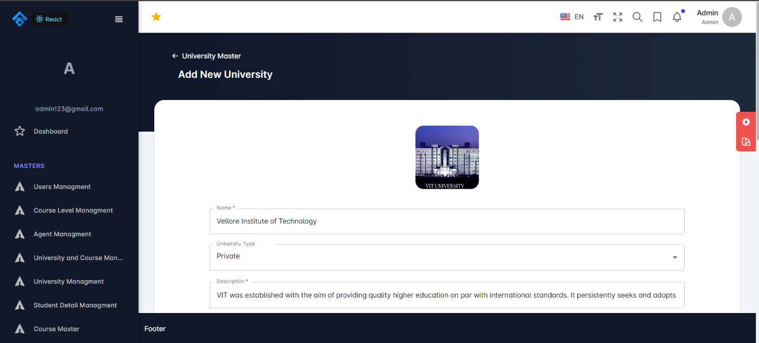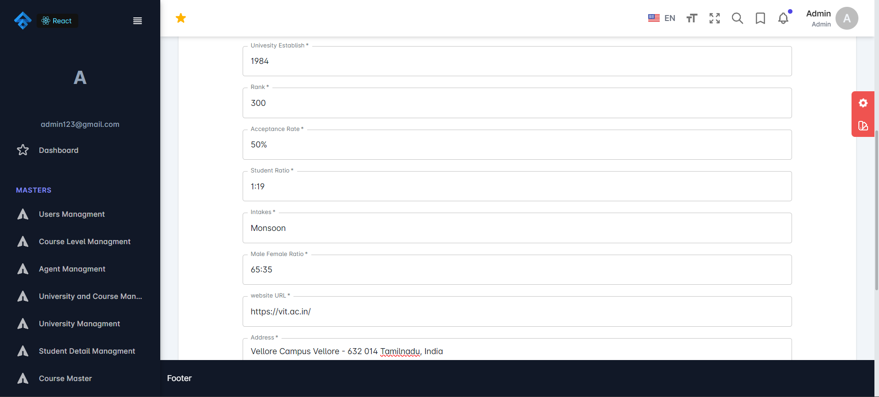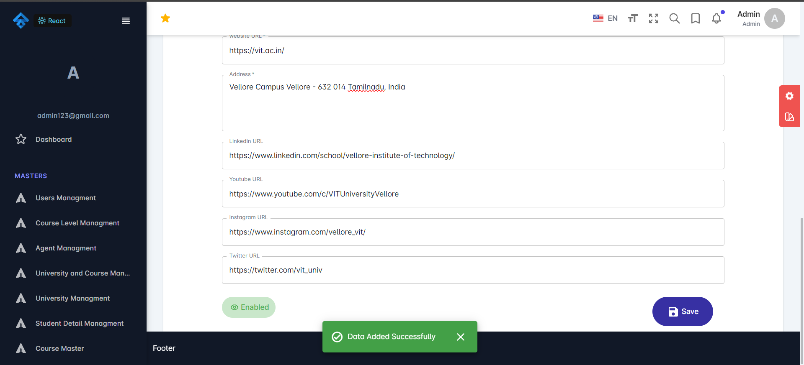

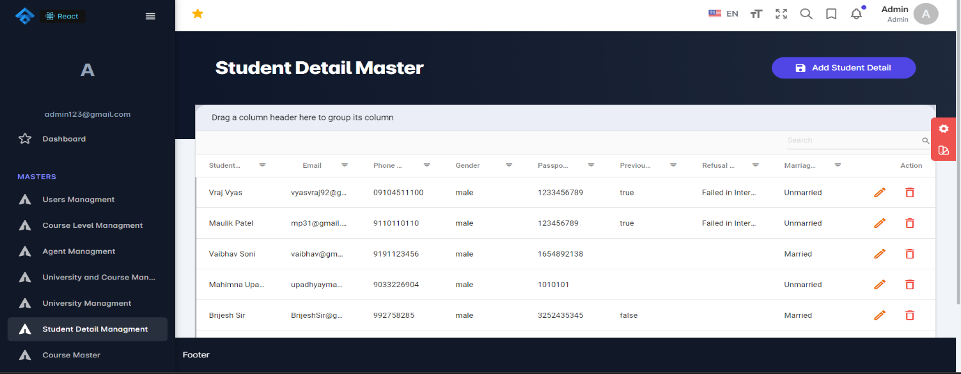

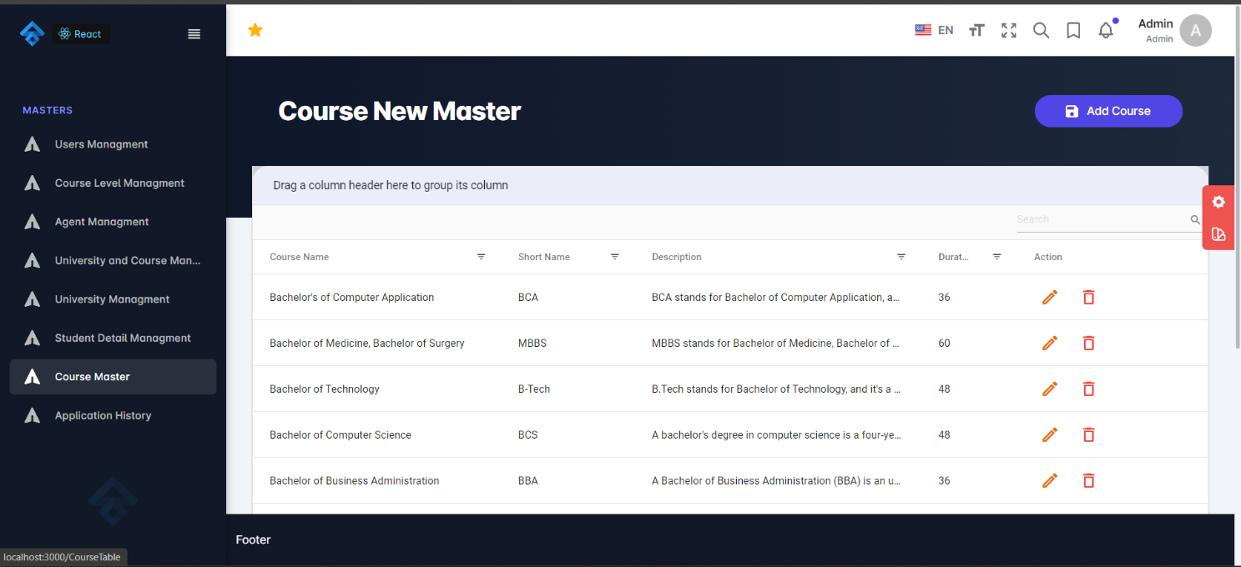

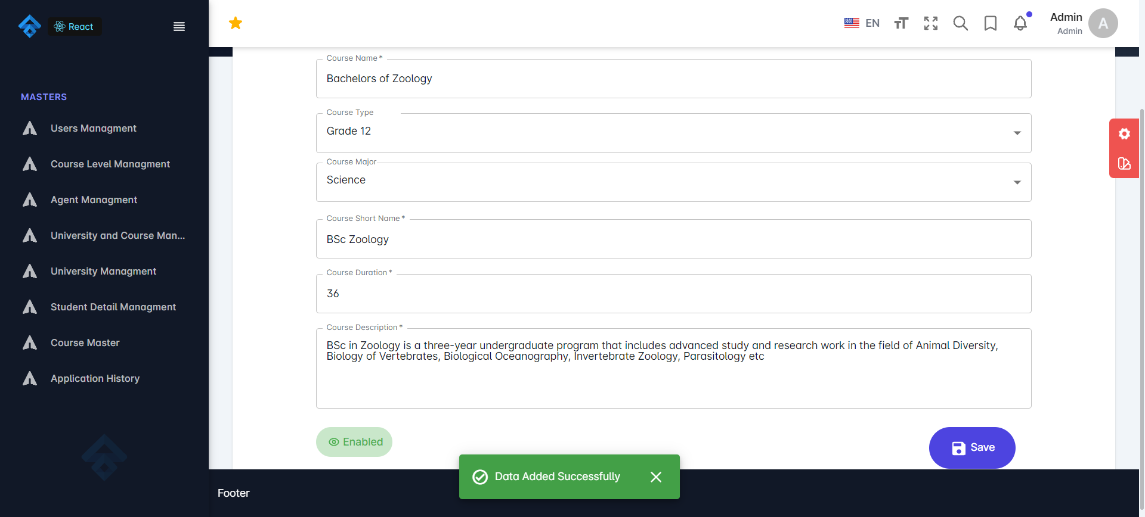

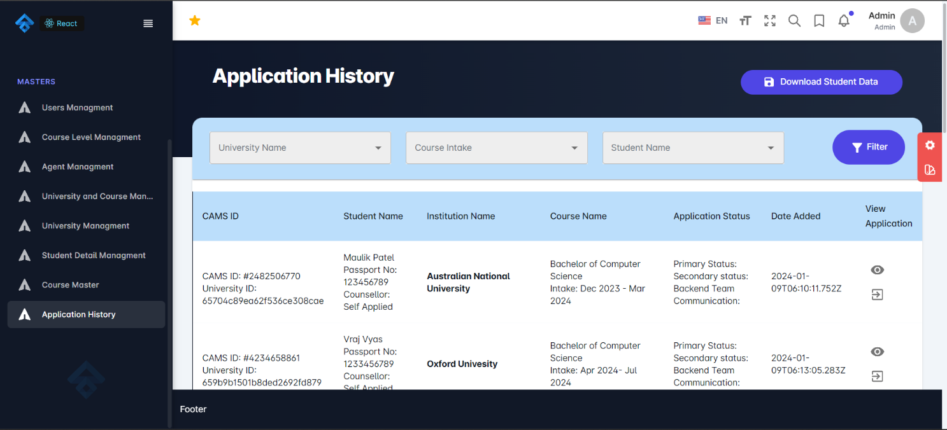



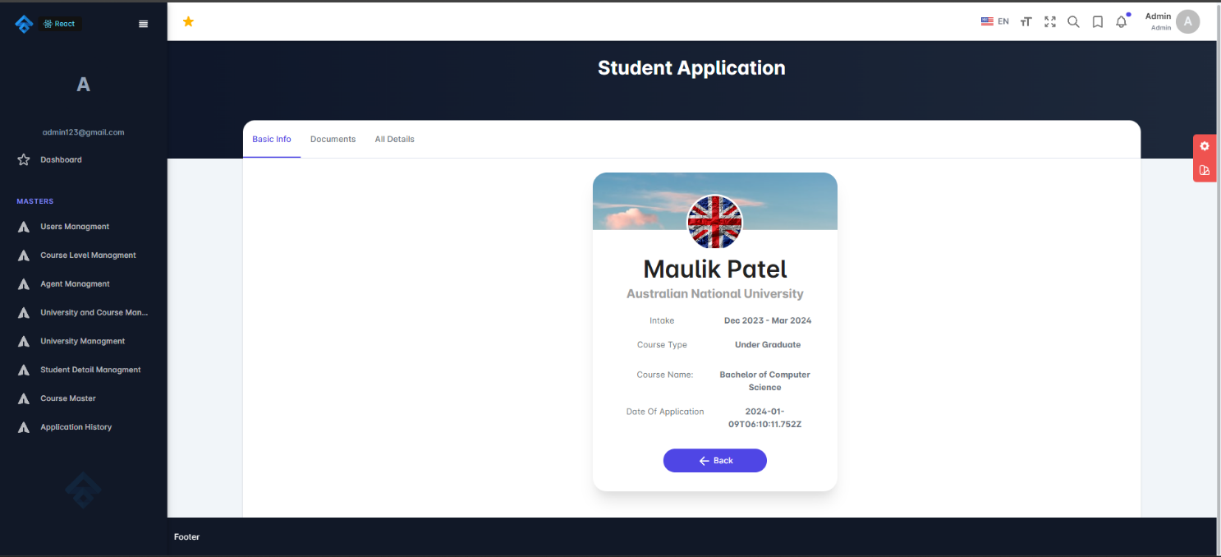



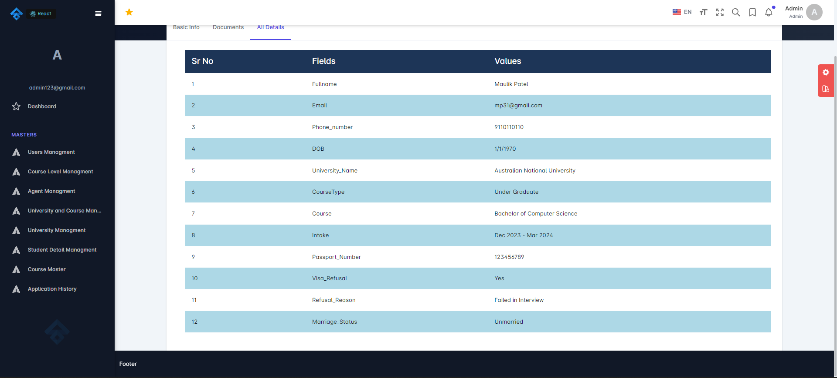

Chapter 6: EXPERIENCES OF CORPORATE AND WORKING ATMOSPHERE

Working at Codewing Technology provided me with invaluable experiences and insights into corporate culture and the working atmosphere. Over the course of four months, I had the opportunity to learn and grow significantly, gaining proficiency in various technologies and development methodologies while actively contributing to live projects. As a full-stack developer, my primary responsibility was to craft a robust and visually appealing website to cater to user needs, predominantly utilizing the MERN (MongoDB, Express.js, React.js, Node.js) tech-stack.

In the initial month of my tenure, my focus was on developing APIs (Application Programming Interfaces) to facilitate seamless communication between different components of the project. This involved careful planning and implementation to ensure efficient data exchange and functionality.

The collaborative environment at Codewing Technology fostered constant learning and innovation. I had the privilege of working alongside talented individuals who were always ready to share their knowledge and support each other. Regular team meetings and brainstorming sessions provided opportunities to exchange ideas, troubleshoot challenges, and refine our approach to project development.

Moreover, the company culture emphasized open communication and transparency. Feedback sessions were conducted regularly, allowing team members to offer constructive criticism and suggestions for improvement. This culture of feedback not only helped in honing our technical skills but also encouraged personal and professional growth.

One aspect of Codewing Technology's culture that stood out to me was its emphasis on work-life balance. Despite the fast-paced nature of the tech industry, the company prioritized employee well-being. Flexible working hours and remote work options were provided, enabling us to maintain a healthy balance between work and personal commitments.

Furthermore, the company encouraged a culture of diversity and inclusivity. Respect for individual differences was ingrained in every aspect of our work, fostering a welcoming and supportive environment for all employees.

In conclusion, my experience at Codewing Technology was enriching on both a professional and personal level. I not only gained valuable technical skills and expertise but also experienced firsthand the importance of a positive corporate culture and a conducive working atmosphere. It is an experience that I will carry with me as I continue to grow and evolve in my career journey.

# REFERENCES

1. **Leverage Edu**: Empowering students worldwide, Leverage Edu provides personalized guidance and mentorship for academic and career success, leveraging technology to connect students with the best resources and opportunities.
2. **Dribbble**: A vibrant community of designers and creatives, Dribbble serves as a platform for showcasing, discovering, and discussing design work. From graphic design to animation, it's a hub for inspiration and collaboration.
3. **Behance**: As a leading platform for showcasing and discovering creative work, Behance offers a space for artists, designers, and photographers to share their portfolios and connect with potential clients and collaborators globally.
4. **Coolors Co**: Simplifying the process of color palette generation, Coolors Co provides designers and creatives with easy-to-use tools for creating harmonious color schemes, whether for digital projects or physical designs.
5. **Stack Overflow**: A go-to resource for developers worldwide, Stack Overflow fosters a collaborative community where programmers can seek solutions to coding challenges, share knowledge, and contribute to the collective expertise of the industry.
6. **Material UI Documentation**: Material UI offers comprehensive documentation for developers utilizing its React components to build sleek and intuitive user interfaces, providing detailed guidance and examples for seamless integration.
7. **TailwindCSS Documentation**: With its utility-first approach to CSS, TailwindCSS Documentation equips developers with the resources needed to rapidly build customizable and responsive web designs, enabling efficient styling without the need for custom CSS.
8. **React Documentation**: As the official documentation for React, this resource provides comprehensive information and tutorials for building dynamic and interactive web applications using the popular JavaScript library, catering to both beginners and experienced developers.
9. **AWS Documentation**: Amazon Web Services (AWS) Documentation offers extensive guides, tutorials, and reference materials for utilizing the vast array of cloud computing services provided by AWS, enabling businesses and developers to leverage scalable and reliable infrastructure for their projects.